eHealth Solution Design Description

Turnkey Solution for Independent Physician Practice

Prepared By:

Adam Tabriz, MD

Sandeep Raghav, Enterprise Integration Architect

Andrew (Huichao) Zhao, PhD, Control Science and Engineering

Kabir Nain, MBA, Healthcare Administration, Policy and Compliance

November 2015

# Scope

This report will define the high level design and technology decisions of the cloud based medical practice management System.

This eSDD defines and describes the use of each view, the architectural constraints of the system, the functional requirements with a significant impact on the architecture, use-case realization, concurrency aspects, the layers and subsystems of the application, performance issues and constraints.

It will also address clinical and non clinical aspects of an efficient, compliant and safe patient and provider encounter by taking into account all the internal, state as well as federal policies, independent physician judgment.

This report will cover all the necessary aspects of the independent physician practice from writing and approving policies, procedures and protocols to Creating Audit trail, providing feedback and training to users across the board.

# References

TITLE XIII—HEALTH INFORMATION

TECHNOLOGY………...<http://www.hipaasurvivalguide.com/hitech-act-text.php>

Software Engineering Standards Committee of the IEEE Computer Society, “IEEE Recommended Practice for Software Design Descriptions”, IEEE Std 1016-1998 in compliant with Health Information Technology for Economic and Clinical Health Act’’ or the ‘‘HITECH Act’’.

# Definitions

**Turnkey**: The provision of a complete product or service that is ready for immediate use.

**Solution:** a means of solving a problem or dealing with a difficult situation.

Independent physician: An Independent Physician practice is a legal entity organized and directed by physicians in private practice.

**Affordable Care Act (ACA) “Obama Care”:** On March 23, 2010, President Obama signed comprehensive health reform, the Patient Protection and Affordable Care Act, into law. ACA focuses on provisions to expand coverage, control health care costs, and improve health care delivery system.

**In the software as a service (SaaS) model:** users gain access to application software and databases. Cloud providers manage the infrastructure and platforms that run the applications. SaaS is sometimes referred to as "on-demand software" and is usually priced on a pay-per-use basis or using a subscription fee.

**Practice management module:** will simplify the process of authoring, approving and distributing documents and capturing attestation. Policy management software uses rules-based work flows and alerts to streamline policy life cycle process, alerting compliance managers about unread policies, and reminding document owners when to update or retire policies.

**EMR (EHR) Module:** connects doctors, patients and allied health professionals and emerging technologies to drive better health and save lives while providing the necessary tools for independent physicians to assess each patient in a more comprehensive way, increase profitability, improve compliance and quality of practice. This is a Cloud-based model for electronic health record (EMR) technology.

**Telemedicine / cloud patient visits / secure consultant interactions:** In conjunction with EMR and virtual office systems will facilitate efficient delivery and access to medical care, regardless of the location or medical specialty, while utilizing evidence-based medicine to achieve superior outcomes.

**E Commerce:** e-commerce, virtual store fronts and payment processing system for independent Allied healthcare providers, patients, physicians and consultants within the system. That will provide a convenient interactive resource.

**Cloud based Virtual Office space:** Provides communication and office services without providing physical office space.

**Medical wearables (i.e. ‘fitbit’):** in conjunction with EMR, EPM and Cloud visits will enable the patient vital signs and tests to be transmitted in real time for a more aggregate picture of the patient’s health.

**Professional multidisciplinary support:** A-Z Practice management consultancy, Policies, standard operating procedures, Audit reports, quality studies

**Writers:** Is a person or group of people whom Can Write, edit, sign and submit for review but cannot approve. Policy writers, editors, etc.

**Reviewers:** is an expert person or a group of experts in certain field whom can review and make suggestion for corrective action to writers and approvers. E.g. Engineers, Consultants, Lawyers, Certified auditors etc.

**Approvers:** Is a person, or group of people whom need to sign off and approve each documents after having been written and reviewed by experts. They are the final authorities responsible for each and individual entity. e.g. CEO, Directors, Chief of departments

·Readers: Is a person of group of people whom will be able to read or must read the documents and sign off electronically. If necessary they should be able to view videos, listen or read and take multiple choice tests with scoring and pass or fail results Note: Each user can have one or more role as document writer, reviewer, approver, reader role

# Considerations for producing an eSDD Software life cycle

## eSDD within the life cycle

In the design part of our waterfall model life cycle we define our sdd. After determining the requirements and specifications as the cycle goes through design part we make a prototype of our software design. Before implementation it is vital to design the software to be more controlled on coding part. As the cycle shows if there is a problem in maintenance about the design part we can go back and fix it.

## Purpose of an eSDD

The purpose of this eSDD is to define and describe the use of each view, the architectural constraints of the system, the functional requirements with a significant impact on the architecture, use-case realization, concurrency aspects, the layers and subsystems of the application, performance issues and constraints.

## Vision of eSDD

The successful Independent Physician practice will depend on performance, efficiency and patient safety at an affordable cost.

## Mission of eSDD

The concept is to provide affordable A-Z, End to End medical practice support to independent physicians enabling them to intuitively comply with increasing government regulations, reduce overhead and increase revenue while maintaining their independence.

## Concept of eSDD

Using combination of software as a service (SaaS) model, Physician, Allied healthcare providers, consultants and engineers to develop a turnkey system that will bring quality practice to independent physician offices enabling them to increase revenue, improve patient safety in accordance with Affordable care act provisions.

## Problems Solved by eSDD

### ICD-10 implementation

### HIPAA

### Meaningful use 2

### Getting paid

### Maintenance of certification

### Collecting co-pays and deductibles

### Administrative burdens

### Rising operational costs

### Pay for performance

### Independence vs. employment

### Payers dictating healthcare

### Patients dictating healthcare

### Keeping pace with technology

### Staff retention

### Avoiding liability

* + 1. Problems overveiw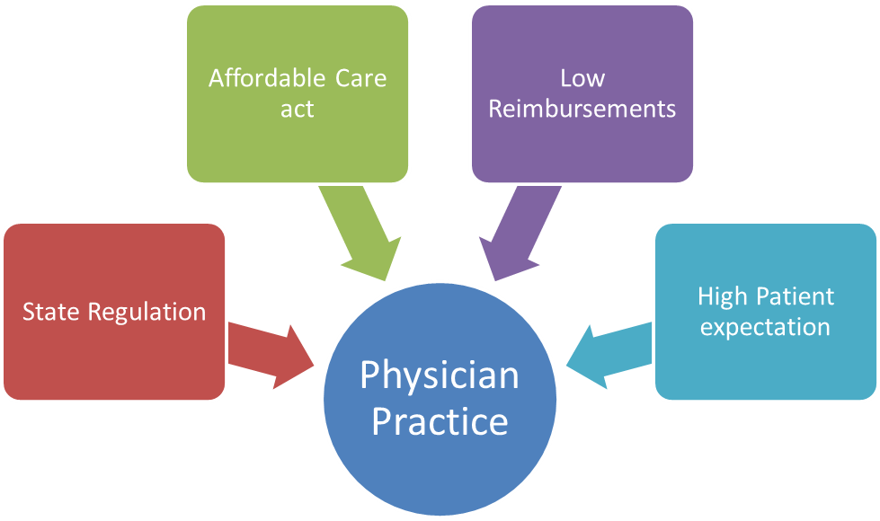

## Evidence / Survey: Independent physicians feel compelled to sell practices By: DAVE LEVITAN, ACS Surgery News Digital Network December 2, 2014

### Physician feels overwhelmed

### Would reaches out to anyone who can shelter him or her from this burden?”

### 2/3 - Rising costs and downward payment pressure the most pressing challenge to their independence

### Competing with larger health care systems for patients was second on that list of challenges

### Many physicians believe the trend will eventually reverse itself, perhaps once some of those newer business models begin to take hold.

### 88% agreed that payment will eventually become dependent on clinical outcomes measures that demonstrate quality and value, which many independent physicians believe will favor them over bigger systems.

### [www.acssurgerynews.com/index.php?id=15051&type=98&tx_ttnews[tt_news]=315017&cHash=da03e20e36](http://www.acssurgerynews.com/index.php?id=15051&type=98&tx_ttnews[tt_news]=315017&cHash=da03e20e36)

### <https://www.youtube.com/watch?v=OPdTtXex57s>

### <https://www.youtube.com/watch?v=nf6w8UJUta8>

### <http://medicaleconomics.modernmedicine.com/medical-economics/news/top-15-challenges-facing-physicians-2015?page=full>

### <http://www.physiciansfoundation.org/uploads/default/Physicians_Foundation_2012_Biennial_Survey.pdf>

### <http://www.entrepreneur.com/article/243297>

### <http://www.procaresystems.com/documents/2015%20Independent%20Physician%20Outlook%20Survey%20FINAL.PDF>

### 

# The Solution

eHealth Solutions will help independent medical practices to comply with affordable care act (ACA) provisions, reduce liability, maximize efficiency, and increase revenue and most of all ensure patient safety at an affordable cost without utilizing additional resources within their practice. eHealth solutions provides a “Cost-effective and Turnkey” solution that enables independent physicians and small practices to improve efficiency and achieve accreditation compliance through innovative approach to healthcare management and automated review/approval lifecycle management, publication, distribution and tracking of policies and procedures.

# Software Design Description Information

# Introduction

This document is adopted from the Software Engineering Standards Committee of the IEEE Computer Society, “IEEE Recommended Practice for Software Design Descriptions”, IEEE Std 1016-1998 in compliant with Health Information Technology for Economic and Clinical Health Act’’ or the ‘‘HITECH Act’’.

The Software Design Descriptions (eSDD) provides an architectural overview of cloud based independent physician practice management system. This document presents to various stakeholders different types of abstraction. It aims to provide the stakeholders a clear understanding of the system.

## 

## Scope

* + - 1. Solutions, Scope of Work and Deliverable
      2. Preliminary Research and Discover Phase:
      3. In-depth research of the filed (done by Adam)
      4. Strategic Planning
      5. Conception of the website’s flow
      6. Preparation of detailed charts and wireframes
      7. Optimization of the navigation based on application goals
      8. Graphic Design Work:
      9. Graphic theme of the website( structure, color, atmosphere, etc., …)
      10. Front End Programming:
      11. Top quality hand coding(XHTML/CSS/JavaScript)
      12. Easy integration of Back end

### 

### Overview In order to fully document all the aspects of the architecture, the eHealth Solution Design Document contains the following subsections:

* Describes the use of each view
* Describes the architectural constraints of the system
* Describes the functional requirements with a significant impact on the architecture
* Describes the most important use-case realization. Will contain the Analysis Model and the Design Model
* Describes designs concurrency aspects
* Describes how the system will be deployed. Will contain the Deployment Model
* Describes the layers and subsystems of the application
* Describes any significant persistent element. Will contain the Data Model
* Describes any performance issues and constraints
* Describes any aspects related to the quality of service (QoS) attributes

## Software Architectural Representation

## The views used to document the eHealth solution System in current phase are:

### 

### **Deployment view**

* + - * 1. **Audience:** Deployment managers.
        2. **Area**: Topology: describes the mapping of the software onto the hardware and shows the system's distributed aspects.
        3. **Related Artifacts:** Deployment model.

### **Use Case view**

### **Audience:** all the stakeholders of the system, including the end-users.

### **Area:** describes the set of scenarios and/or use cases that represent some significant, central functionality of the system.

### **Related Artifacts :** Use-Case Model, Use-Case documents

# Software Architectural Goals and Constraints. This section describes the software requirements and objectives that have some significant impact on the architecture.

* 1. Technical Platform
  2. Transaction
  3. Security
  4. Persistence
  5. Reliability/Availability
  6. Performance
  7. Internationalization
  8. Use-Case View

This section provides a functional overview of the system by a use-case diagram. 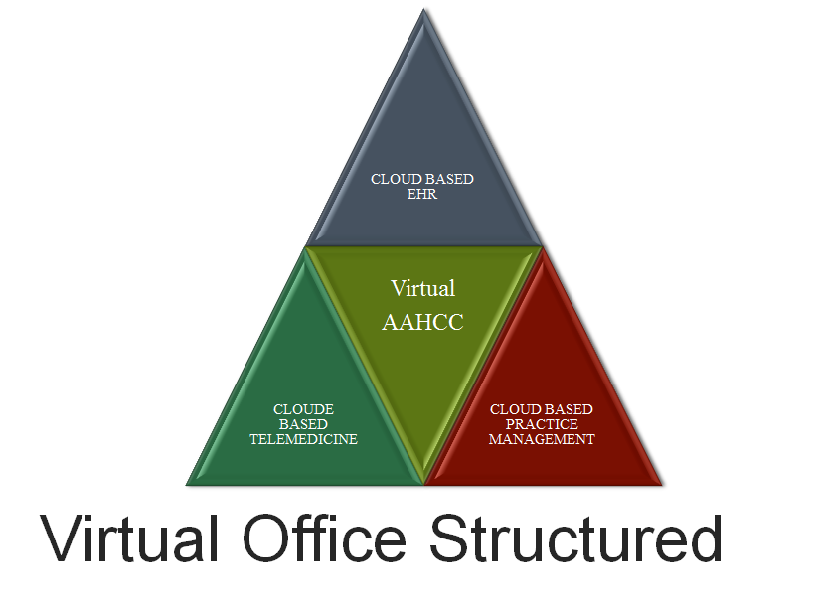

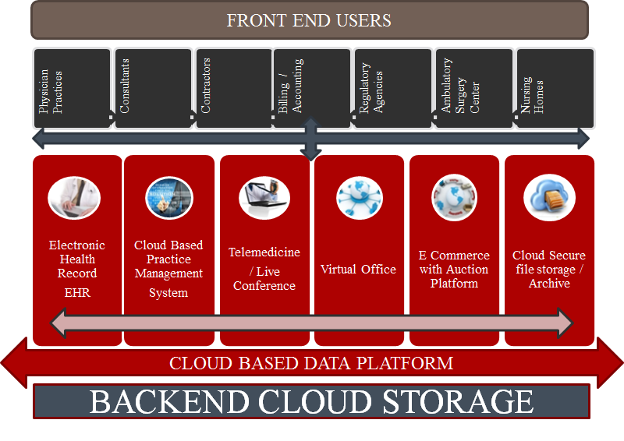

### Use-Case Realizations

### 

* + - 1. **Back end Users**
         1. Technology
         2. Clinical Staff
         3. Administration
         4. Billing
         5. Accounting
         6. Marketing
         7. Compliance / Audit
         8. Engineering
      2. **Front end users**
         1. Patients
         2. Physicians/Healthcare providers
         3. Nursing
         4. Office staff
         5. Billing
         6. Allied Healthcare Services
         7. Pharmacy
         8. stores
         9. Consultants
         10. other Businesses

### **Logical View**

### **Overview**

### 

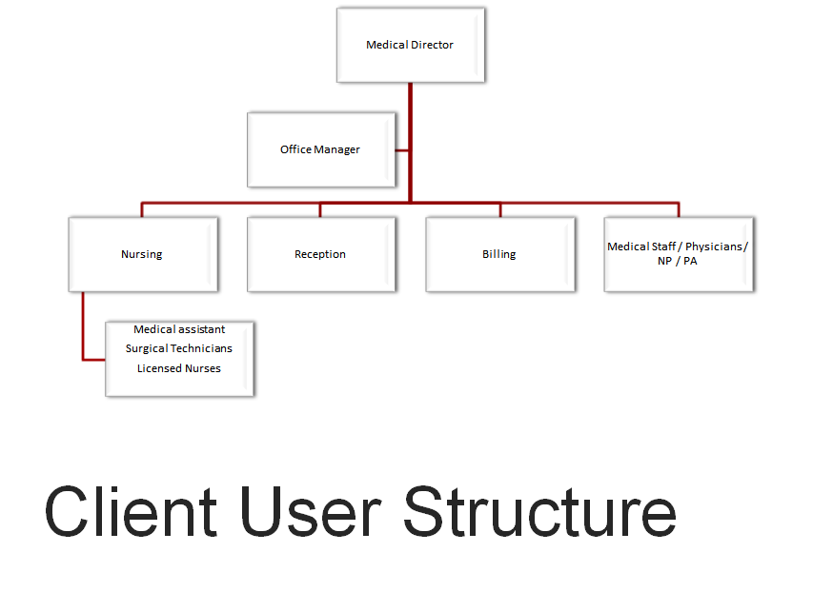

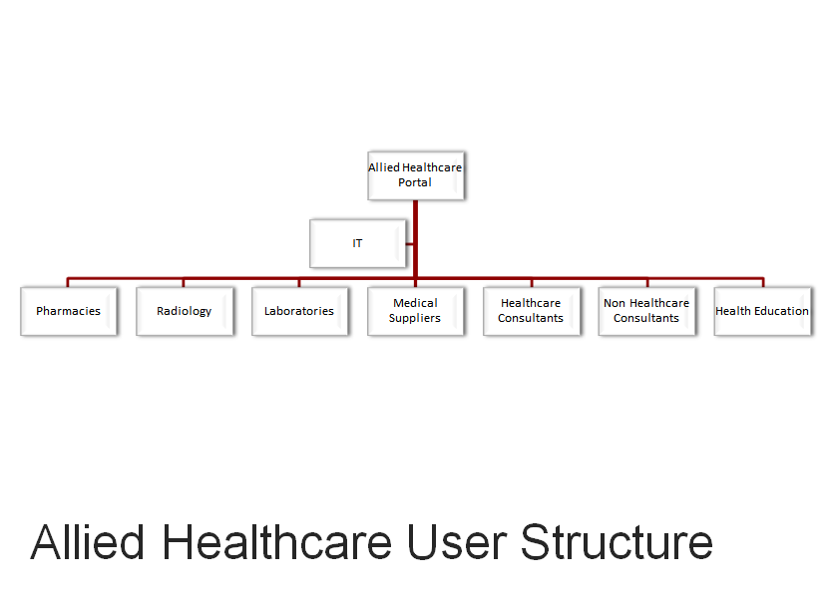Our Practice Management also works well for Allied Healthcare Providers (Acupuncturist, Chiropractor, Dentist, Nutritionist, PT, OT, Naturopath etc.)

### **Deployment View**

### 

### Scalability: The architecture would allow horizontal scaling , data would be partitioned using multi tenancy architecture in single database which would be replicated across multiple data centers

### Reliability: Use multi zone data replication for reliability . Full transaction rollback management in place .

### Availability: Use elastic load balancing for availability

### Portability:

### Security: Multi layers security at various levels

* + - 1. User level
         1. Two form factor authentication
         2. Full audit trail
         3. Implement HIPPA specifications for storing and encrypting data
         4. Data Loss preventions policy
         5. System level :

Cloud based encryption (Follow HIPAA specs) for storage

Only support HTTPS SSL version grater then TSL 1.0

Description : (Authentication and authorization mechanisms)

LDAP used for authentication

Manual implementation of authorization

Create Permissions at API level

Create Roles using one-many Permissions

User assigned one or many Roles .

#### Solution :

## Risks and Mitigation Plan

### Hardware failure: Reliability and Availability to prevent system disruption . Alert and notification to notify Admin about failure . Alert to have multiple severity , Low , High , Critical

### Software failure:

* + - 1. Proper Notification to Admin to notify failure
      2. Define business policy to take actions
      3. Ability to apply patches on rolling bases

### Software Design description organization

### Introduction: The eHealth Software Design Description (eSDD) details the chosen software architecture and the justification for selecting that architecture. In this project the team was tasked with architecting (maybe designing or choreographing…?) and implementing an Independent physician practice management solution platform.

### Design views: Entity attribute information can be organized in several ways to reveal all of the essential aspects of a design. In so doing, the user is able to focus on design details from a different perspective or viewpoint. A design view is a subset of design entity attribute information that is specifically suited to the needs of a software project activity. Each design view represents a separate concern about a software system. Together, these views provide a comprehensive description of the design in a concise and usable form that simplifies information access and assimilation. A recommended organization of the eSDD into separate design views to facilitate information access and assimilation is given. Each of these views, their use, and representation are discussed in detail.

Various Design views help various parties understand the system architecture . There are some of design viewpoints :

1. UI Design
2. UI Controller Design
3. Authentication and Access Control Design
4. Transaction design
5. Data storage design
6. Even and Alert design
7. High availability and Fail-over design

All view do designs sometime is complicated and time consuming and high level of design is provided . High level design gives implementation freedom to implement fine grained features on choice bases . Any complicated feature are run through architects to provide proper and consistent pattern based solution .

## Decomposition description

### Scope: We first must understand our organization's business functions before beginning developing information systems. The decomposition descriptions are done in order to plan business functions, processes, and sub processes within “eHealth solution”Project.

### 

### Use: Our Project will perform a variety of different functions. Before we plan what systems to build for the organization, it is helpful to first understand the functions of “eHealth Solutions” Projects needs to perform. Then it is much easier to identify processes that occur within the business functions, and ultimately the systems that will support those processes. This is a top-down approach to systems development. The process of starting at a high level and moving into smaller and smaller subsystems is called decomposition. The functional decomposition diagram (FDD) is a planning tool for identifying business functions and the processes that comprise them. The diagram is the starting point for more detailed process diagrams, such as data flow diagrams

**List and define all the features**

1. Define fine grained flow of each feature
2. Define user profile and actions
3. Capture full flow for the activity including successful flow , incomplete exit , change users mind , block incorrect flow and proper validation to help user guide through process .
4. Collect full data which is relevant at each step and way it should be handled .
5. Error handling

## Representation:

## 

* + - 1. Objectives: ·

### Understand the rules and style guidelines for functional decomposition diagrams (FDDs).

### Understand the process used to create FDDs.

### Be able to create a Functional Decomposition Diagram.

## Dependency description:

### Scope: In our Project many methods are available for visualization and measurement of structure during the design of a programming solution.

### Use : In order to avoid the possible problems might occur due to visualizing the program structure we draw as many diagrams as possible since the diagrams are more clear and easily understandable under any case. As we are working on, adding, moving and deleting pieces as the program developed and problems with the translation from design through pseudo-code to high-level language code were overcome. Over time, we decided that it was most helpful to make the diagram show the relationships between sections of the program.

### A decomposition diagram shows a hierarchy between modules but does not show that some modules are dependent on other modules. When one module cannot occur until another module is completed, there is a dependency between the two modules. These dependencies are illustrated on a Dependency Diagram. Just as a decomposition diagram does not show dependencies, a Dependency Diagram does not show program structure.

### Representation:

### 

## 

## Interface description

### **Scope:** front end user interaction (patients, office staff, independent businesses) back end management at eHealth solutions inc.

### **Use:** Since our project is going to work through a cloud based platform, the main screen we met with users is very important for providing the efficiency and productivity. The graphic user interface (GUI) of a computer system comprises the interaction metaphors, images, and concepts used to convey function and meaning on the computer screen. It also includes the detailed visual characteristics of every component of the graphic interface and the functional sequence of interactions over time that produce the characteristic look and feel of Web pages and hypertext linked relations. Graphic design and visual "signature" graphics are not used simply to enliven Web pages — graphics are integral to the user's experience with the site. In interactive documents graphic design cannot be separated from issues of interface design. There are some criteria that we are going to apply to our platform in order to have effective, efficient, easily understandable and usable interface. These are:

### **Visibility of system status:** The system should always keep users informed about what is going on, through appropriate feedback within reasonable time.

### **Match between system and the real world:** The system should speak the users' language, with words, phrases and concepts familiar to the user, rather than system-oriented terms. Follow real-world conventions, making information appear in a natural and logical order.

### **User control and freedom:** This platform will enable each user to be given a unique access privileges depending their credentials and responsibilities.

### **Consistency and standards:** Users should not have to wonder whether different words, situations, or actions mean the same thing. Follow platform conventions.

### **Error prevention:** Even better than good error messages is a careful design which prevents a problem from occurring in the first place. Either eliminate error-prone conditions or check for them and present users with a confirmation option before they commit to the action.

### **Recognition rather than recall:** Minimize the user's memory load by making objects, actions, and options visible. The user should not have to remember information from one part of the dialogue to another. Instructions for use of the system should be visible or easily retrievable whenever appropriate.

### **Flexibility and efficiency of use:** This platform is designed to be customizable to any physician practice and clients. Provide single login and independent control over the content. Accelerators -- unseen by the novice user -- may often speed up the interaction for the expert user such that the system can cater to both inexperienced and experienced users. Allow users to tailor frequent actions.

### **Aesthetic and minimalist design:** The goal of the design is to provide a simple, easy to navigate and brows through pages with minimal typing requirement and more of template usage and drag and drop functionality.

### **Help users recognize, diagnose, and recover from errors:** Error messages should be expressed in plain language (no codes), precisely indicate the problem, and constructively suggest a solution.

### **Help and documentation:** Even though it is better if the system can be used without documentation, it may be necessary to provide help and documentation. Any such information should be easy to search, focused on the user's task, list concrete steps to be carried out, and not be too large. In addition to automated help and FAQ section, each module will have 1 or more dedicated IT specialist for technical support. Clinical and non clinical consultants will also be available for none technical assistance.

### **Representation:** This section will be described on module to module basis bellow

## Detailed design description

### **Scope:** The detailed design description contains the internal details of each design entity. These details include the attribute descriptions for identification, processing, and data. This attribute information should be provided for all design entities.

### **Use:** text

### **Architectural Structure:**

**API Framework :**

This framework would be fundamental backbone of system , which would allow development of system on top of it , this framework would have all the capability to build any module on tip of it using predefined pattern .

1. Defile technology to be used
2. Data flow between controller and storage
3. Full Create, update , retrieve and delete operations implemented for each object .
4. Common framework for authentication and authorization .
5. Some way to test the framework
6. Data integrity management
7. Data encryption management
8. State management

### Administrative Aspect:All software will adhere to the most current requirements of data encryption and if possible, a level ahead of federally mandated data encryption standards and will be molded by requirements from the Agencies of Health and Human Services, the Office of the Inspector General, Centers for Medicare and Medicaid Services.

#### Compliance Measures: This system will be in compliance with all the regulatory requirements e.g. HIPAA, and modifications to HIPAA through the HITECH Act. Breaches of PHI will be self reported per HIPAA requirements and compliance will be met by taking advantage of all the cost incentives through meeting and/or exceeding the meaningful use component of the HITECH Act.

##### Technology:Need to be discussed in more detail about compliance and see if we need to do basic compliance using alert/notification framework or there is more enforcement and auditing needed . The concept of fines and penalties when failing to protect e-PHI can result for the covered entity even when the e-PHI is exposed by a third-party (even if this is no fault of the covered entity). This may require a separate contract between the third party non-covered entity and the covered entity.--Kabir to follow up on contract solution to resolve.

##### Clinical: Each user will need to be able to read all HIPAA rules as well as disclaimers prior to using the system. All activities are recorded in real time and subject to periodic audit and as needed. Users need to be trained in person, through the platform on the rules. (This will include a one-time or periodic acknowledgment form for all users who will be exposed to e-PHI in order to best insure internal protection measures through employee compliance)

* + 1. **Administrative**:

**General Rules**

The Security Rule requires covered entities to maintain reasonable and appropriate administrative, technical, and physical safeguards for protecting e­PHI.   
Specifically, covered entities must:  
1. Ensure the confidentiality, integrity, and availability of all e­PHI they create, receive, maintain or transmit;  
2. Identify and protect against reasonably anticipated threats to the security or integrity of the information;  
3. Protect against reasonably anticipated, impermissible uses or disclosures; and  
4. Ensure compliance by their workforce.  
The Security Rule defines “confidentiality” to mean that e­PHI is not available or disclosed to unauthorized persons. The Security Rule's confidentiality requirements support the Privacy Rule's prohibitions against improper uses and disclosures of PHI. The Security rule also promotes the two additional goals of maintaining the integrity and availability of e­PHI. Under the Security Rule, “integrity” means that e­PHI is not altered or destroyed in an unauthorized manner. “Availability” means that e­PHI is accessible and usable on demand by an authorized person.  
HHS recognizes that covered entities range from the smallest provider to the largest, multi­state health plan. Therefore the Security Rule is flexible and scalable to allow covered entities to analyze their own needs and implement solutions appropriate for their specific environments. What is appropriate for a particular covered entity will depend on the nature of the covered entity’s business, as well as the covered entity’s size and resources. Therefore, when a covered entity is deciding which security measures to use, the Rule does not dictate those measures but requires the covered entity to consider:  
Its size, complexity, and capabilities, Its technical, hardware, and software infrastructure, The costs of security measures, and The likelihood and possible impact of potential risks to e­PHI.  
Covered entities must review and modify their security measures to continue protecting e­PHI in a changing environment.  
**Risk Analysis and Management**  
The Administrative Safeguards provisions in the Security Rule require covered entities to perform risk analysis as part of their security management processes. The risk analysis and management provisions of the Security Rule are addressed separately here because, by helping to determine which security measures are reasonable and appropriate for a particular covered entity, risk analysis affects the implementation of all of the safeguards contained in the Security Rule.  
A risk analysis process includes, but is not limited to, the following activities:  
Evaluate the likelihood and impact of potential risks to e­PHI; Implement appropriate security measures to address the risks identified in the risk analysis; Document the chosen security measures and, where required, the rationale for adopting those measures; and Maintain continuous, reasonable, and appropriate security protections.  
Risk analysis should be an ongoing process, in which a covered entity regularly reviews its records to track access to e­PHI and detect security incidents, periodically evaluates the effectiveness of security measures put in place, and regularly reevaluates potential risks to e­PHI.

**Administrative Safeguards**

**Security Management Process.** As explained in the previous section, a covered entity must identify and analyze potential risks to ePHI, and it must implement security measures that reduce risks and vulnerabilities to a reasonable and appropriate level.

**Security Personnel.** A covered entity must designate a security official who is responsible for developing and implementing its security policies and procedures.

**Information Access Management.** Consistent with the Privacy Rule standard limiting uses and disclosures of PHI to the "minimum necessary," the Security Rule requires a covered entity to implement policies and procedures for authorizing access to ePHI only when such access is appropriate based on the user or recipient's role (role based access)

**Workforce Training and Management.**

A covered entity must provide for appropriate authorization and supervision of workforce members who work with ePHI.

A covered entity must train all workforce members regarding its security policies and procedures,18 and must have and apply appropriate sanctions

against workforce members who violate its policies and procedures.

Evaluation.

A covered entity must perform a periodic assessment of how well its security policies and

**procedures meet the requirements of the Security Rule.**

**Physical Safeguards**

**Facility Access and Control.** A covered entity must limit physical access to its facilities while ensuring that authorized access is allowed.

**Workstation and Device Security.** A covered entity must implement policies and procedures to specify proper use of and access to workstations and electronic media.A covered entity also must have in place policies and procedures regarding the transfer, removal, disposal, and reuse of electronic media, to ensure appropriate protection of electronic protected health information (ePHI).

**Technical Safeguards**

**Access Control.** A covered entity must implement technical policies and procedures that allow only authorized persons to access electronic protected health information (ePHI).

**Audit Controls.** A covered entity must implement hardware, software, and/or procedural mechanisms to record and examine access and other activity in information systems that contain or

use ePHI.

**Integrity Controls.** A covered entity must implement policies and procedures to ensure that ePHI is not improperly altered or destroyed. Electronic measures must be put in place to confirm that ePHI has not been improperly altered or destroyed.

**Transmission Security.** A covered entity must implement technical security measures that guard against unauthorized access to ePHI that is being transmitted over an electronic network.

**Required and Addressable Implementation Specifications**

Covered entities are required to comply with every Security Rule "Standard." However, the Security

Rule categorizes certain implementation specifications within those standards as "addressable," while others are "required." The "required" implementation specifications must be implemented. The "addressable" designation does not mean that an implementation specification is optional. However, it permits covered entities to determine whether the addressable implementation specification is reasonable and appropriate for that covered entity. If it is not, the Security Rule allows the covered entity to adopt an alternative measure that achieves the purpose of the standard, if the alternative measure is reasonable and appropriate.

**Organizational Requirements Covered Entity Responsibilities.** If a covered entity knows of an activity or practice of the business

associate that constitutes a material breach or violation of the business associate’s obligation, the covered entity must take reasonable steps to cure the breach or end the violation. Violations include the failure to implement safeguards that reasonably and appropriately protect ePHI.

**Business Associate Contracts.** HHS is developing regulations relating to business associate obligations and business associate contracts under the HITECH Act of 2009.

**Policies and Procedures and Documentation Requirements.** A covered entity must adopt reasonable and appropriate policies and procedures to comply with the provisions of the

**Security Rule.** A covered entity must maintain, until six years after the later of the date of their creation or last effective date, written security policies and procedures and written records of

required actions, activities or assessments.

**Updates.** A covered entity must periodically review and update its documentation in response to environmental or organizational changes that affect the security of electronic protected health information (ePHI).

**State Law**

**Preemption.** In general, State laws that are contrary to the HIPAA regulations are preempted by the federal requirements, which means that the federal requirements will apply. “Contrary” means that it would be impossible for a covered entity to comply with both the State and federal requirements, or that the provision of State law is an obstacle to accomplishing the full purposes and objectives of the Administrative Simplification provisions of HIPAA.

**Enforcement and Penalties for Noncompliance**

**Compliance.** The Security Rule establishes a set of national standards for confidentiality, integrity and availability of ePHI.

The Department of Health and Human Services (HHS), Office for Civil Rights (OCR) is responsible for administering and enforcing these standards, in concert with its enforcement of the Privacy Rule, and may conduct complaint investigations and compliance reviews.

Learn more about enforcement and penalties in the Privacy Rule Summary and on OCR's Enforcement Rule page.

**Compliance Dates**

**Compliance Schedule.** All covered entities, except “small health plans,” must have been compliant with the Security Rule by April 20, 2005. Small health plans had until April 20, 2006 to comply.

**Copies of the Rule and Related Materials.** See Combined Regulation Text of All Rules section of our site for the full suite of HIPAA Administrative Simplification Regulations and Understanding HIPAA for additional guidance material.

General eSDD Structure

## 

## The Turnkey Solution

## The eHealth solution

## The Organizational Structure

## Client user structure

## 

## 

## Allied Healthcare user structure

## 

## 

## 

## 

## 

## 

## 

## 

## 

## 

## 

## eHealth Solution Technology Structure

## 

## The Operational requirement: The system will bring all independent physicians, allied healthcare providers and healthcare related businesses and consultants in together on a single platform. It also creates a centralized healthcare system. All operations will be moderated and coordinated by the eHealth staff.

## The Technical Requirement: Text

## The User Interface:Text

## Database: text

## Back end Design: text

## The User Interface: text

## General e Health Solution Information Technology (IT) Process

## eHealth System IT interaction and communication

# Design by Platform and Modul

# Main Module (Login, Home page):

### Clinical / Operational Requirements

### User login

* + - * 1. Local Employees / Readers
        2. Client employees / readers
        3. eHealth Writer/reviewers/ Approvers / Administrators / Consultants / (Customizable privileges)
        4. Local Facility administrator (Office Manager, Medical Director) (With customizable privileges.
        5. Users must have a unique email address
        6. Must be able to communicate via internal secure system (Documented ) with certain privileges.
        7. Email can only be used once per person
        8. Identifier code must be given to each user (Number or a code)
        9. They must login to create THEIR OWN PASSWORD WITH RESET OPTION by main administrator
        10. Their role must be specified and can be changed at any time by main administrator only
        11. There will be local administrators whom can have limited role relevant to their own practice e.g. adding editing their own roles.

### **Administrative Requirements**

* + - 1. Document Management Structure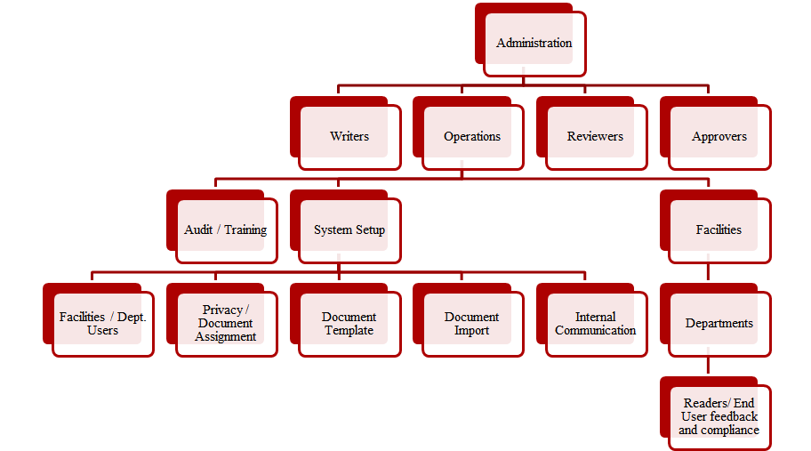
      2. All processes must be recorded in real time and location recorded.
      3. All documents must have an option for expiration date and renewal alert system.
      4. After final approval, documents shall not be editable (Only can be voided and a new document created)
      5. Each document must have its own unique number, code, or reference number and after renewal a new number to be assigned with date.
      6. Types of Documents: Audio / Video Training, readable document,
      7. Examples of Documents: memos, policies, procedures, Standard operating procedures, training, post training tests, notices, protocols, etc.
      8. Documents must be user friendly, may be word, Pdf upload, may be able create within the system, template option
      9. Tag, key word option (Searchable)

### User Interface (UI)

#### Home (Example)

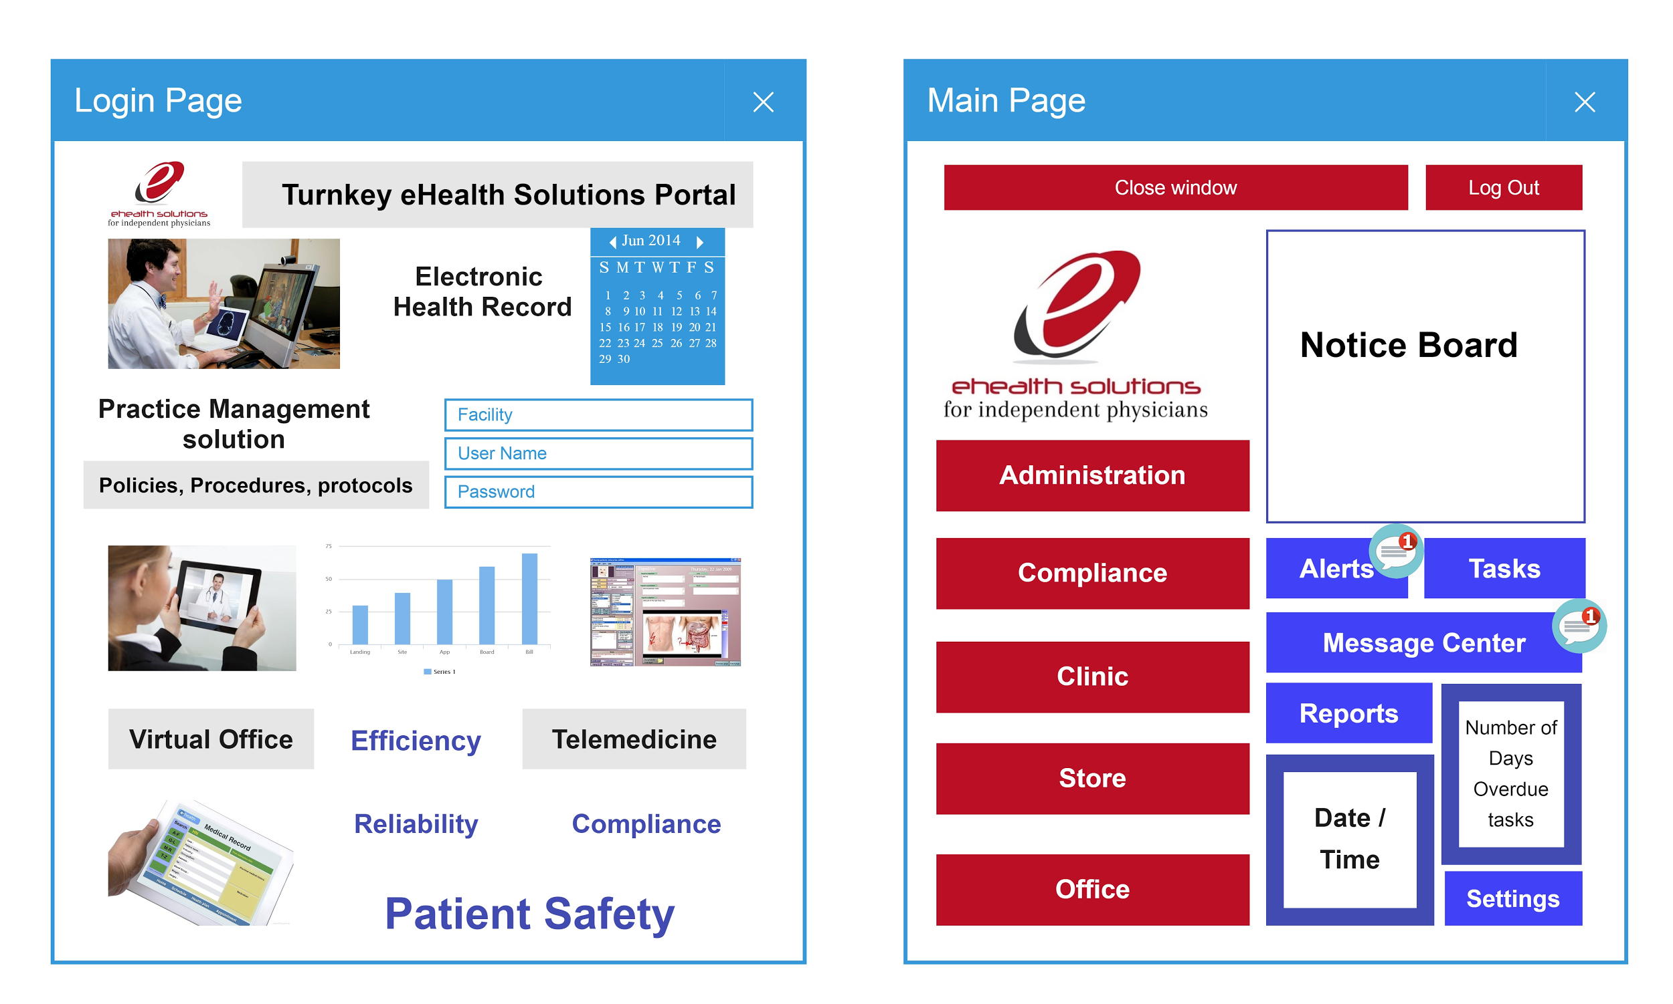

**Operation:** These windows are can be pushed aside or minimized using finger touch, to enable the users to return with ease without closing the other windows. and be able to open pop up windows next to each other for reference and/ or comparison. (e.g. to have a policy page opened next to patients encounter) Also icon needs to be included to return to home page, close a page.

**Process:**  Once the user logs in he/or she will see this page then will see indicator icon on top of every horizontal menu bar task with number e.g. # of tasks to carry out, messages waiting, Important alerts with pop up on the notice section, # of reports waiting to review or sign, any updates to the setting pending. When clicked it will take the user to the respective page. Side (Left) menu bar will take user to the respective Department.

**Protocol:** **Overdue tasks** Numbers appear immediately, followed by green colors in 24 hrs blinking change , then orange 72 hr , then red then privilege suspension over 1 week. **Total** **Number of pending tasks, messages, reports, documents to be signed, etc.** will appear as a bubble icon on each category. By clicking or touching each box a new screen will open showing the content.

#### Task Page

#### This page will include task category with number of tasks for each category light up on each button. By clicking it will take us the respective page.

* + - 1. Review Item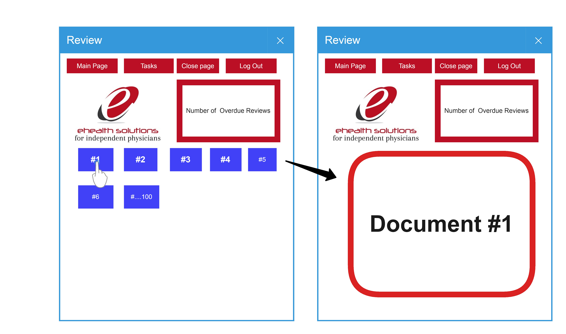
      2. Review Item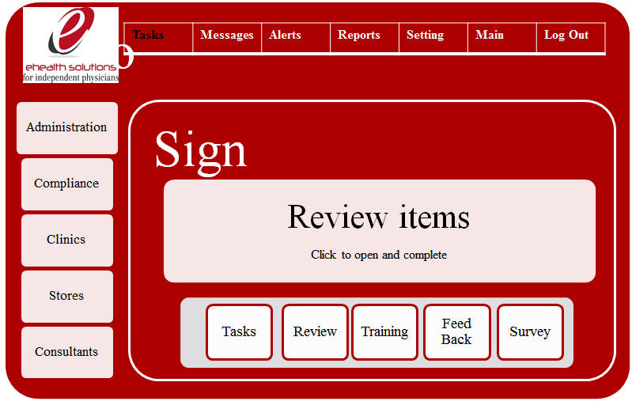
      3. Training screen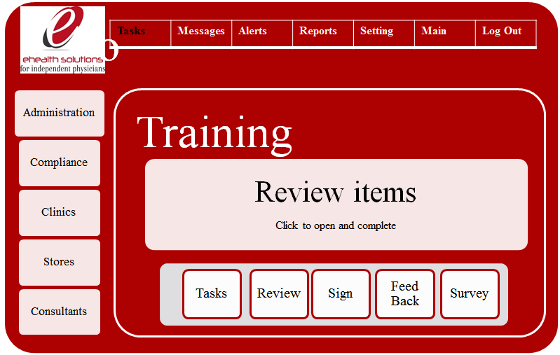
      4. Feedback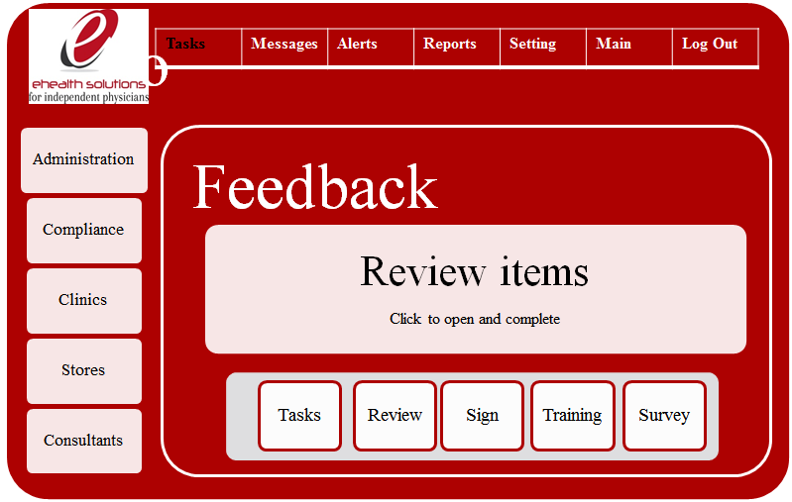
      5. Survey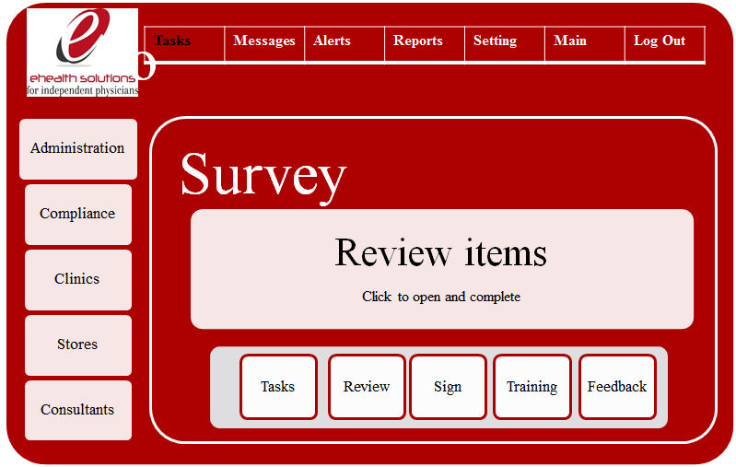
      6. Messages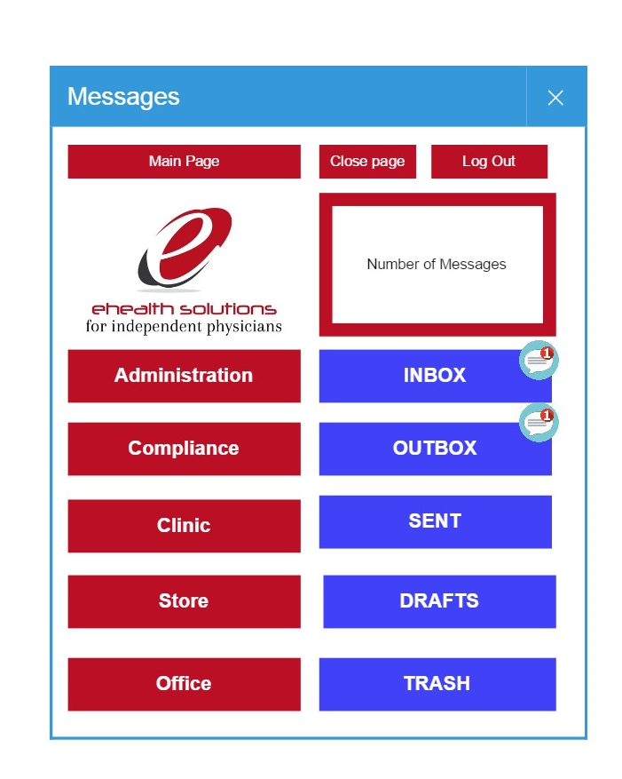
         1. Inbox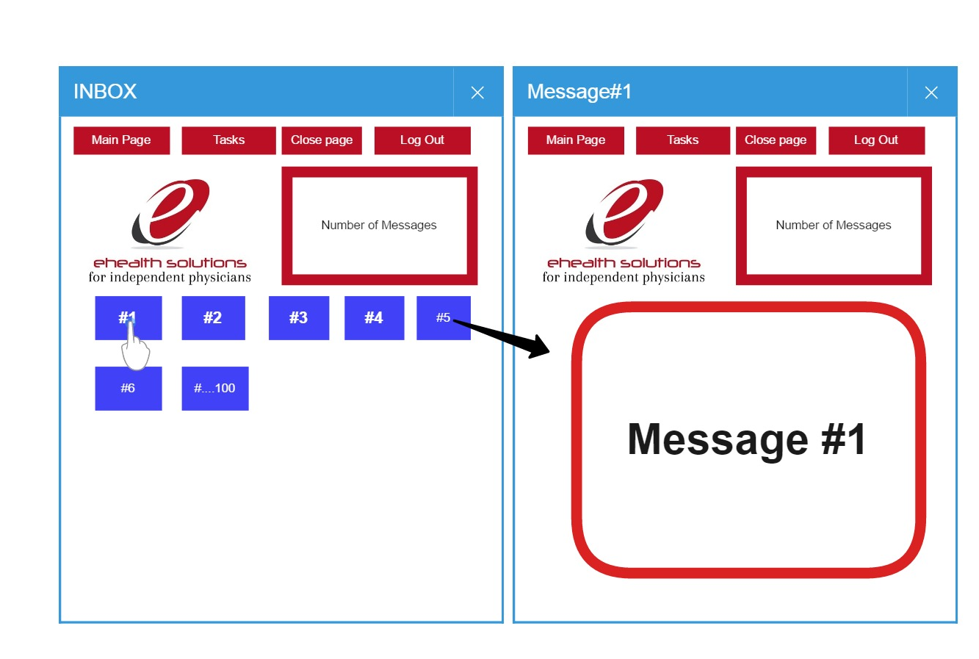
         2. Outbox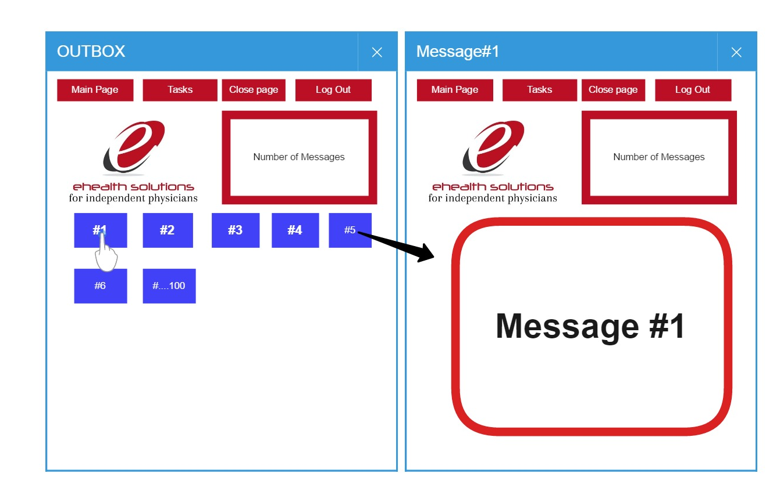
         3. Sent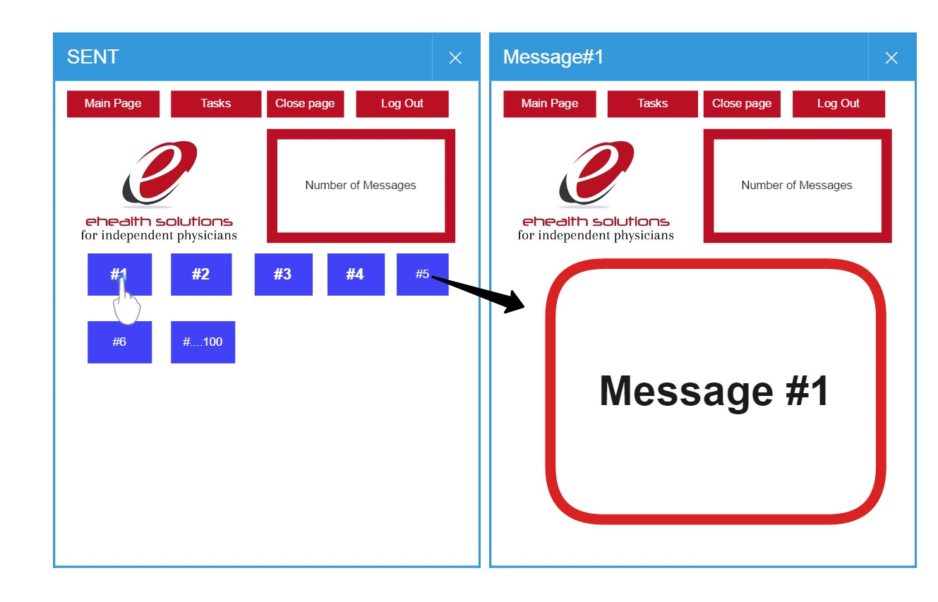
      7. Alerts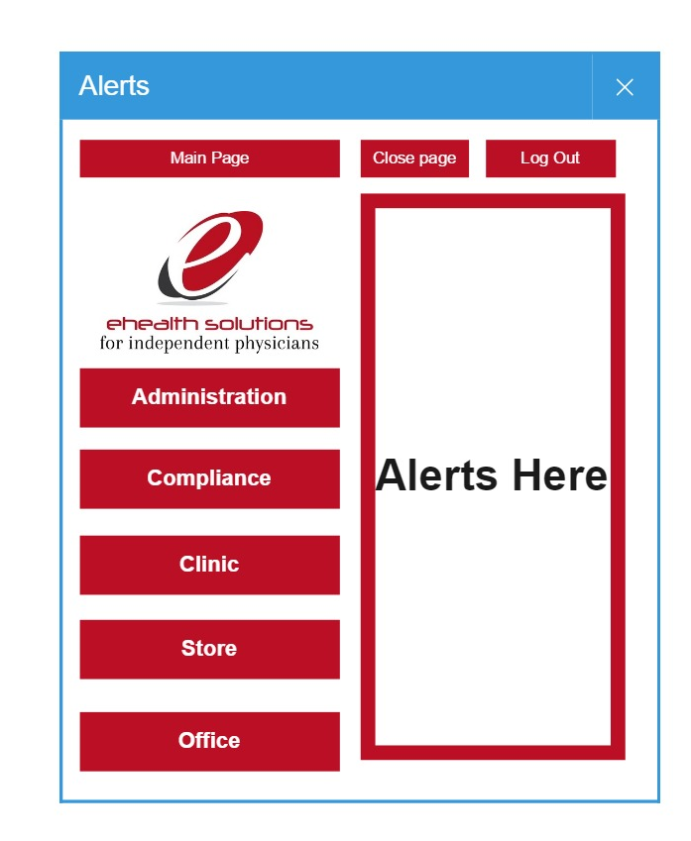
      8. Draft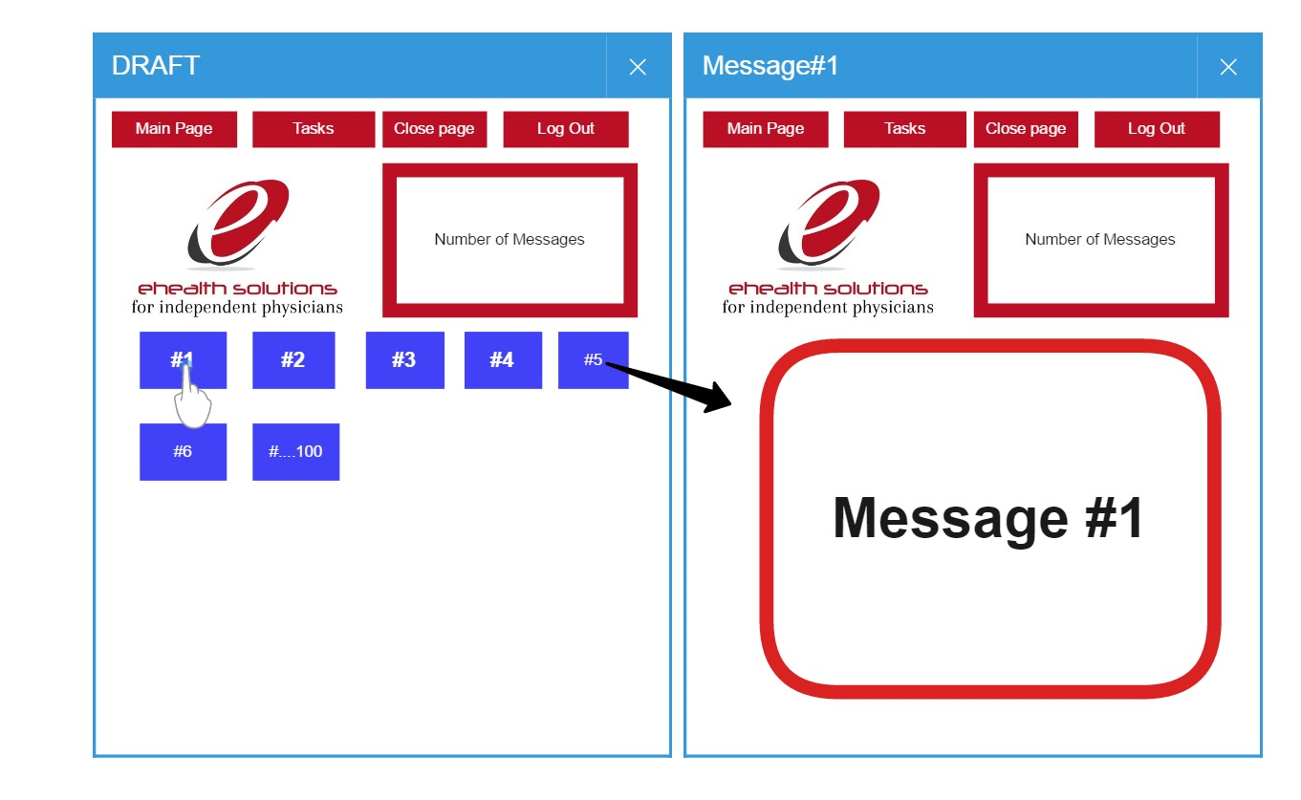
      9. Trash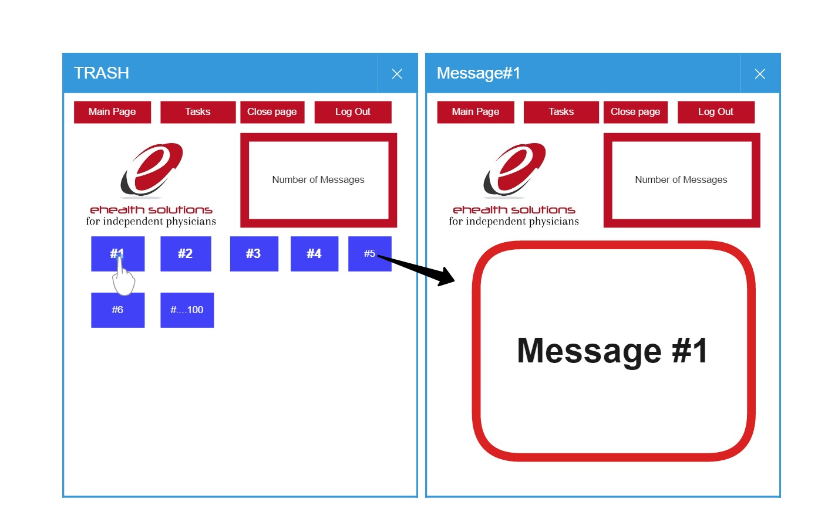
      10. Reports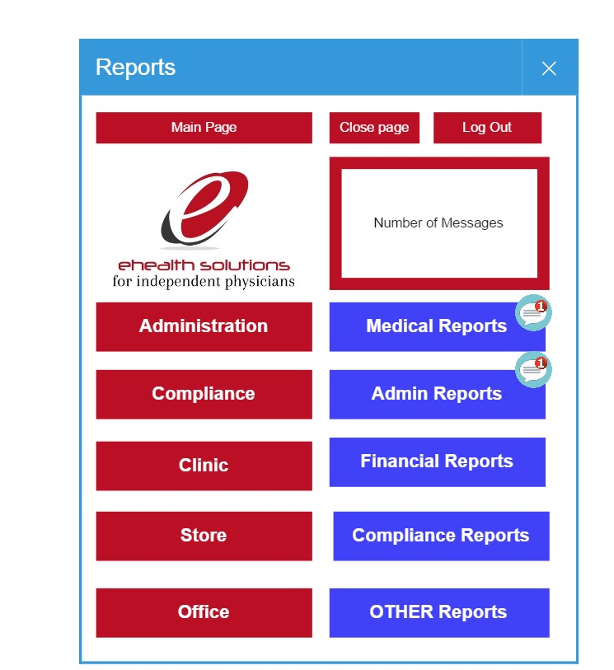
      11. Medical Reports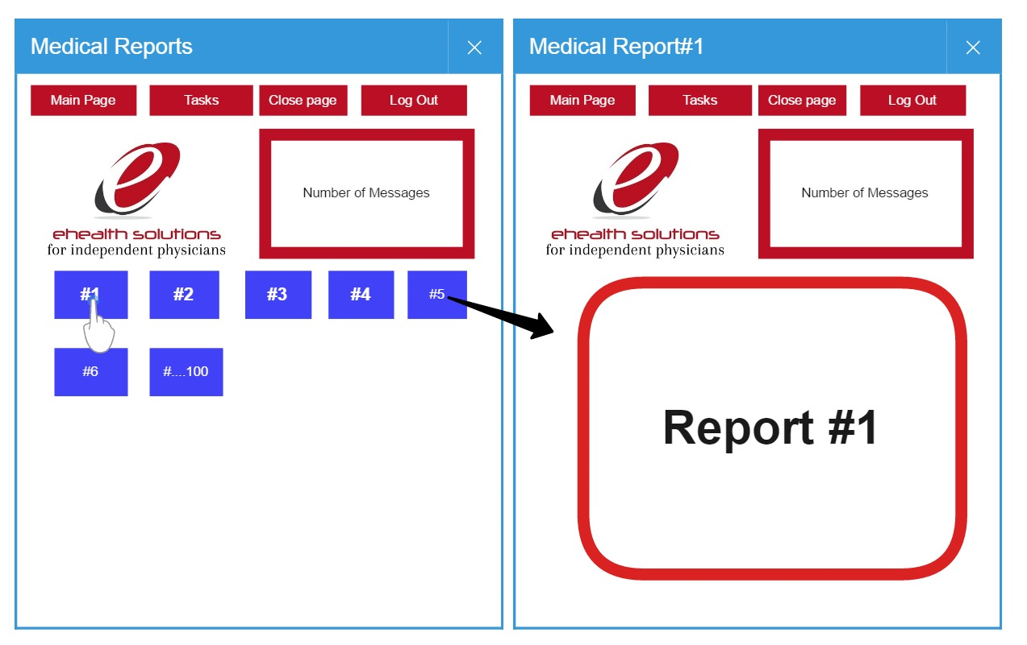
      12. Compliance Reports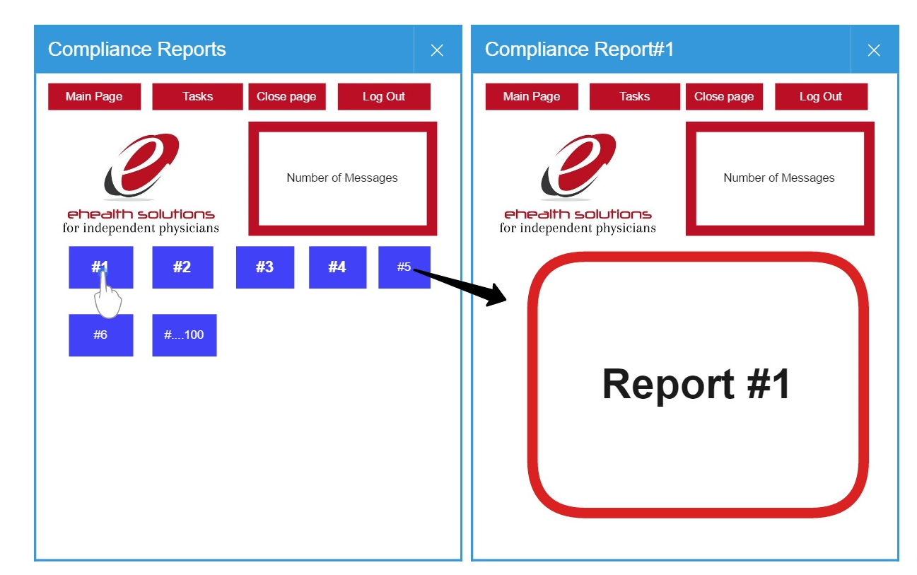
      13. Administrative Reports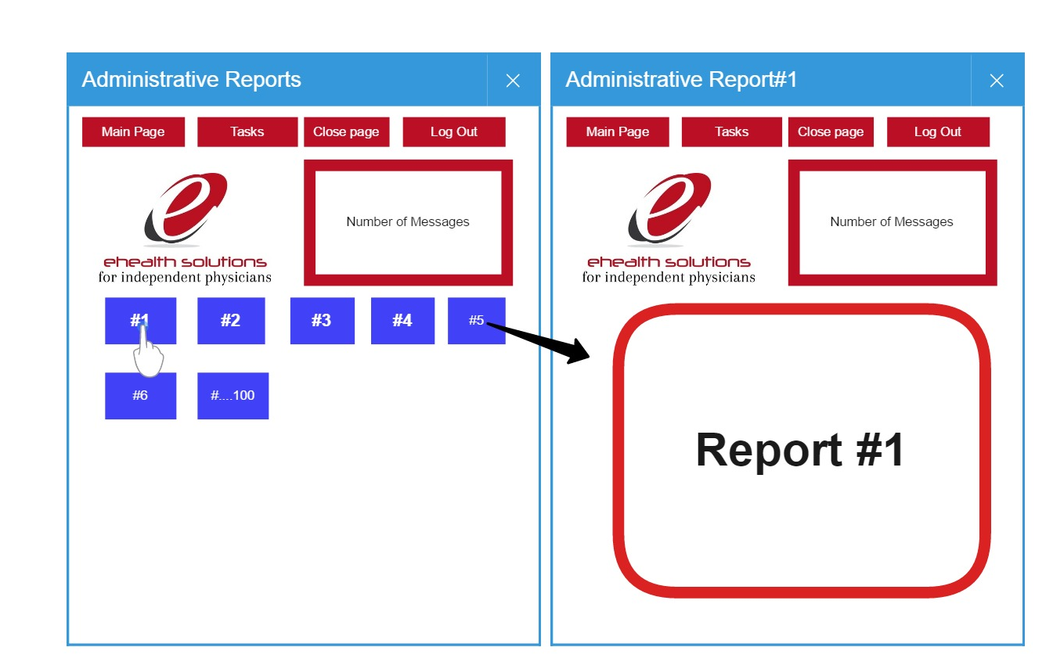
      14. Financial Reports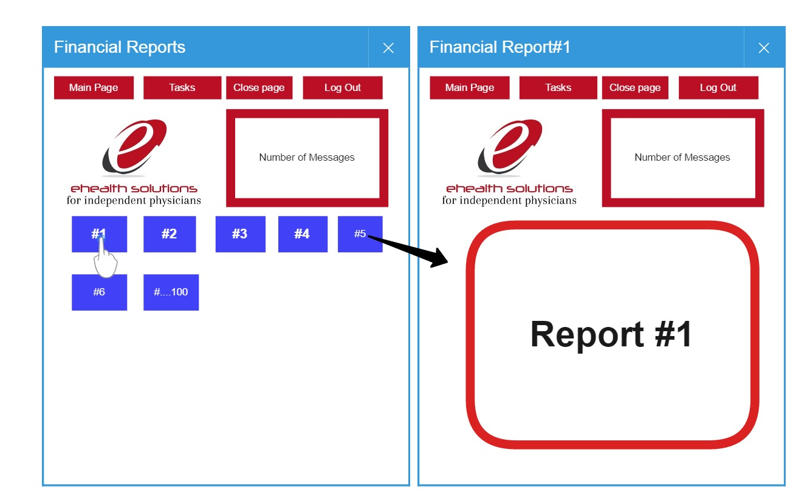
      15. Other Reports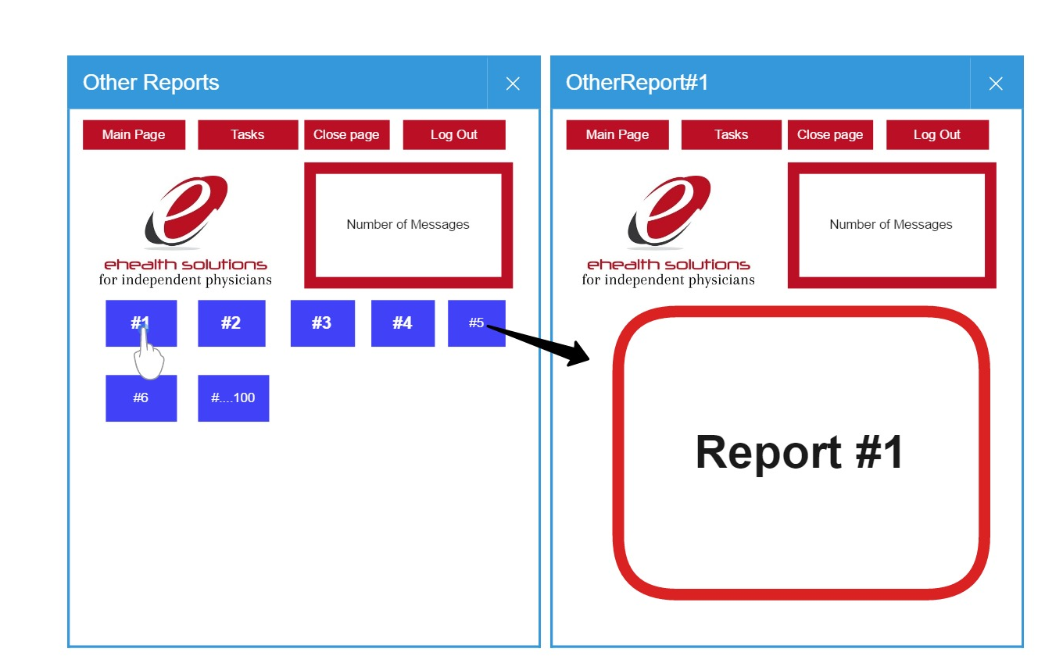
      16. Settings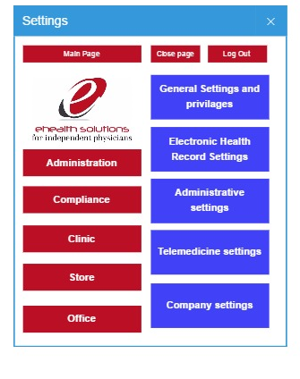
      17. User Setup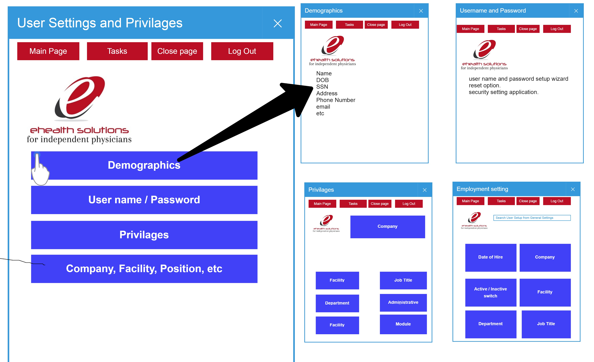
      18. Administrative User Set up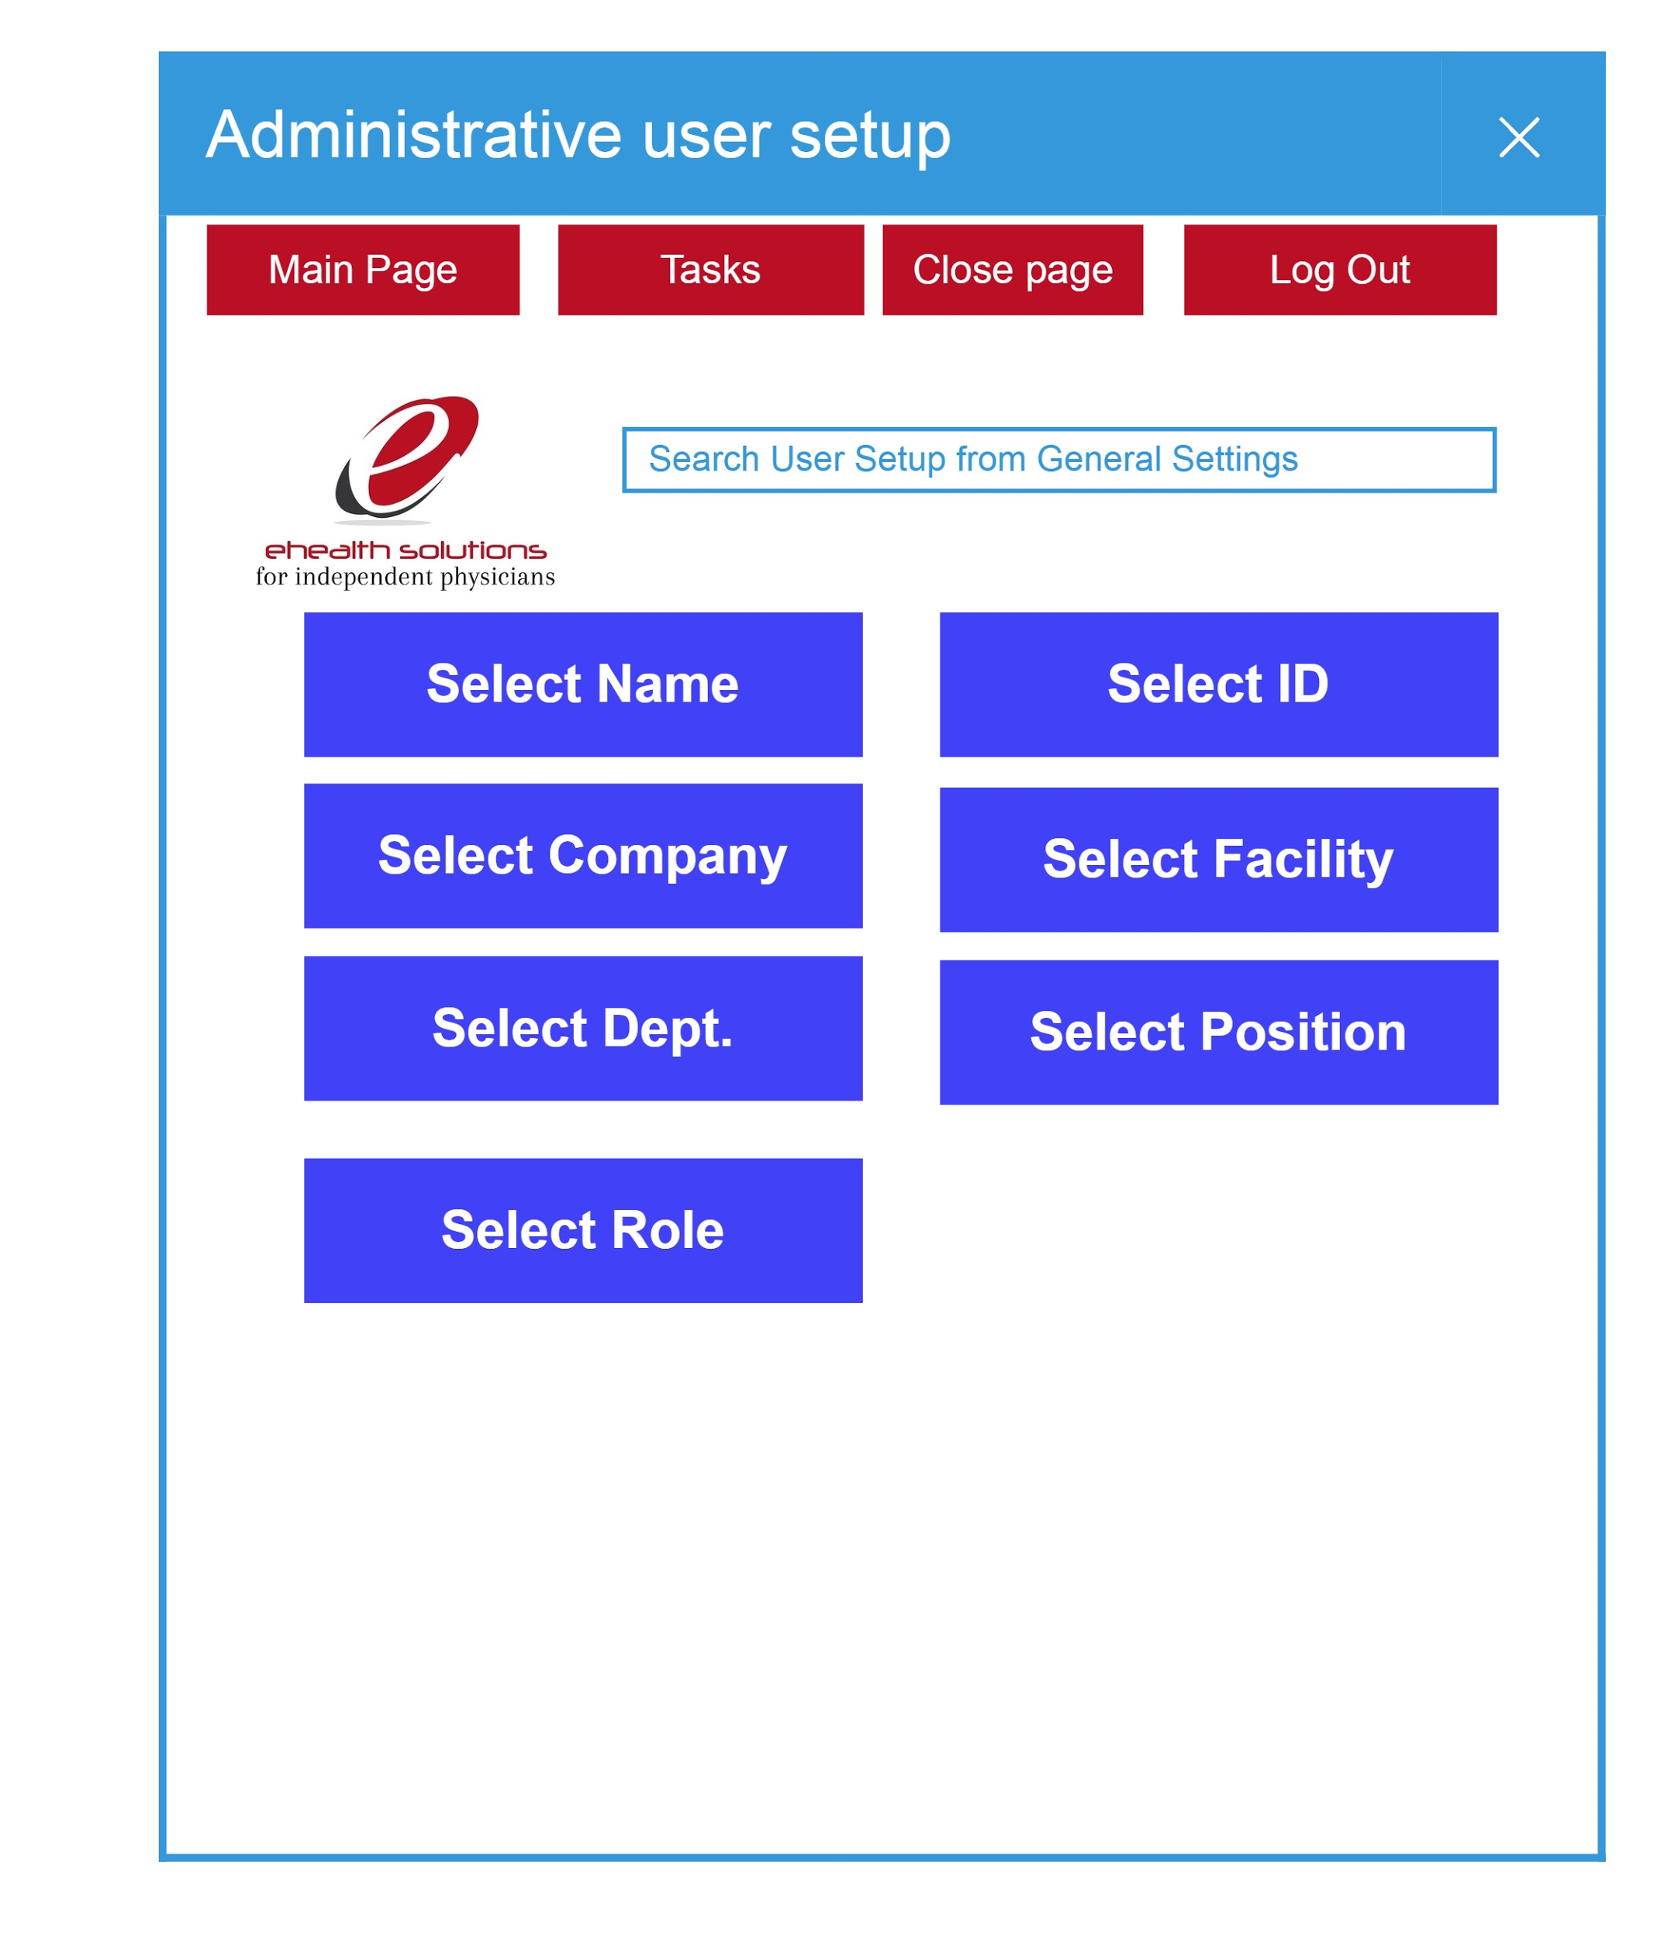
      19. Telemedicine User setup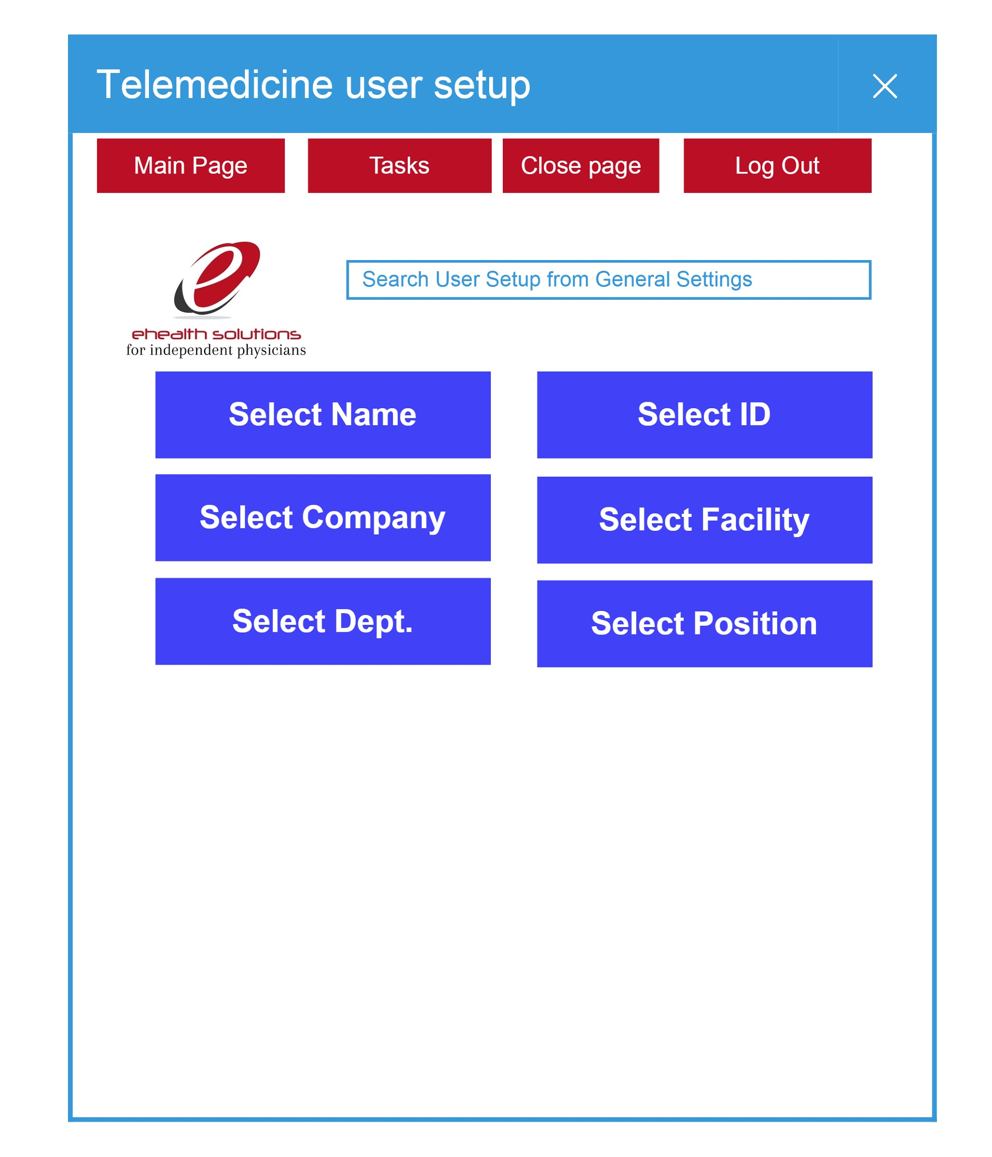
      20. Recycle Bin 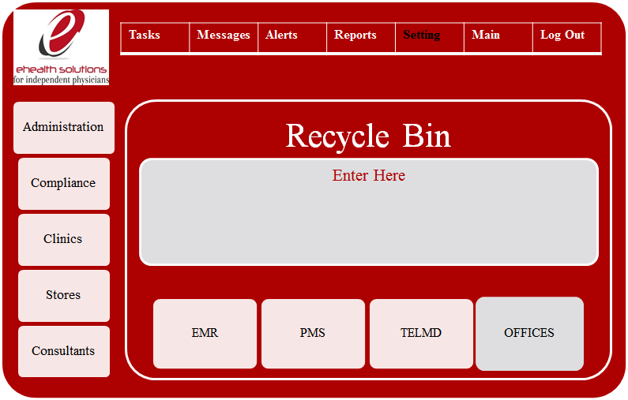
      21. Personal Settings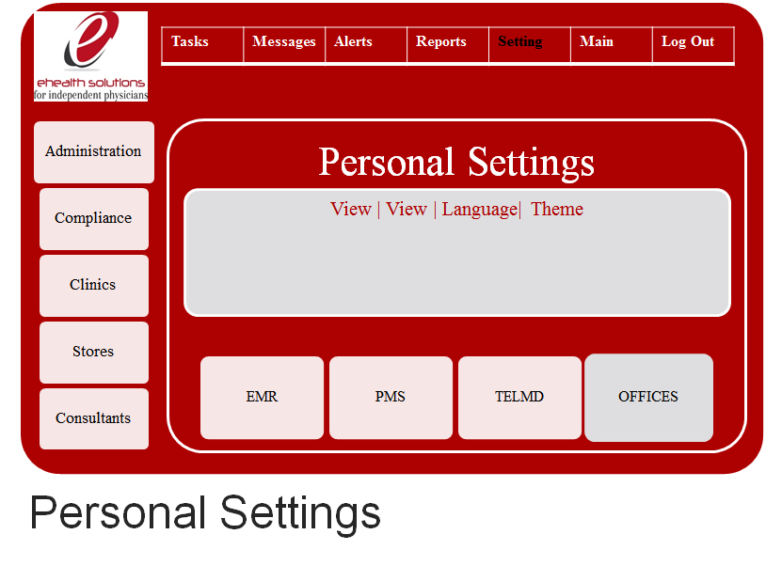
      22. New Client / Company Setup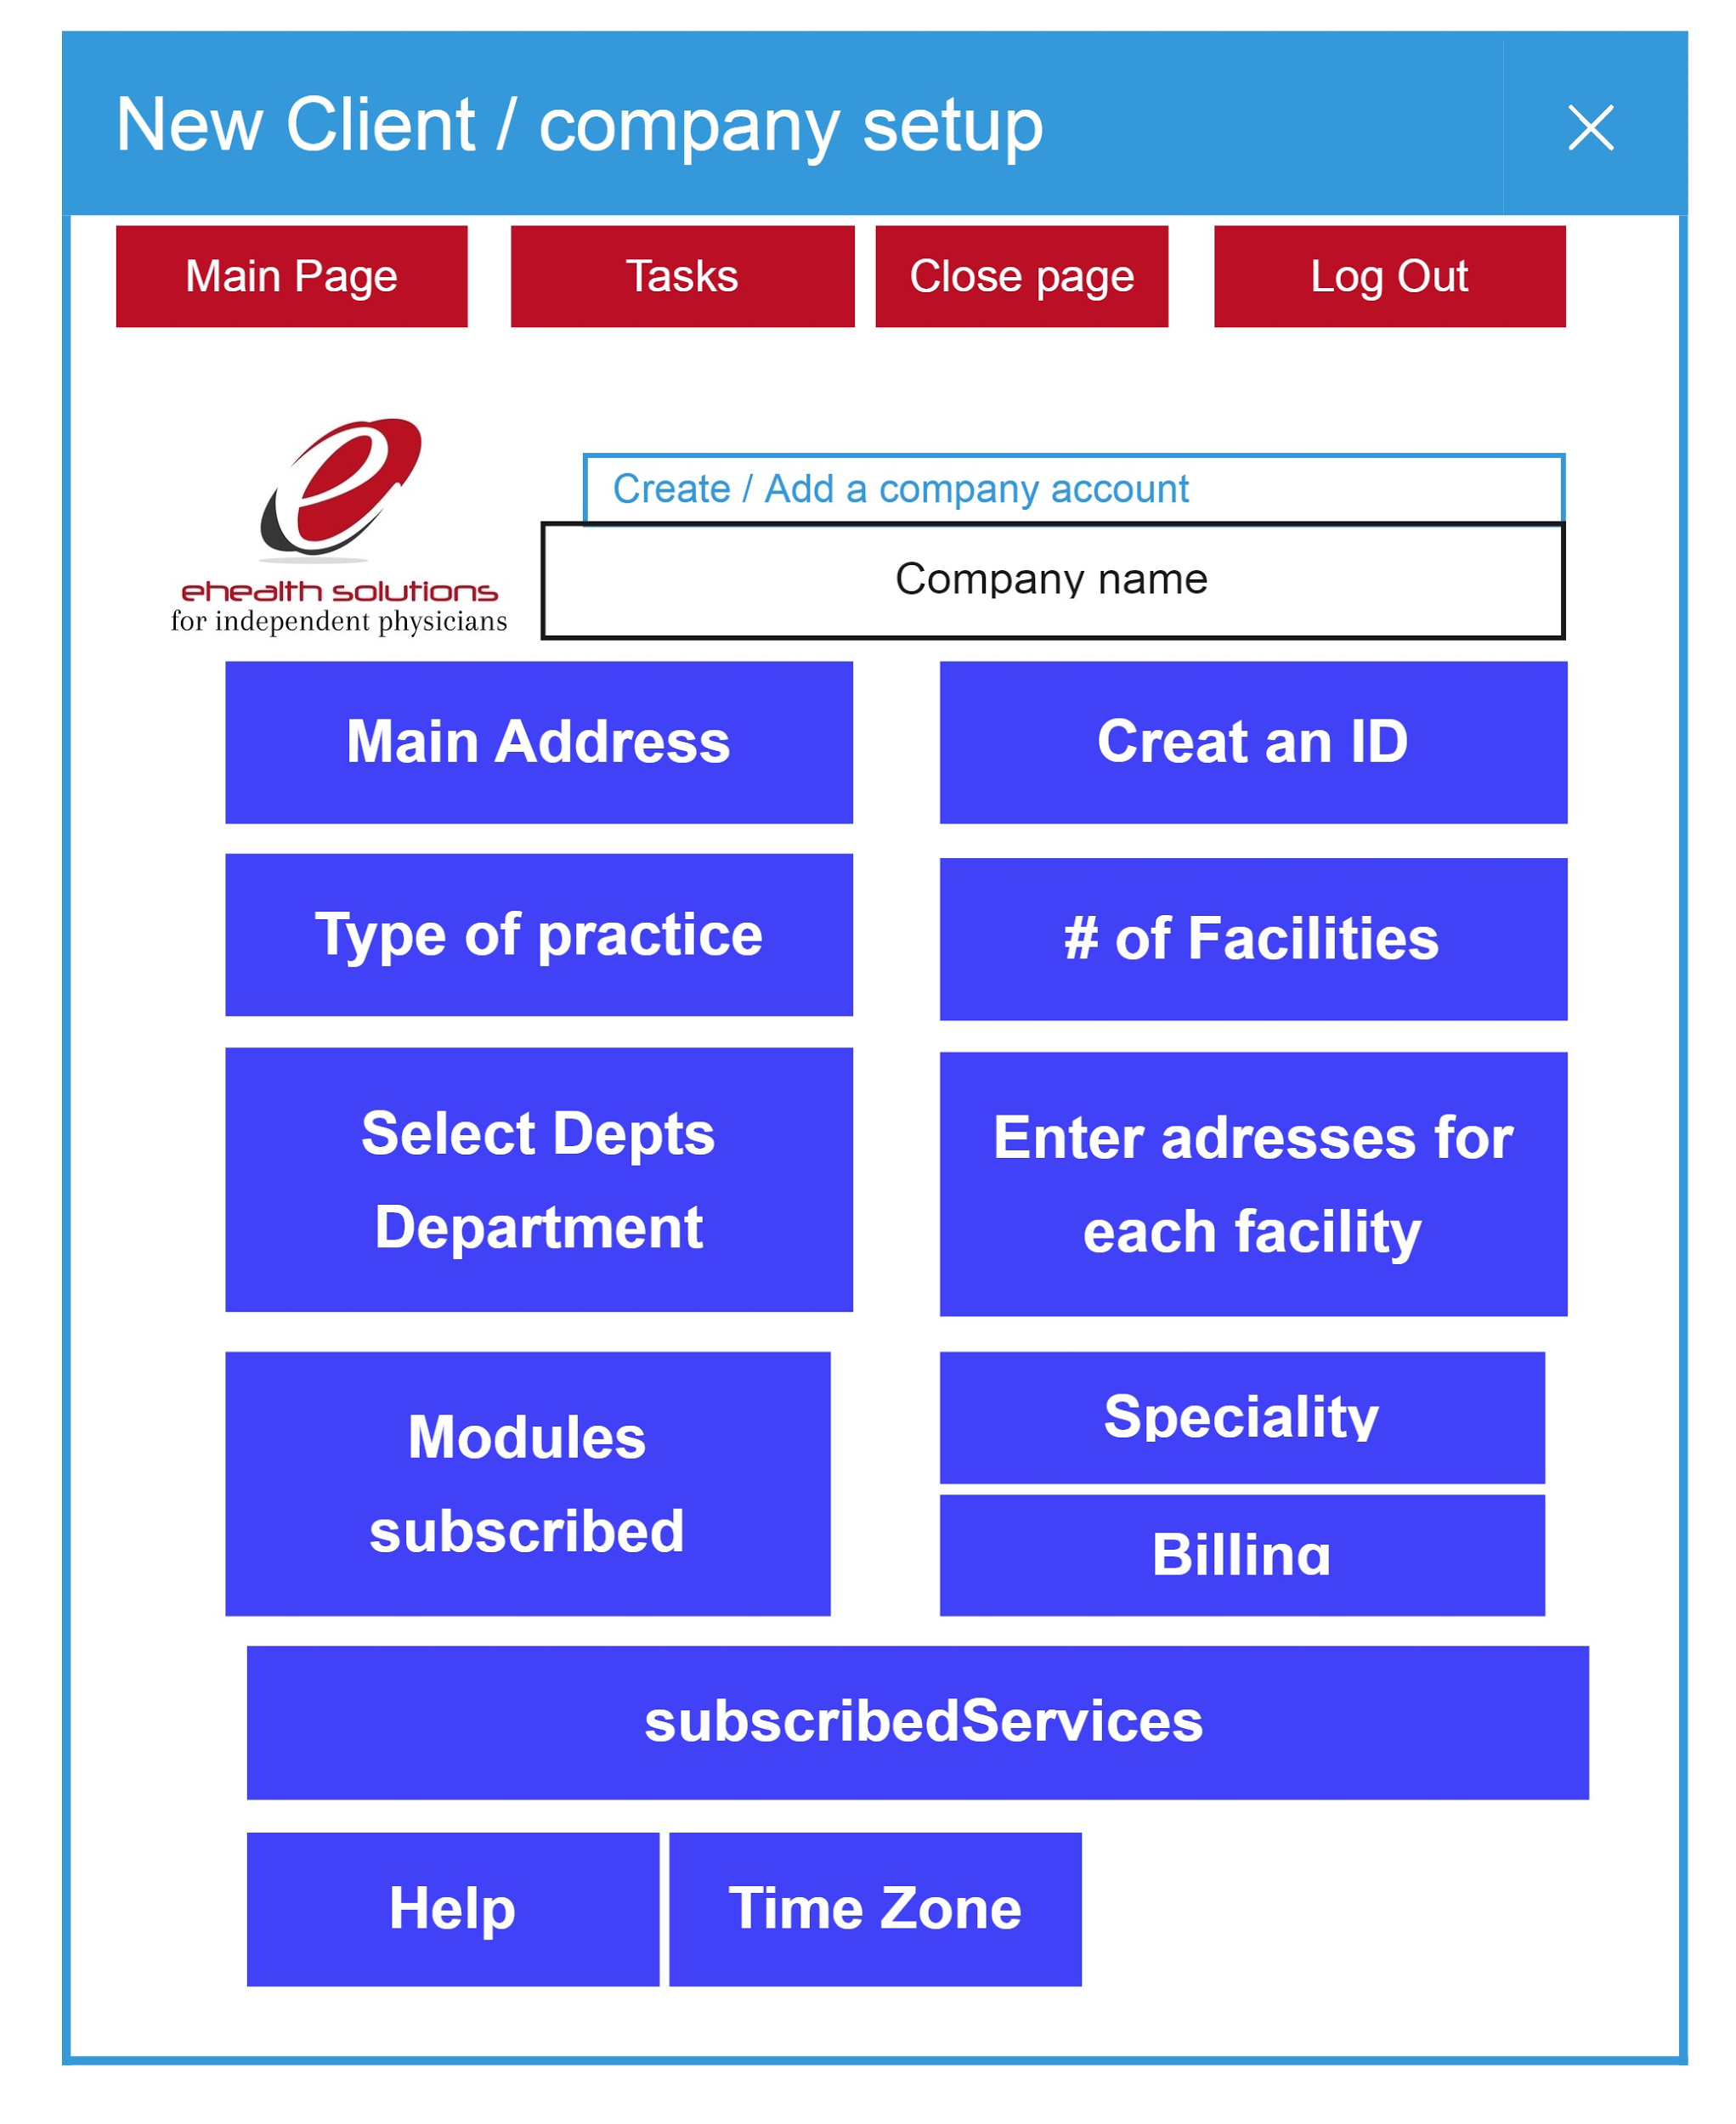
          1. Administration settings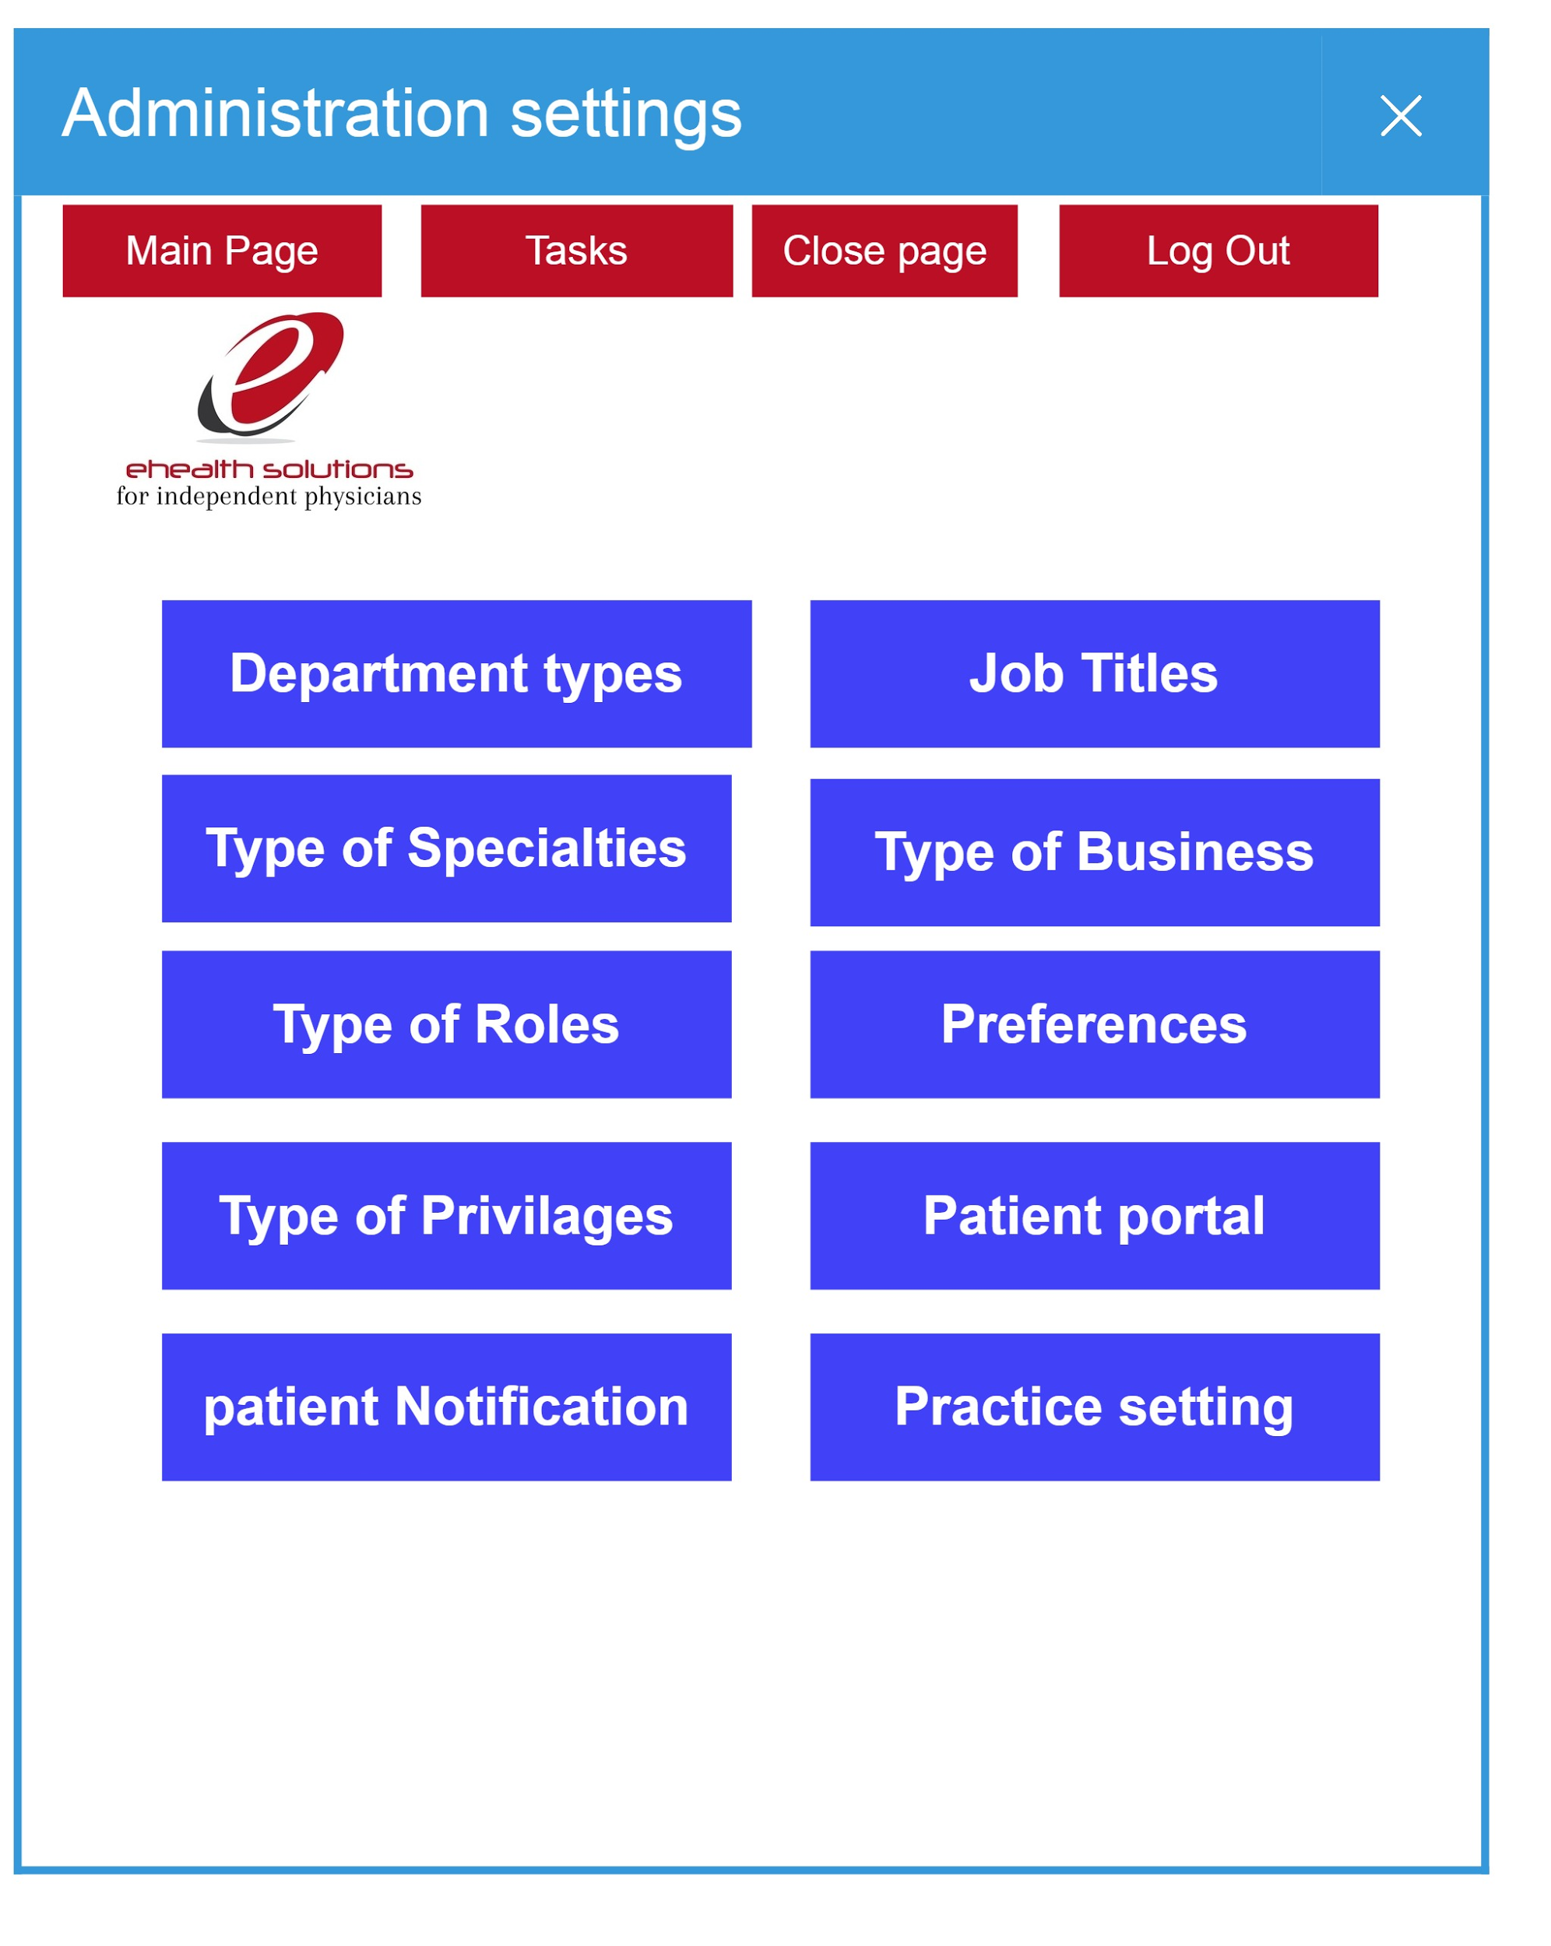
          2. Office / store setup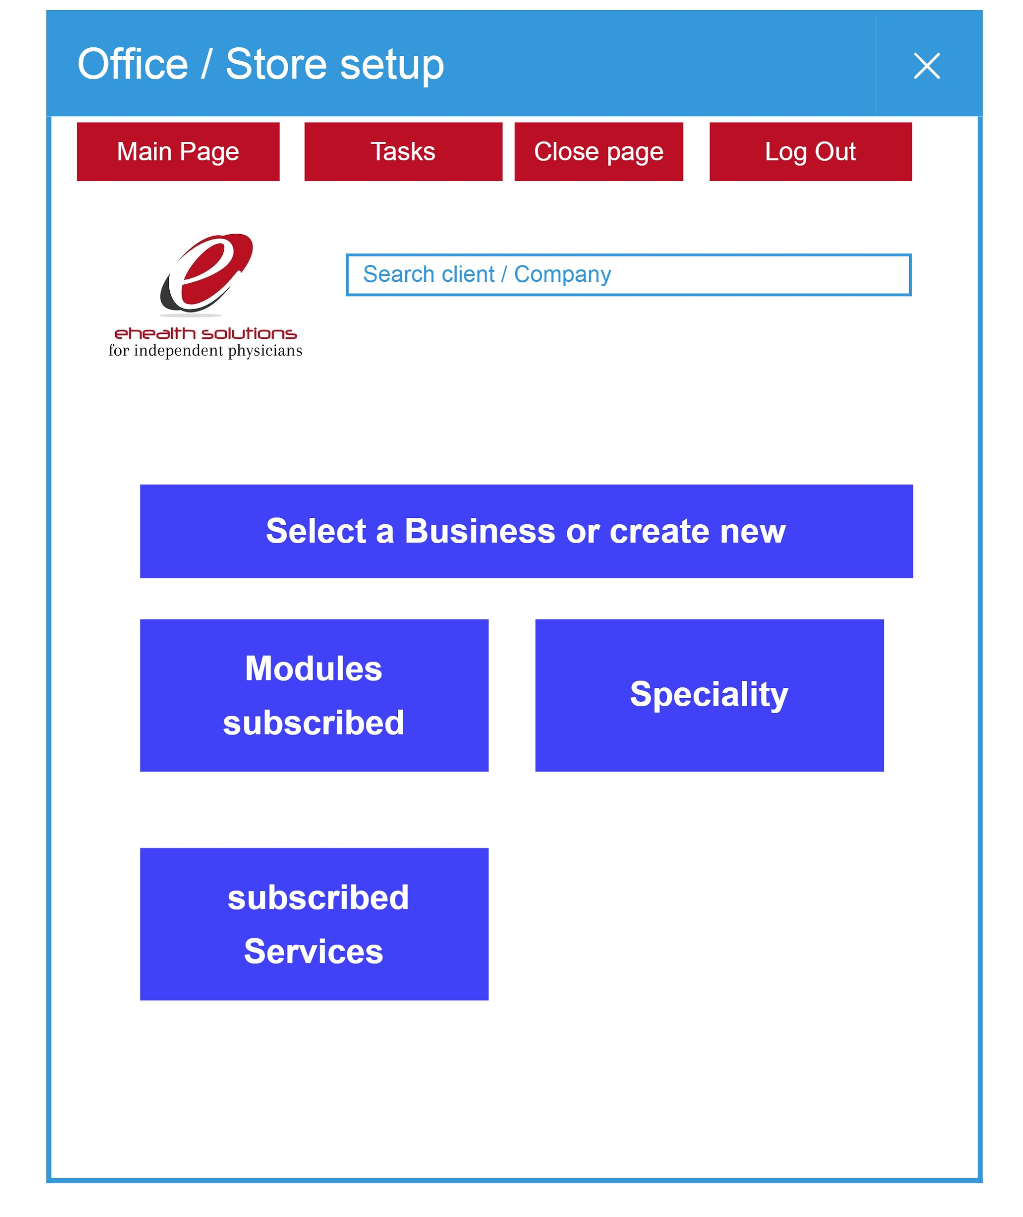
      23. EMR Settings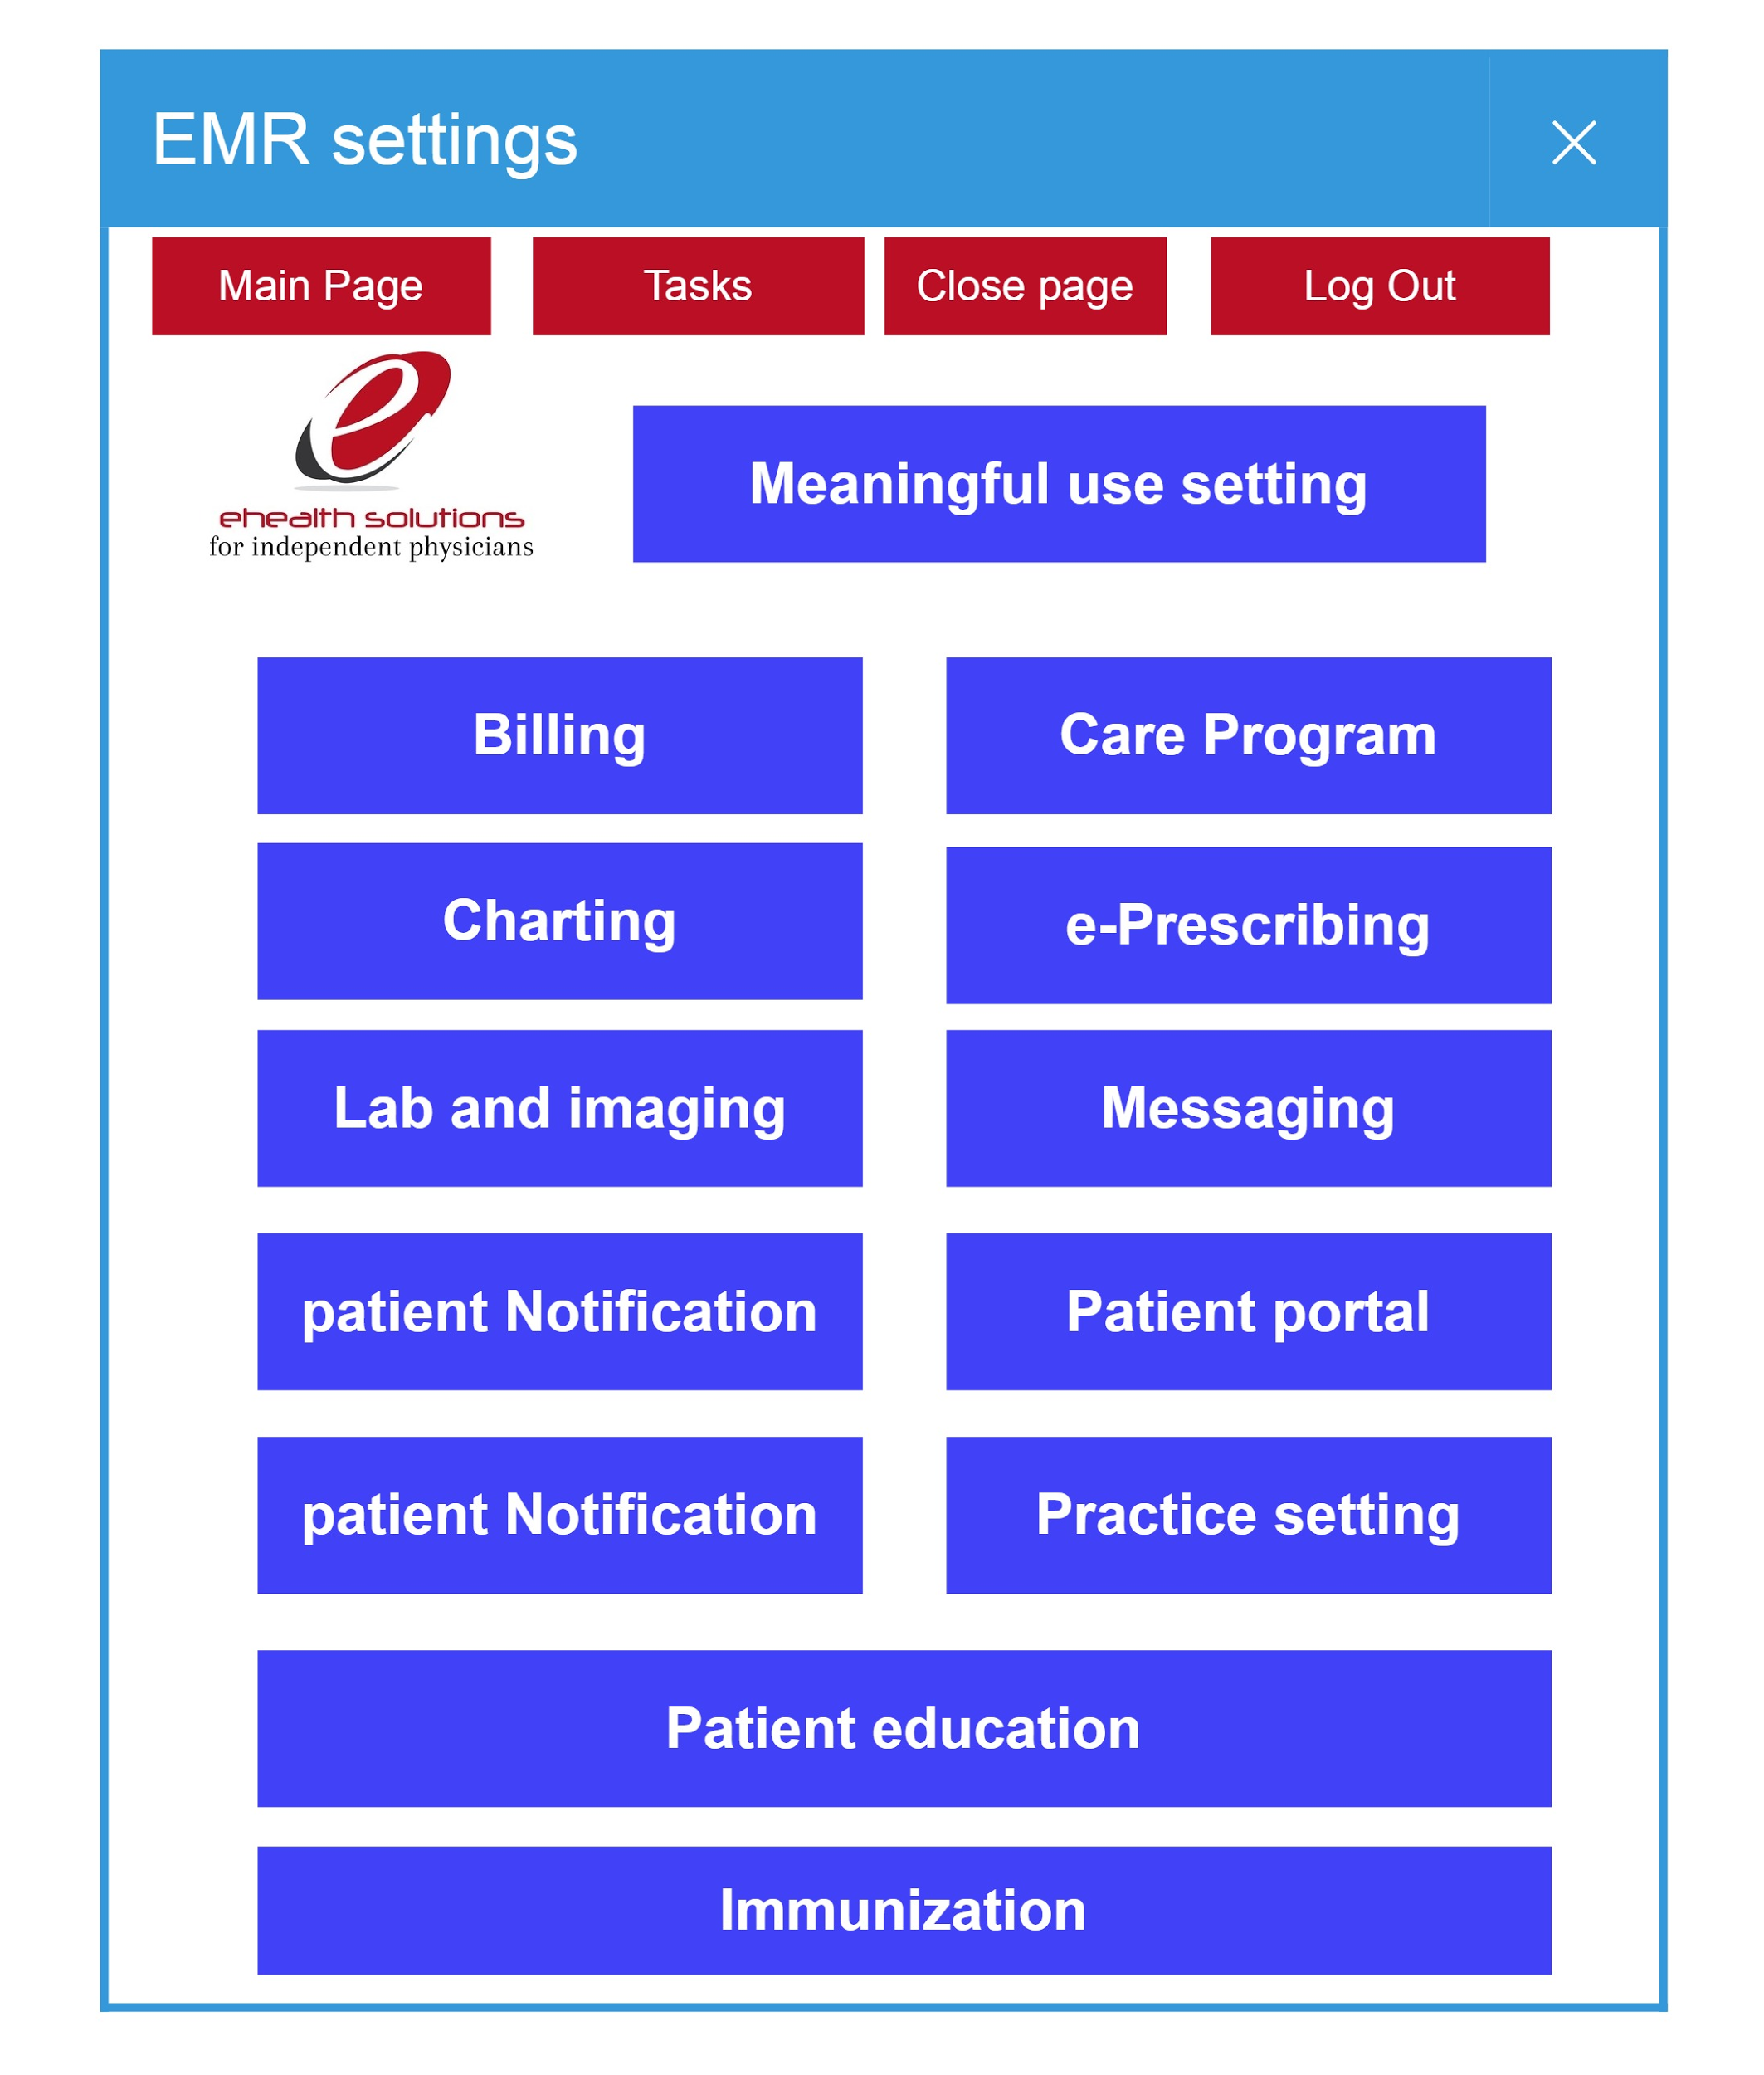

### User Privileges Each user will be assigned a customized privilege to log in and use one or more of modules at time . User will only have the icons (i.e. On the side bar) to use. The privileging and revoking them responsibility will be assigned by the designated administrator. (e.g. Medical assistant in Clinic A will be given privilege to sign in to see patient record in EMR without being able to prescribe medication and review, take test and sign off on designated policies and procedure. Each module will have a specific group of privileging options and choices. ehealth solutions111015 40.jpg

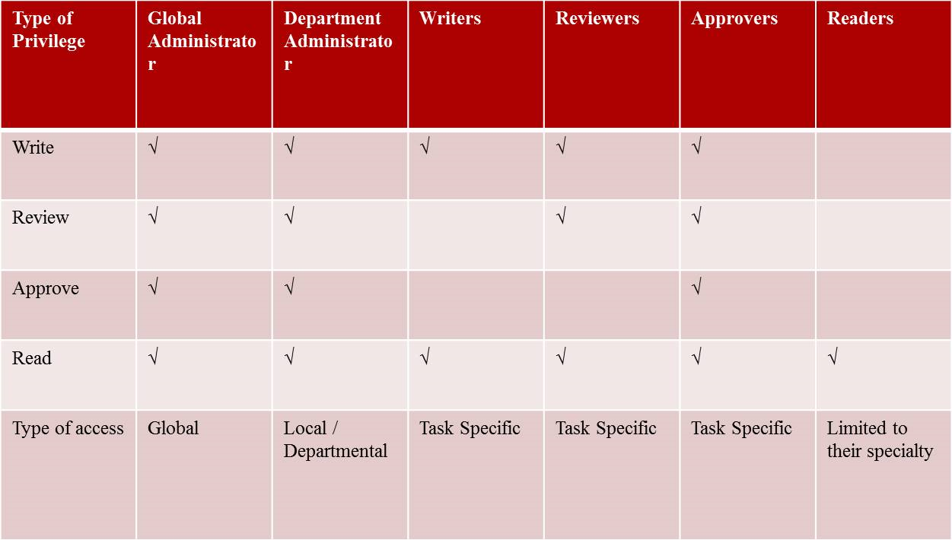

* Full Name
* DOB
* Email
* Password set up
* Client ID
* Address
* Phone number
* Facility
* Department
* Role (e.g. physician, attorney, engineer, Administrator, Manager, Director, medical assistant. Nurse, pharmacist, sales, etc.)
* Global Administrator, Department Administrator, Writer, Reviewer, Approver, Reader, etc.)
* Privileges: One or more of EMR, Practice management, Telemedicine, Virtual office, Wearable module, cloud storage.

### Protocols / Process

In this section each user will be assigned a unique ID number and custom privileges will be given depending on the job title, facility, department, role and responsibilities. each privilege will be based on their initial intake and consequent reassignment of duties approved by the facility administration. Once the intake form was received a temporary password and a user-name will be generated for login. At the same time the privileges will be set. In the event of termination of the user from his/or current job a set of protocols will be followed to inactivate the user account. Periodically Passwords need to be reset and/or platform access from each new IP address will require verification.

### Technical Requirements: (Back End Data Process)

### Technical Requirements: (Front End User Interface)

### Additional Technical Details: (Code, Diagrams,etc)

### Practice Management Module

### Use-Case Realizations

### Clinical Requirements

* + - * 1. Writers: Is a person or group of people whom Can Write, edit, sign and submit for review but cannot approve. Policy writers, editors, etc.
        2. Reviewers: is an expert person or a group of experts in certain field whom can review and make suggestion for corrective action to writers and approvers. E.g. Engineers, Consultants, Lawyers, Certified auditors etc.
        3. Approvers: Is a person, or group of people whom need to sign off and approve each documents after having been written and reviewed by experts. They are the final authorities responsible for each and individual entity. e.g. CEO, Directors, Chief of departments
        4. Readers: Is a person of group of people whom will be able to read or must read the documents and sign off electronically. If necessary they should be able to view videos, listen or read and take multiple choice tests with scoring and pass or fail results
        5. Note: Each user can have one or more role as document writer, reviewer, approver, reader role
        6. Note: Any one can be designated as one or more of the above e.g. Nurse, physician, administrator, manager, receptionist, IT, engineer, lawyer, etc.)
        7. Document creation chain of process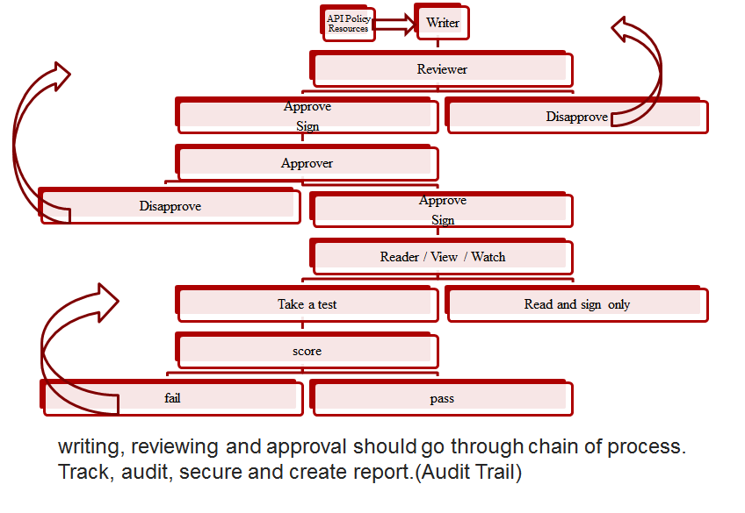
        8. Overall Sequence in Document creation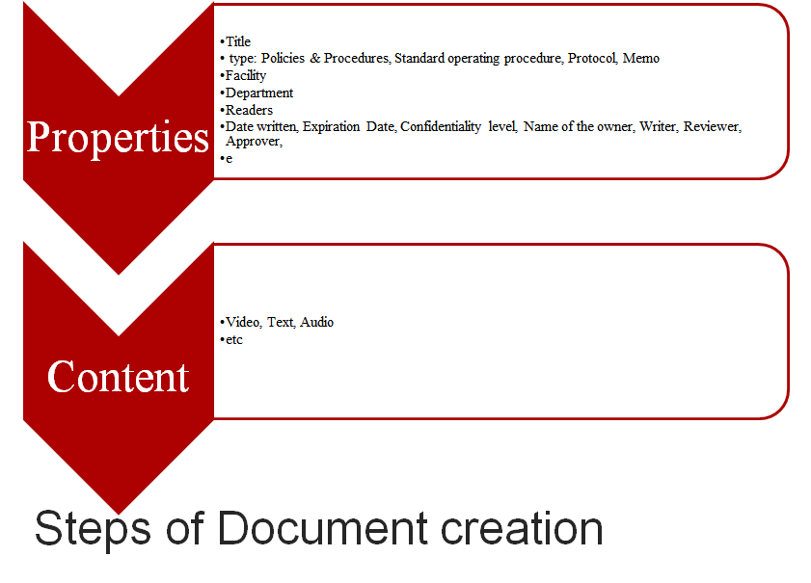
        9. Document Creation Steps: Open document creation wizard >>Enter title>>Serial Number>>Type of Document>>Name of the owner>>Name of Reviewer>>Name of Approver>>Facility>>Department>>Date Written>>Expiration date>>Date to be revised>>Readers to be assigned and alerted>>Type of action to be taken by reader e.g Take a test, sign only, etc>>Write the content, attach multimedia>>Submit to reviewer>>Automatically submit to Approver after signed by reviewer.
        10. ·All processes must be recorded in real time and location recorded.
        11. ·All documents must have an option for expiration date and renewal alert system.
        12. ·After final approval, documents shall not be editable (Only can be voided and a new document created)
        13. ·Each document must have its own unique number, code, or reference number and after renewal a new number to be assigned with date.
        14. ·Types of Documents: Audio / Video Training, readable document,
        15. ·Examples of Documents: memos, policies, procedures, Standard operating procedures, training, post training tests, notices, protocols, etc.
        16. ·Documents must be user friendly, may be word, PDF upload, may be able create within the system, template option
        17. ·Tag, key word option (Searchable for audit purpouse)
        18. User Setup

Full Name

Email

Password set up

Client ID

Address

Phone number

Facility

Department

Role (e.g. physician, attorney, engineer, Administrator, Manager, Director, medical assistant. Nurse, pharmacist, sales, etc.)

Global Administrator, Department Administrator, Writer, Reviewer, Approver, Reader, etc.)

* + - * 1. Practice Management users

Local Employees / Readers

Client employees / readers

eHealth Writer/reviewers/ Approvers / Administrators / Consultants / (Customizable privileges)

Local Facility administrator (Office Manager, Medical Director) (With customizable privileges.

Users must have a unique email address

Must be able to communicate via internal secure system (Documented ) with certain privileges.

Email can only be used once per person

Identifier code must be given to each user (Number or a code)

They must login to create THEIR OWN PASSWORD WITH RESET OPTION by main administrator

Their role must be specified and can be changed at any time by main administrator only

There will be local administrators whom can have limited role relevant to their own practice e.g. adding editing their own roles.

* + - * 1. 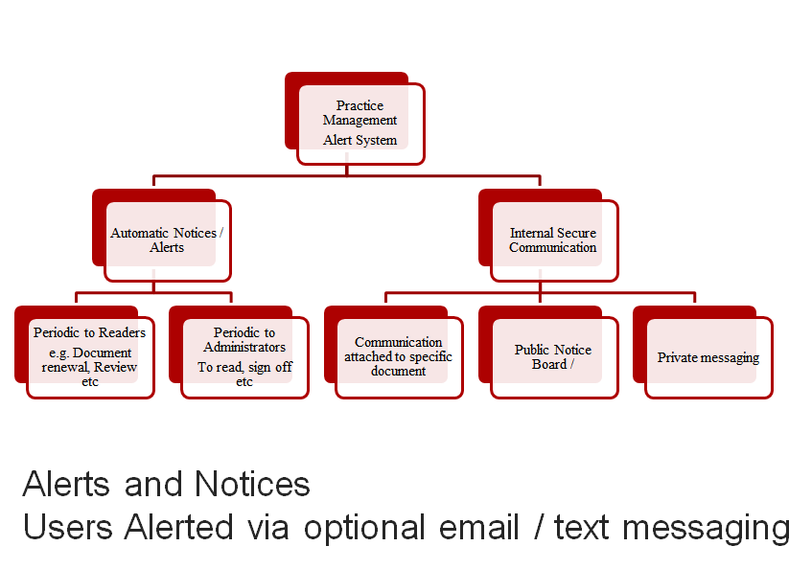

Any documents written, Any change made to any document must lead to generate alert notice to the person / user designated for that specific task. e.g. if a memo was created on day 2 for all Medical assistants to read in all facilities and departments, alert will be automatically will be generated by the system for those specific group of users.

* + - * 1. 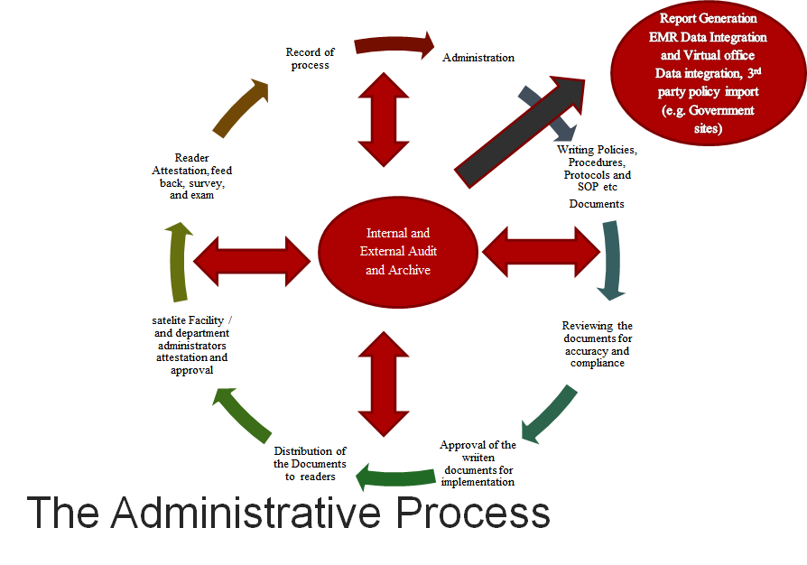
* Write >>>>Review>>>>Approve>>>> Distribute to Readers>>>> Sign off / Take a test
  + - * 1. 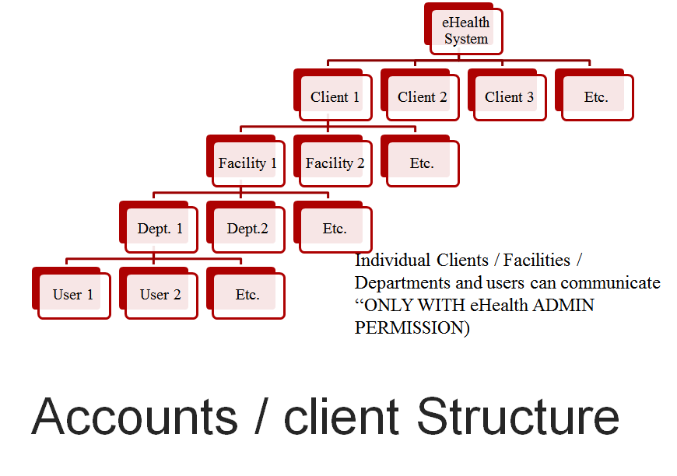
        2. Facilities & Department Structure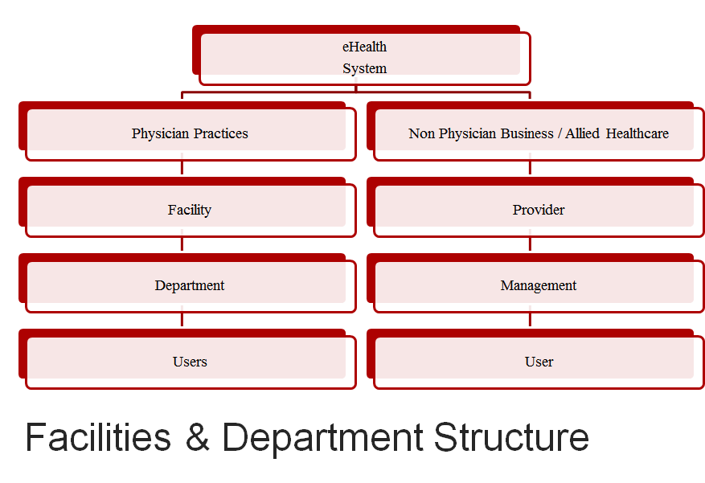

Clients: Are the Practices whom are using our services

Facility: Are the locations that belong to the any client (i.e. each client may have more than one facility)

Departments: Within the facility

Users: Within the departments

* + - * 1. Communication Module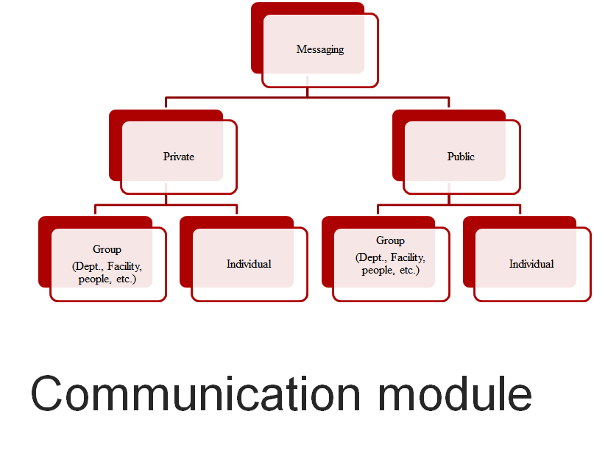

Private messaging must be encrypted, needs a identity verification system prior to use to be HIPAA compliant (e.g. using credit check, email verification etc.)

Public messaging is usually the group message, notice board and shared messages)

* + - * 1. Methods of Communication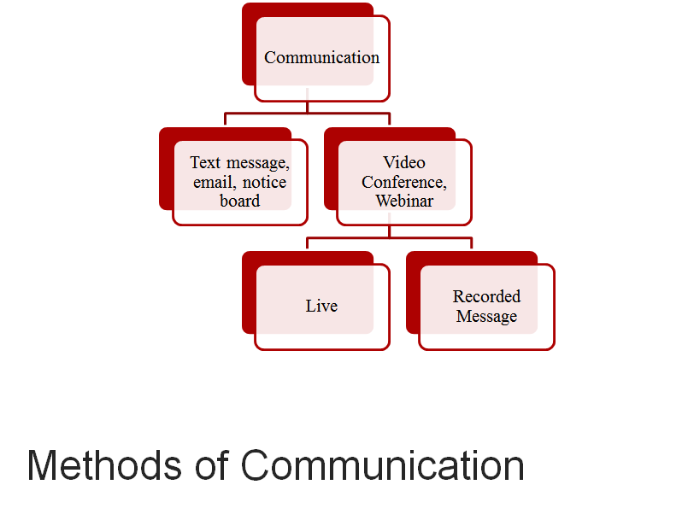
        2. External Audit tool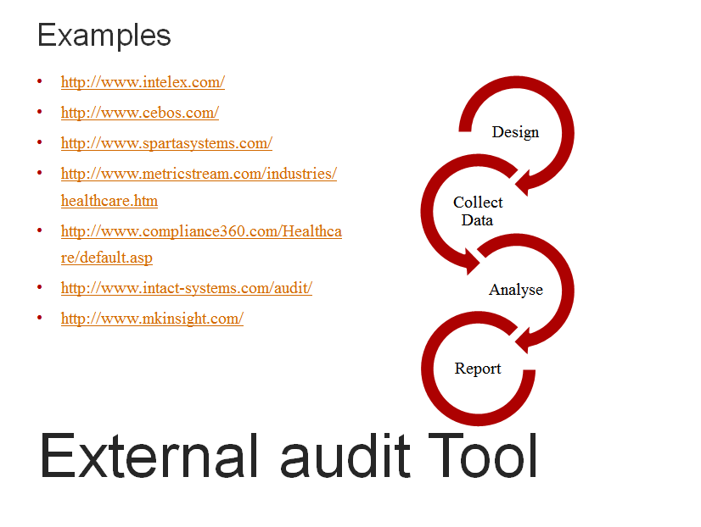
        3. Internal Audit tool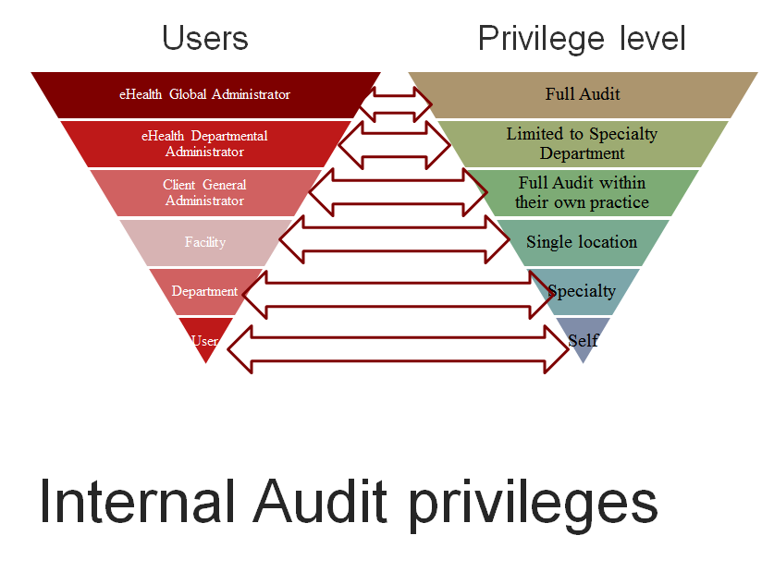
        4. Audit Reports

Meaningful Use dashboard Track progress and take action toward meeting Core, Menu, and Clinical Quality Measures

PQRS Clinical Quality Measures dashboard Manage CQMs for Physician Quality Reporting System (PQRS)

Activity feed and audit report Sort and filter personal and practice activities

Billing report Review and manage your practice’s superbills

Chart notes report Search all of your practice’s chart notes

Diagnosis registry Search patients that have a particular diagnosis or ICD 10 code

Drug interactions report Review the responses to Drug-Drug and Drug-Allergy interaction reports

e-Prescription report Retrieve a history of all e-Prescriptions per provider

Referrals report View all the referrals you have made

Meaningful Use dashboard - Historic Core and menu measure values for Meaningful Use 2011-2013

Medication report Search patients that have been prescribed a particular medicine

Patient lists Search patients various combinations of criteria

Payer report Retrieve a list of payers for your practice and the associated patients

Population health management Population health management dashboard

Patient Rx history View Rx history for your patients

Tasks by Document

Tasks by User

Tasks by Group

Document Reports

User Reports

Questionnaire Reports

Exception Reports

Search by Keyword

Failed Logins Due to Insufficient Licenses...

Lists users who failed to log in during a specific timeframe due to insufficient licenses.

Users Currently Logged In This link opens in a new window

Lists all users that are currently logged into the system.

* + - * 1. Audit Design tool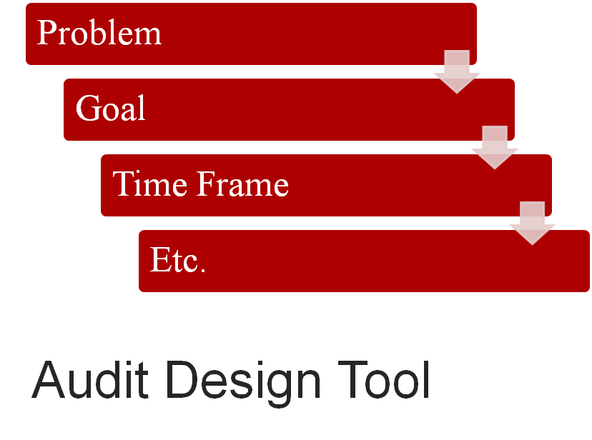

On Audit tool we would like to select the choice of data that we would like to collect from the data base >>>>initiate search>>>> Extracted data will be analysed by category, individually, by facility, region, user role, time frame, etc

* + - * 1. Audit tool Data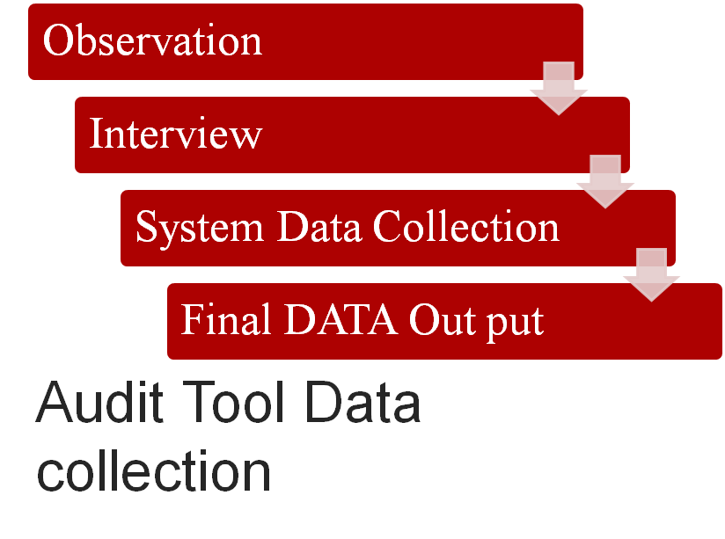
        2. Benchmarking tool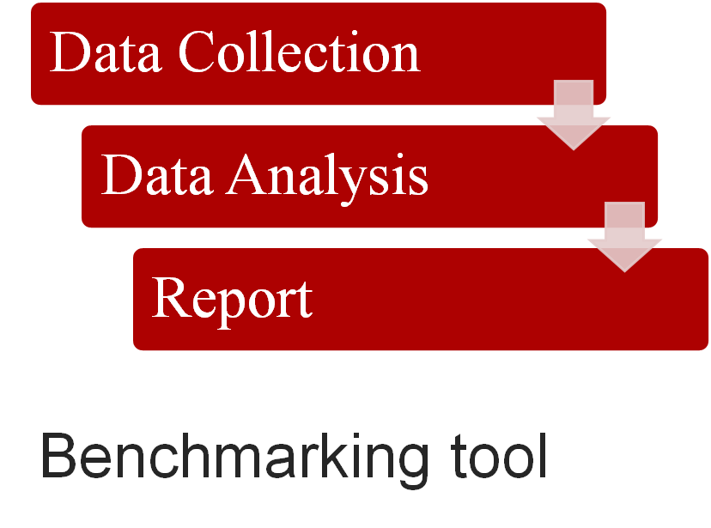

### Administrative Requirements

## User Interface (UI)

* + - 1. Administration main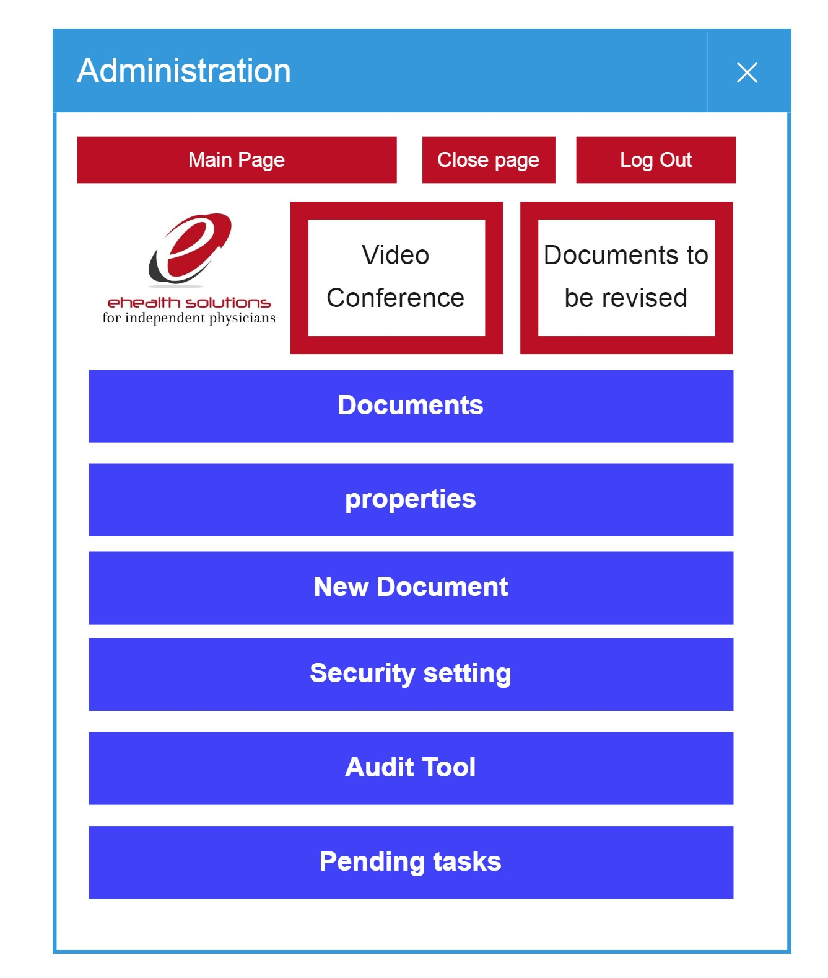This is the Global administrator view which shows all the options on the screen, other users may have limited or no privilege to this section. This screen will provide the choice navigate to various sections.
      2. Document Search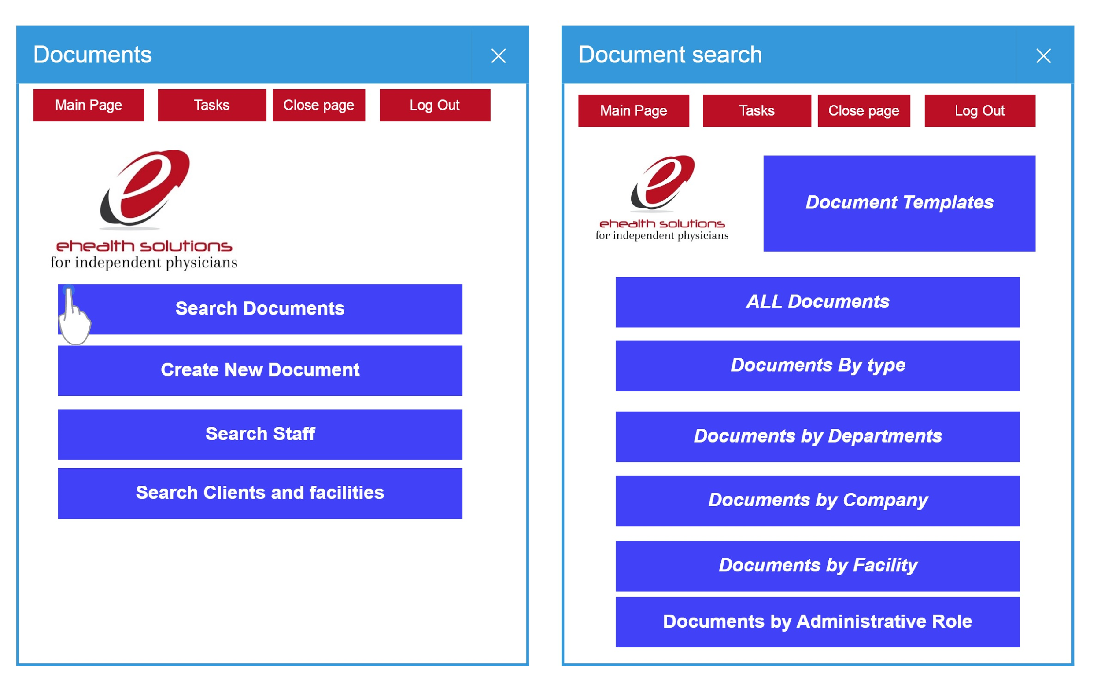Already approved documents can be searched, browsed on the basis of category.
      3. Document- User Read and sign screen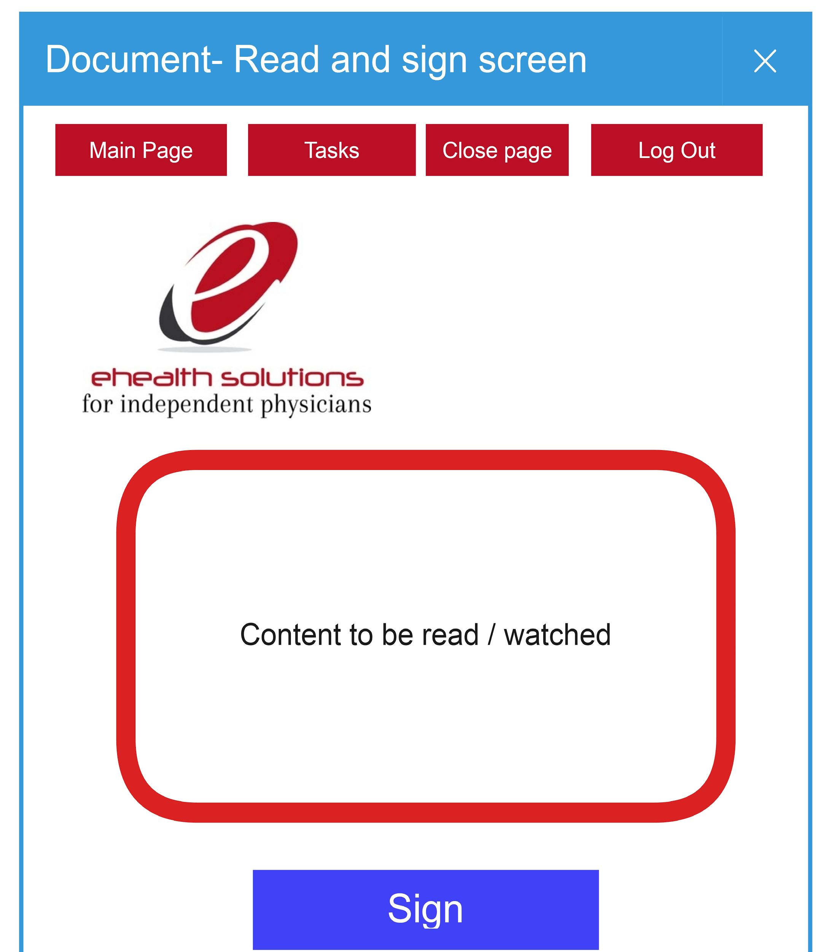
      4. Document- Read and respond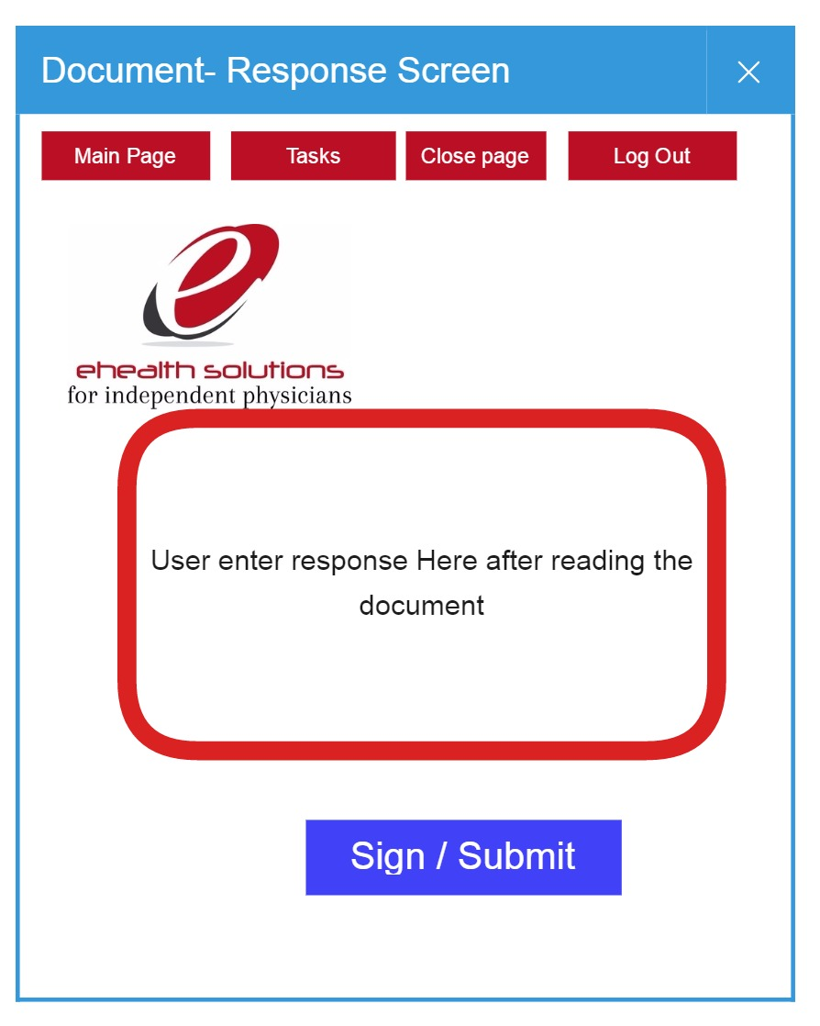
      5. Document-Test Screen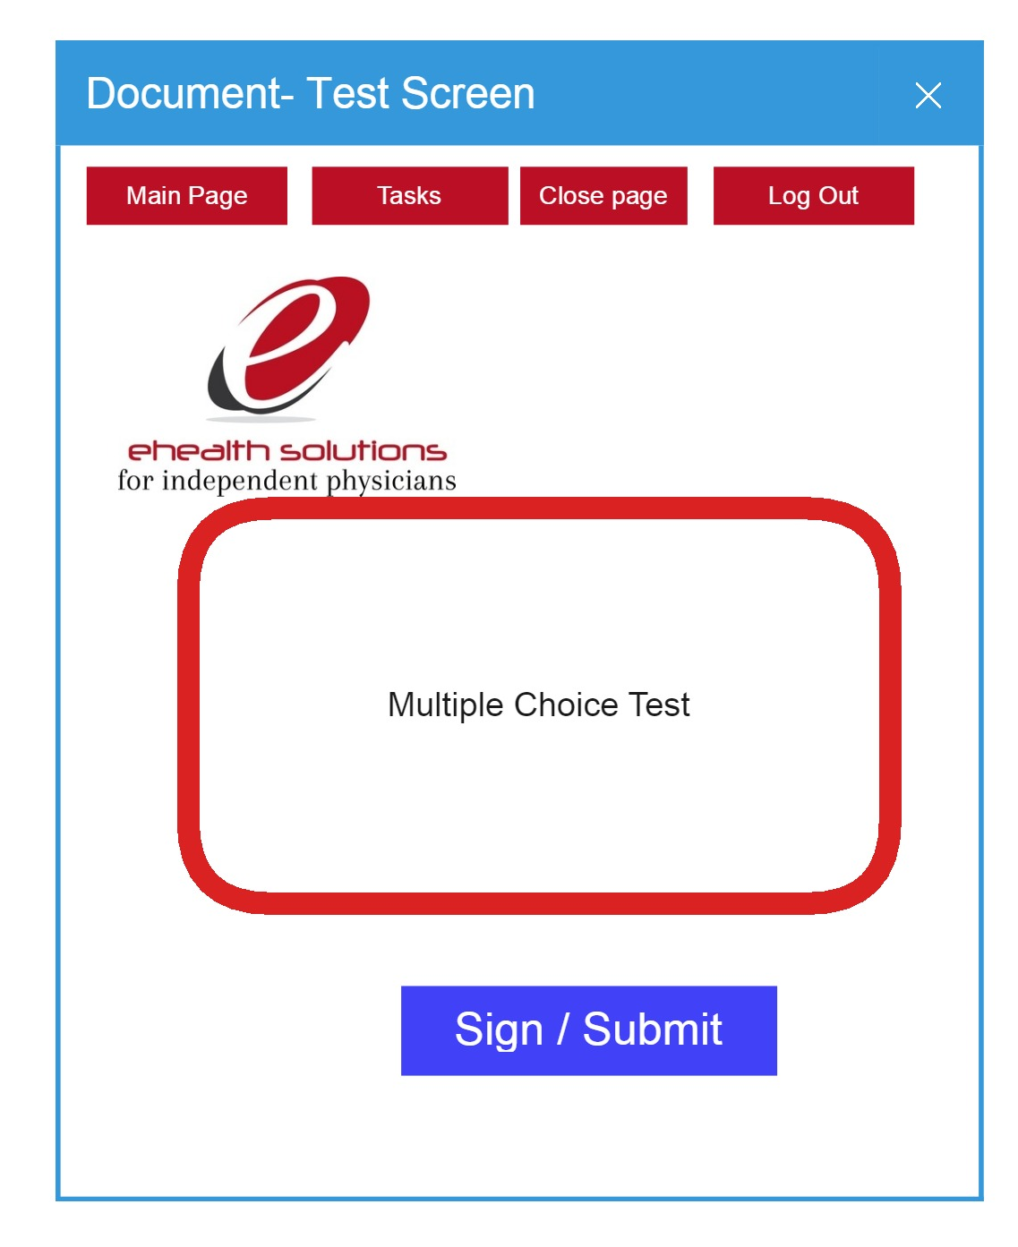
      6. Document Creation wizard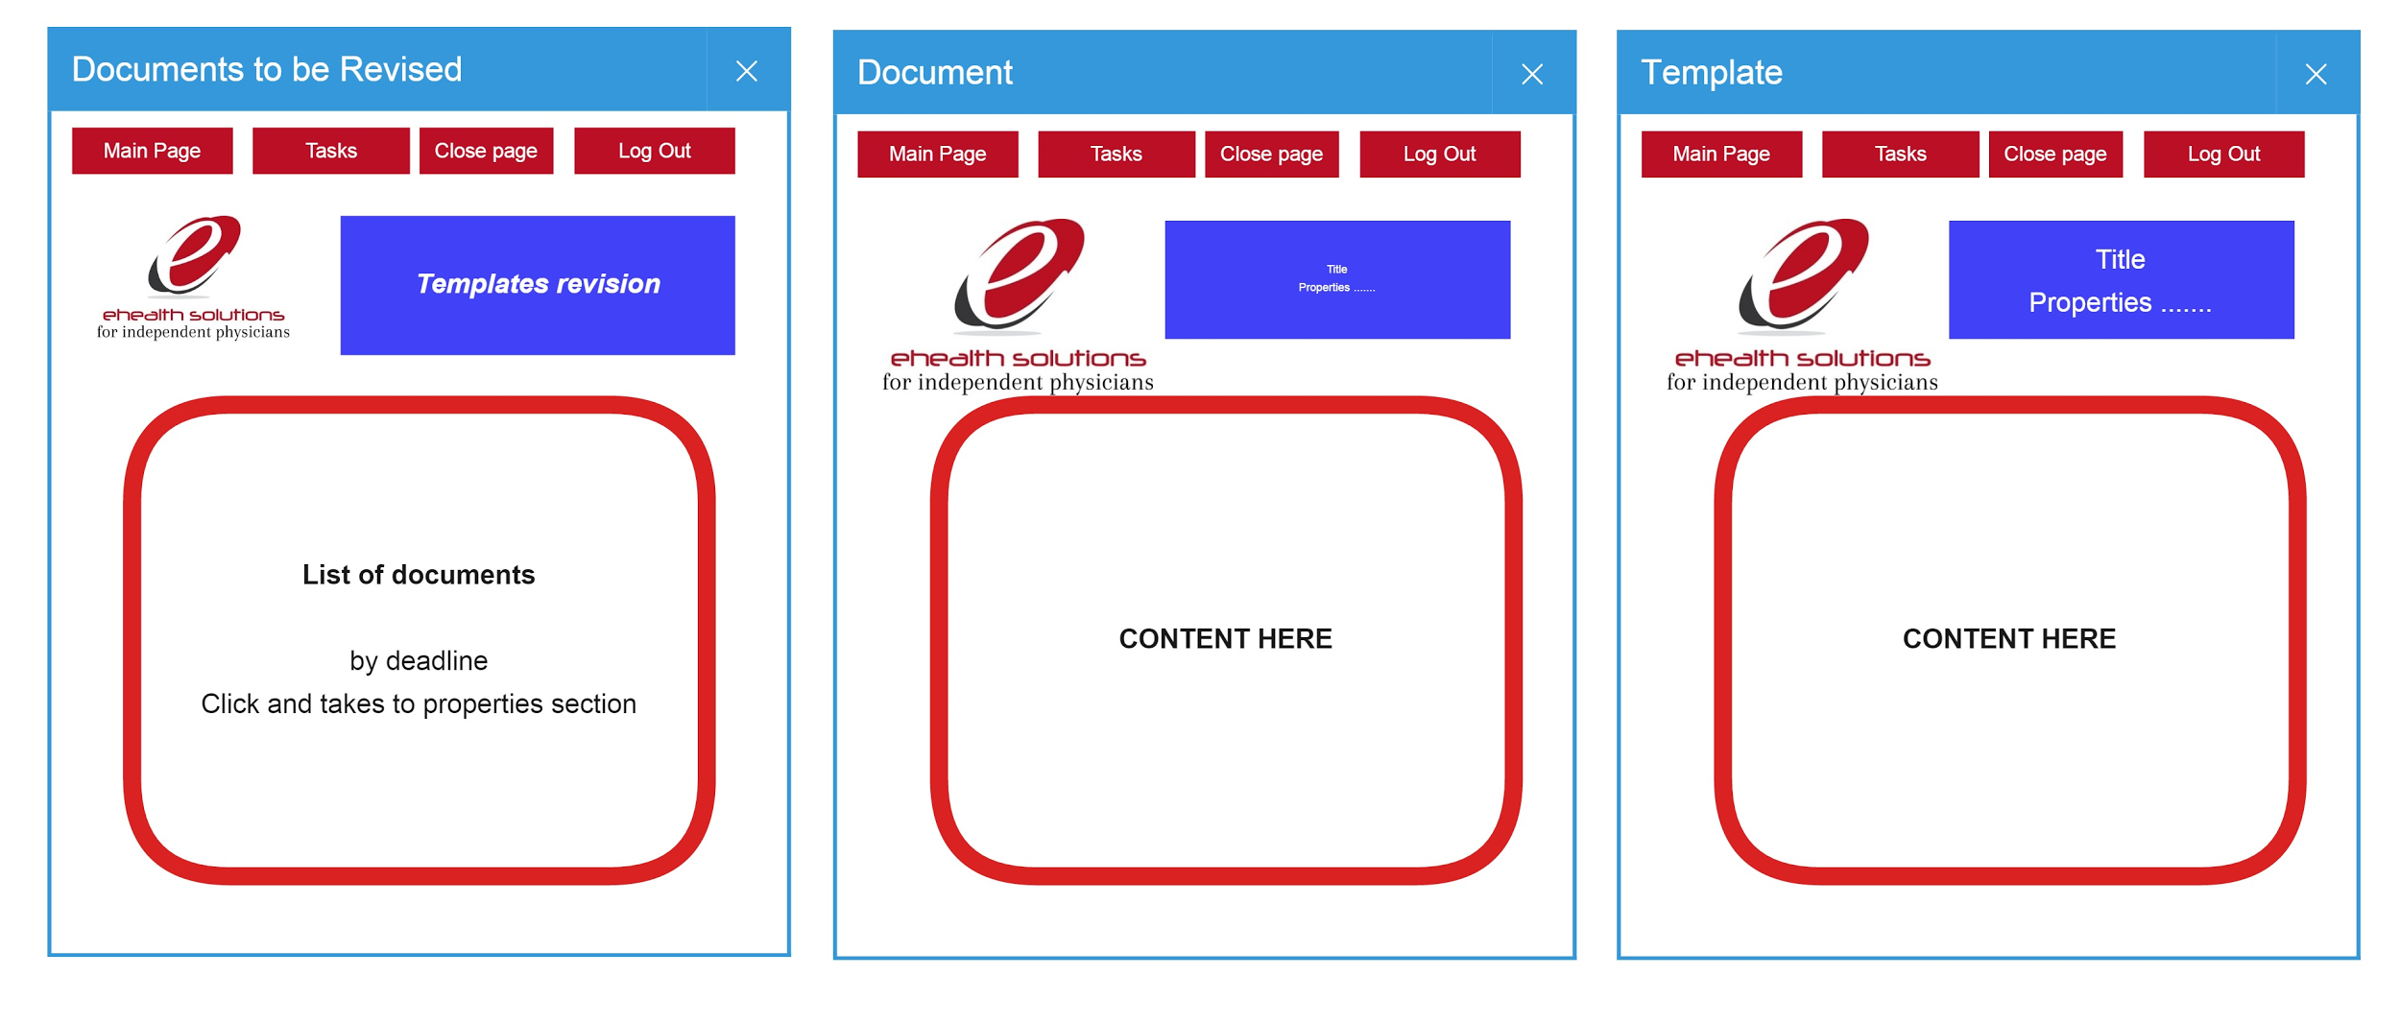In this section basic properties of the document will be set prior to draft.
         1. New Document-Title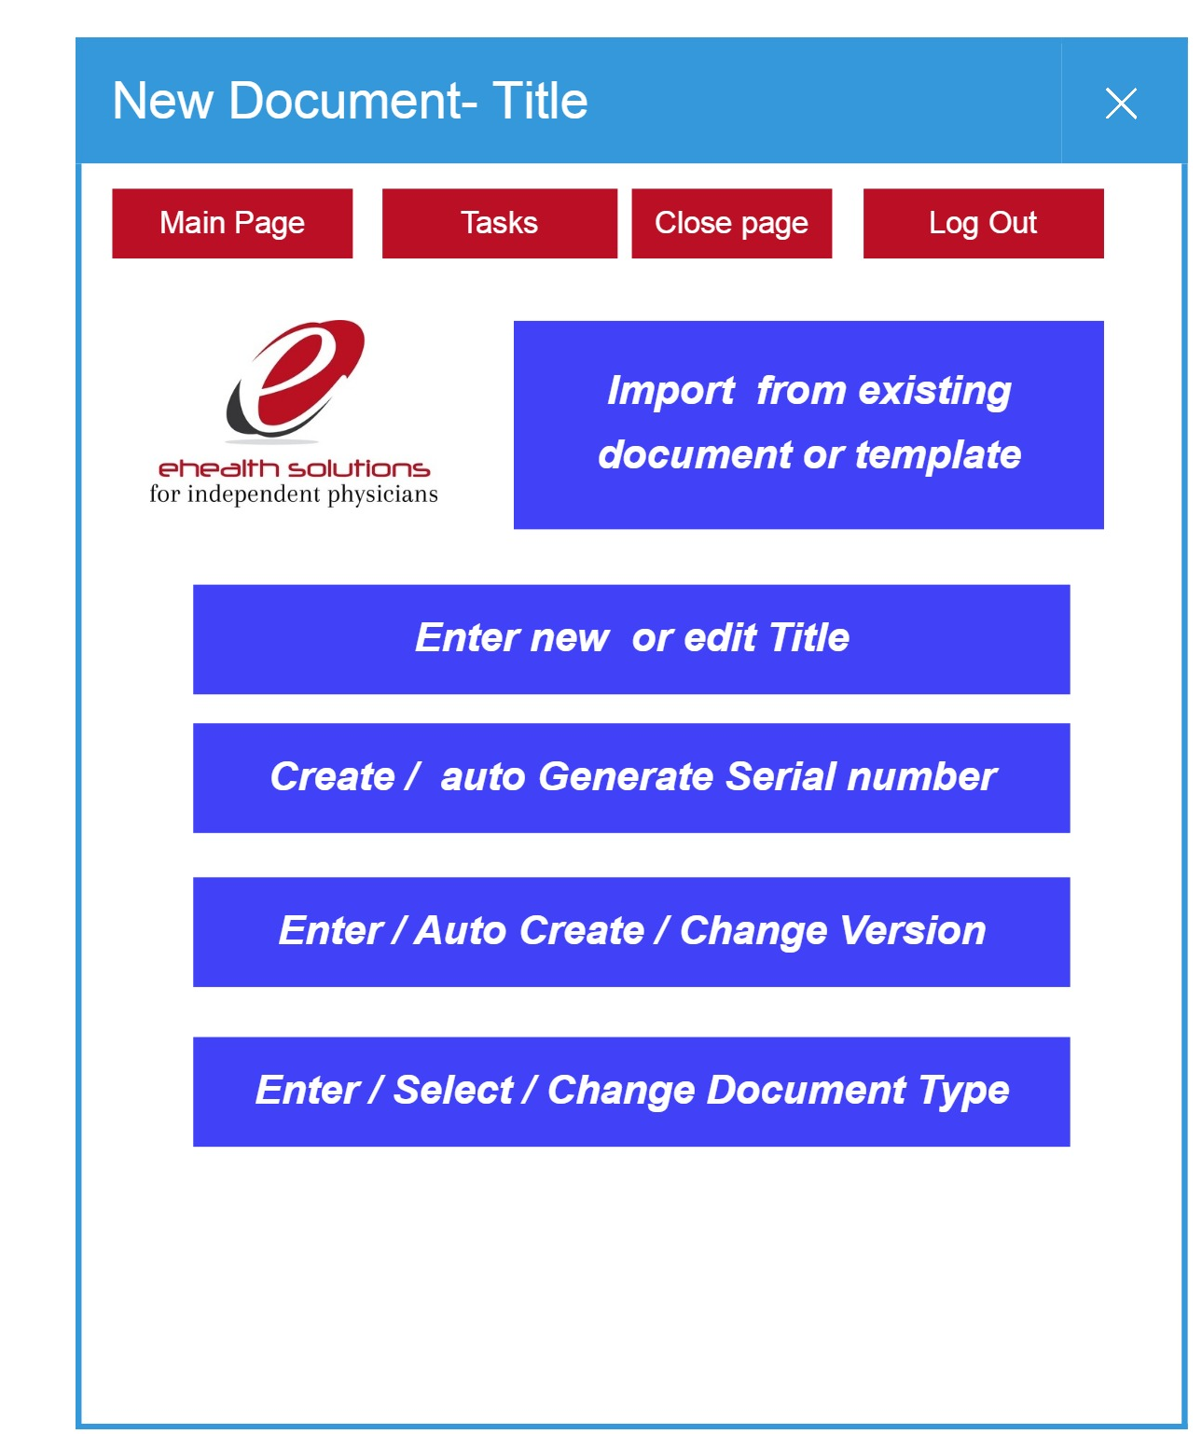In this section the optional properties of the documents are set
         2. New Document-Properties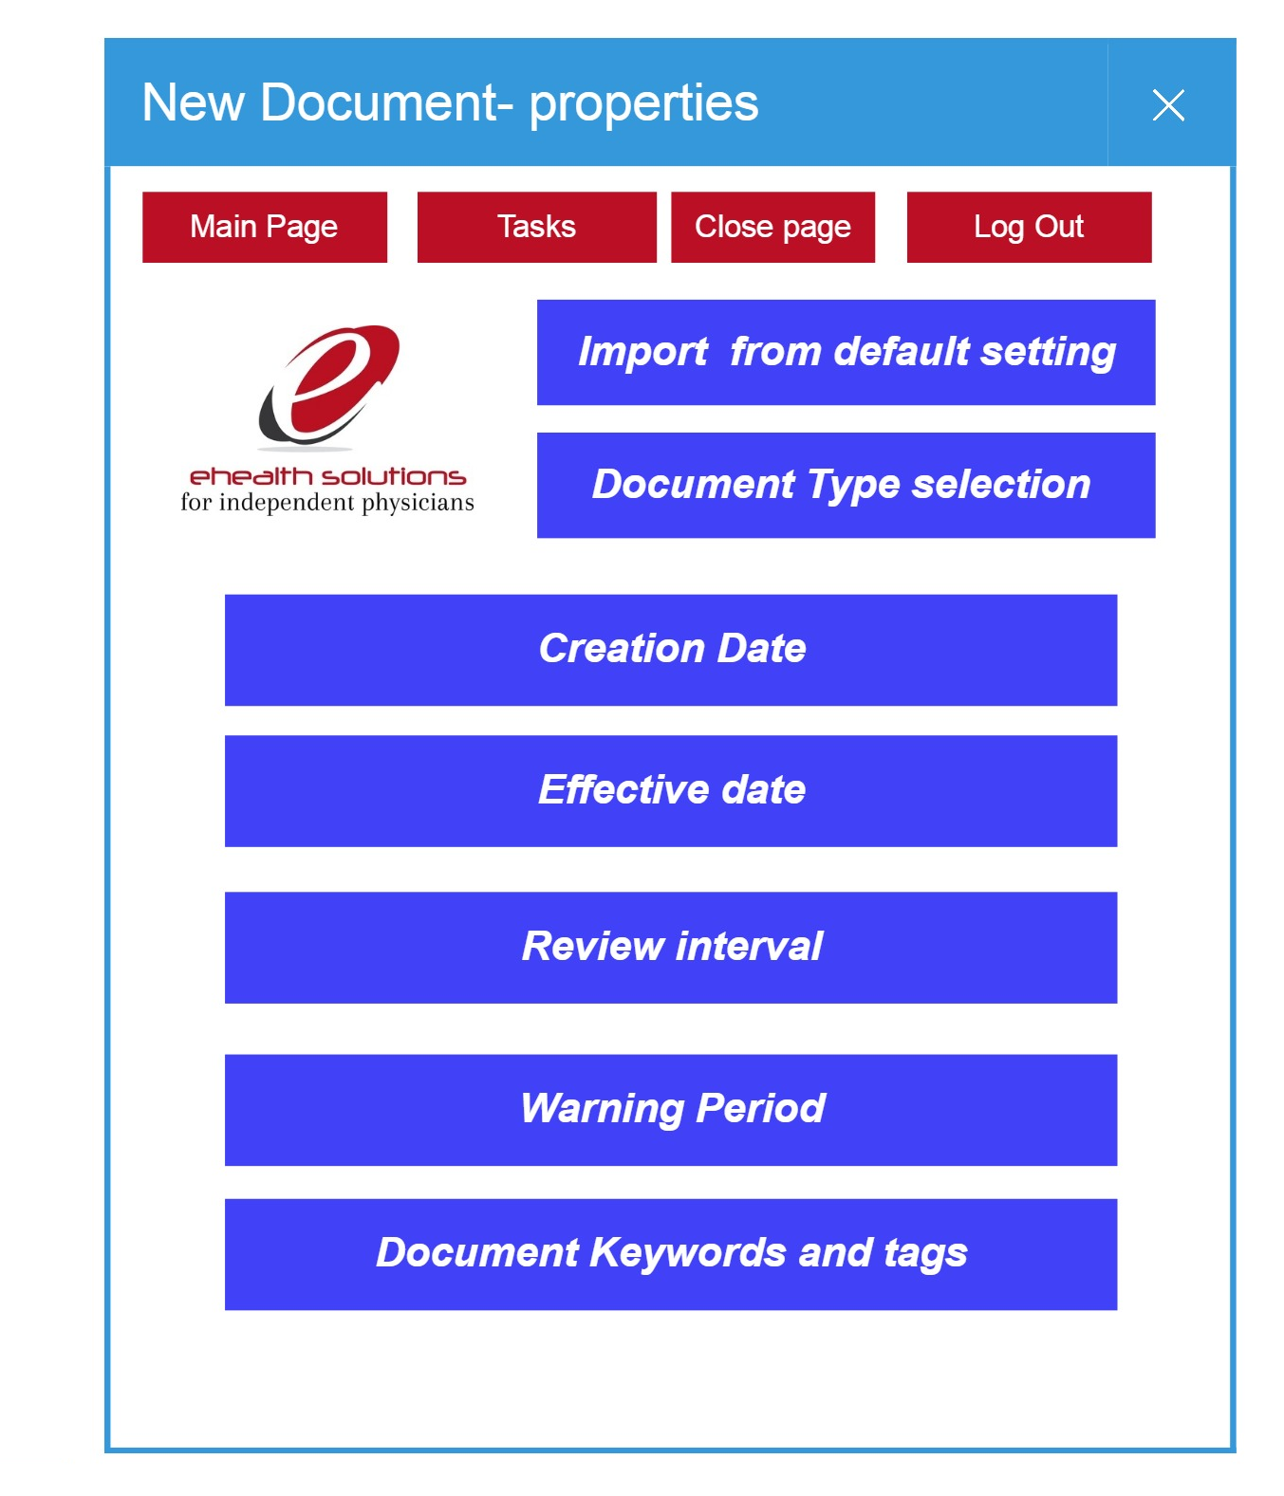
         3. New Document- User Assignment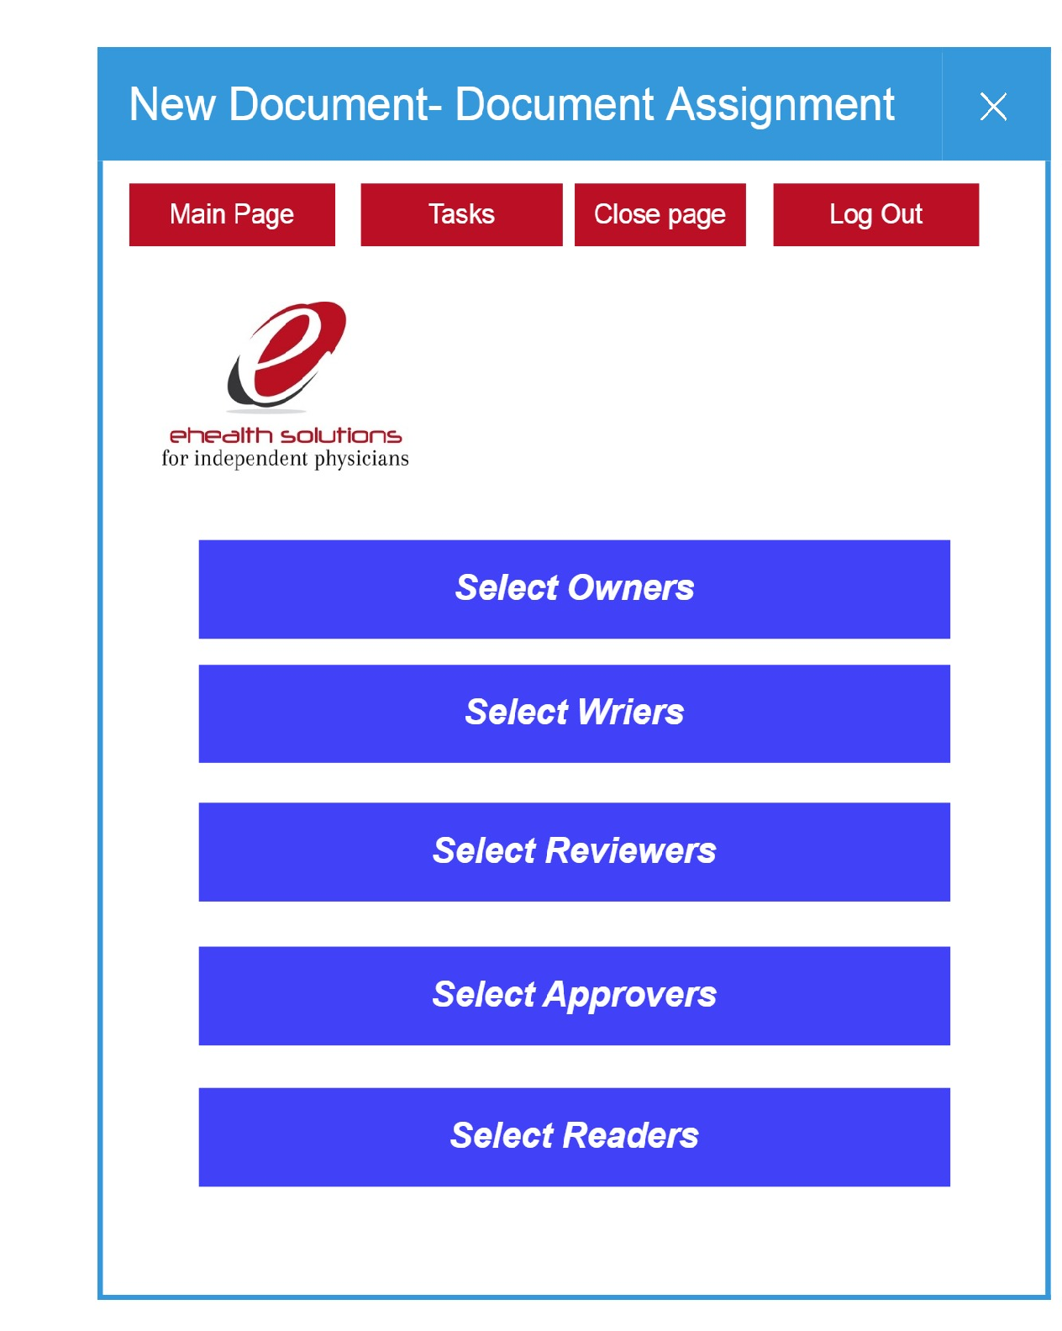
         4. New Document Assignment / Owner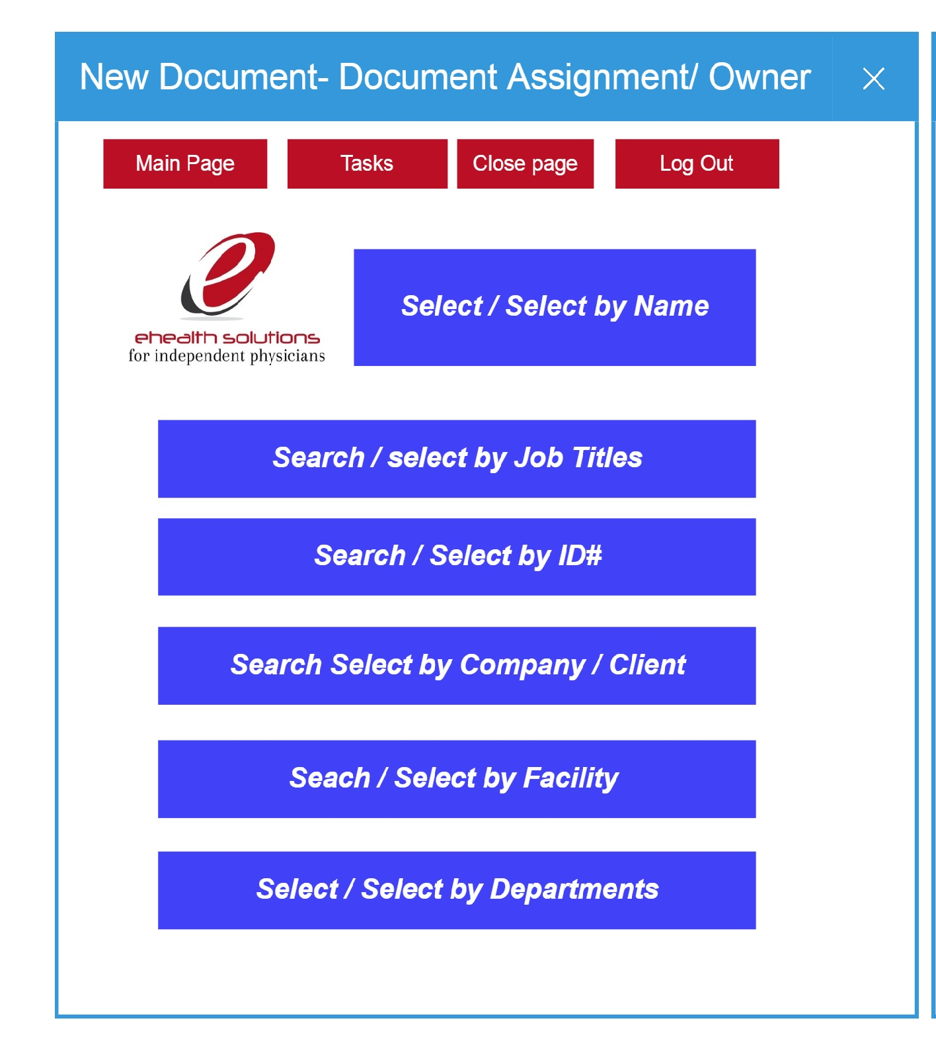
         5. New Document- user Assignment/Writer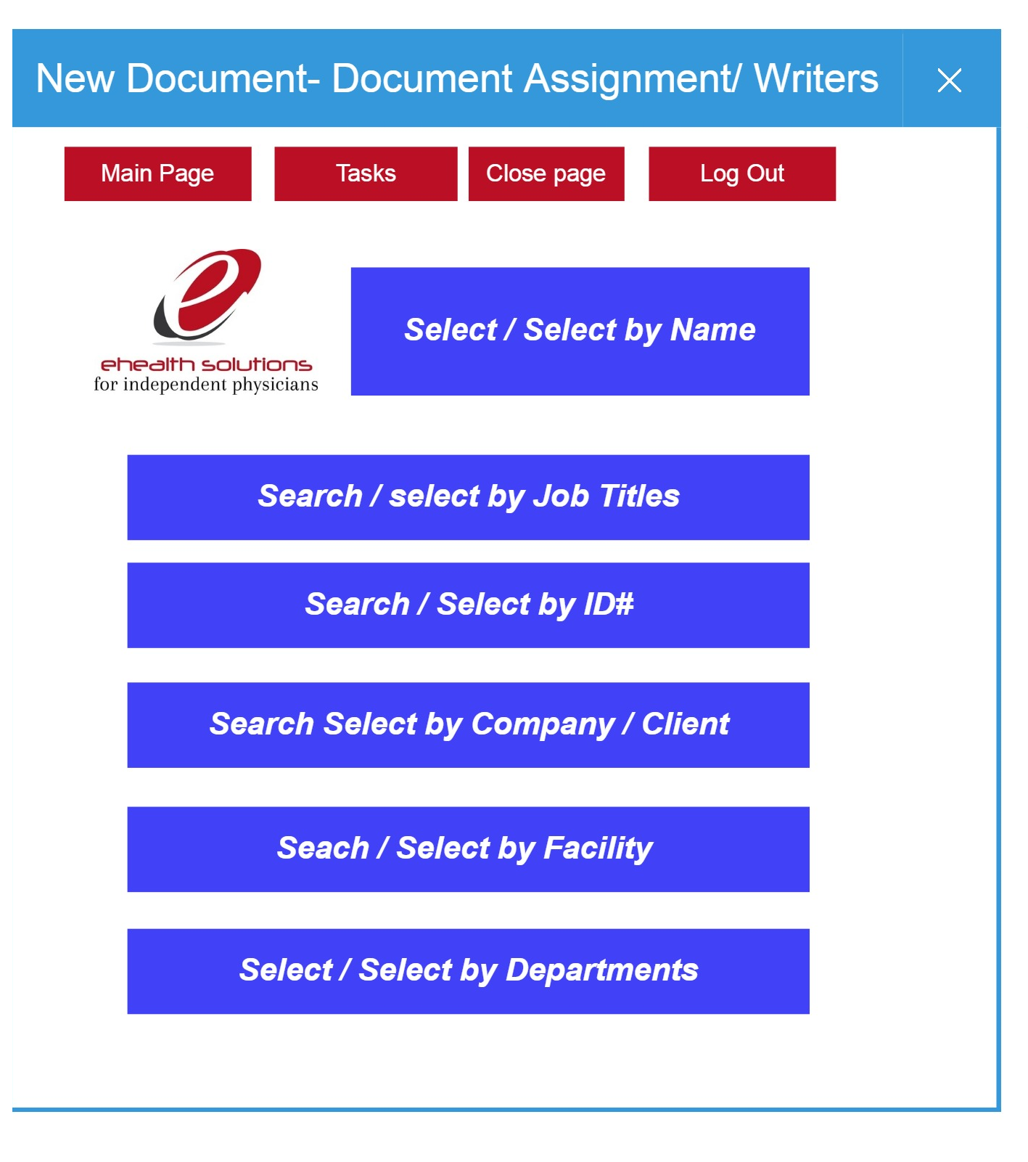
         6. New Document-user assignment/reviewer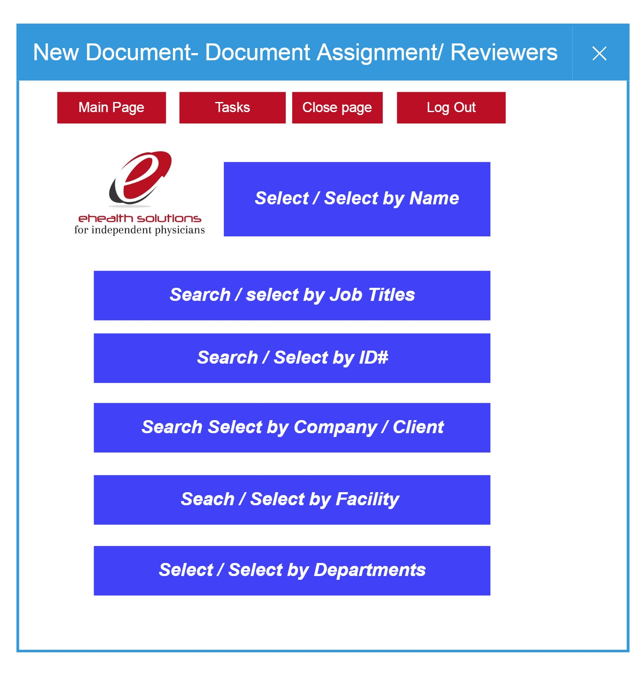
         7. New Document- user assignment / approver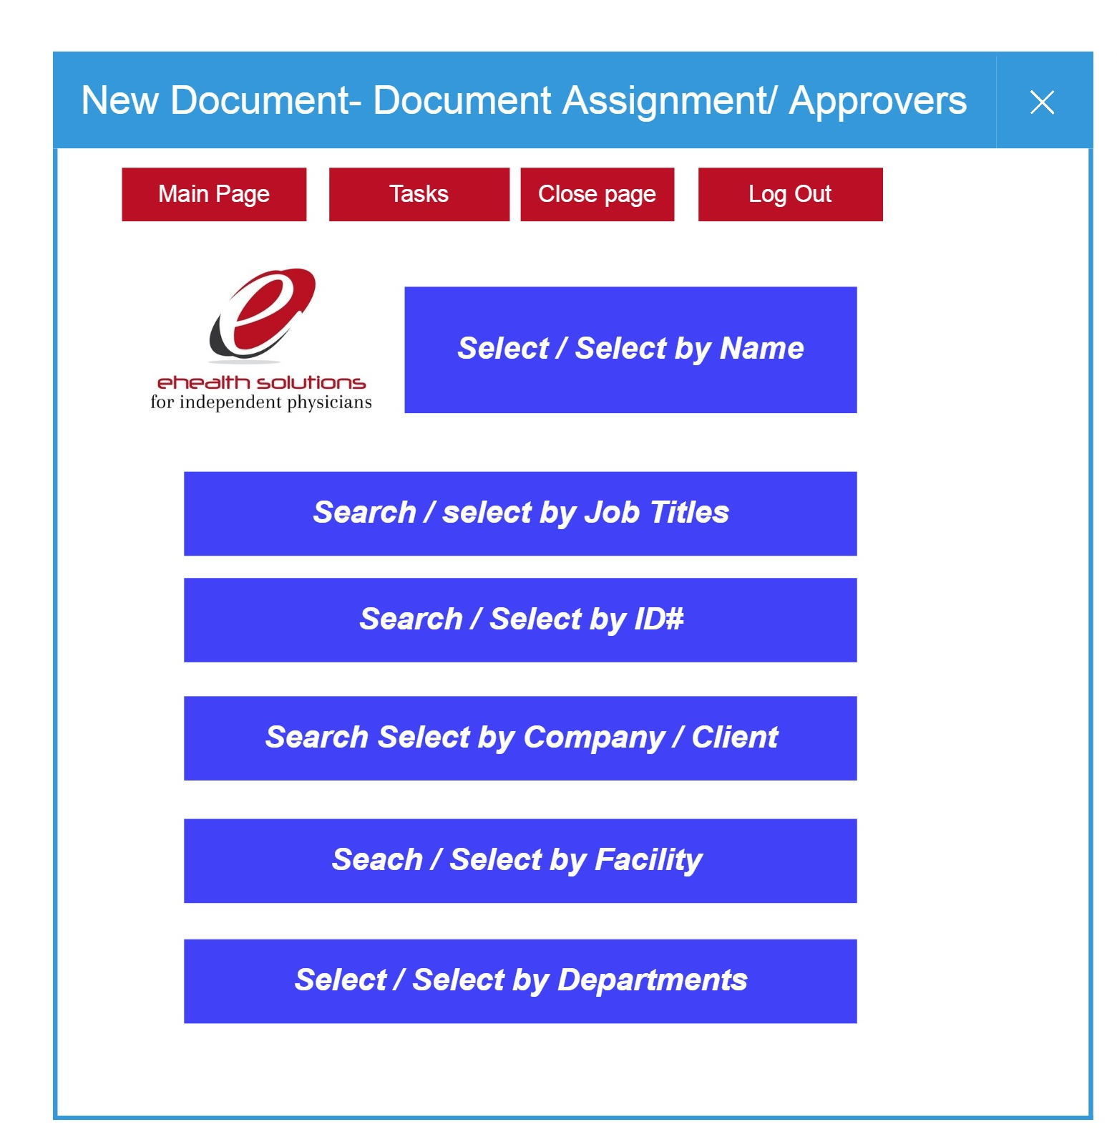
         8. New Document- User assignment /Reader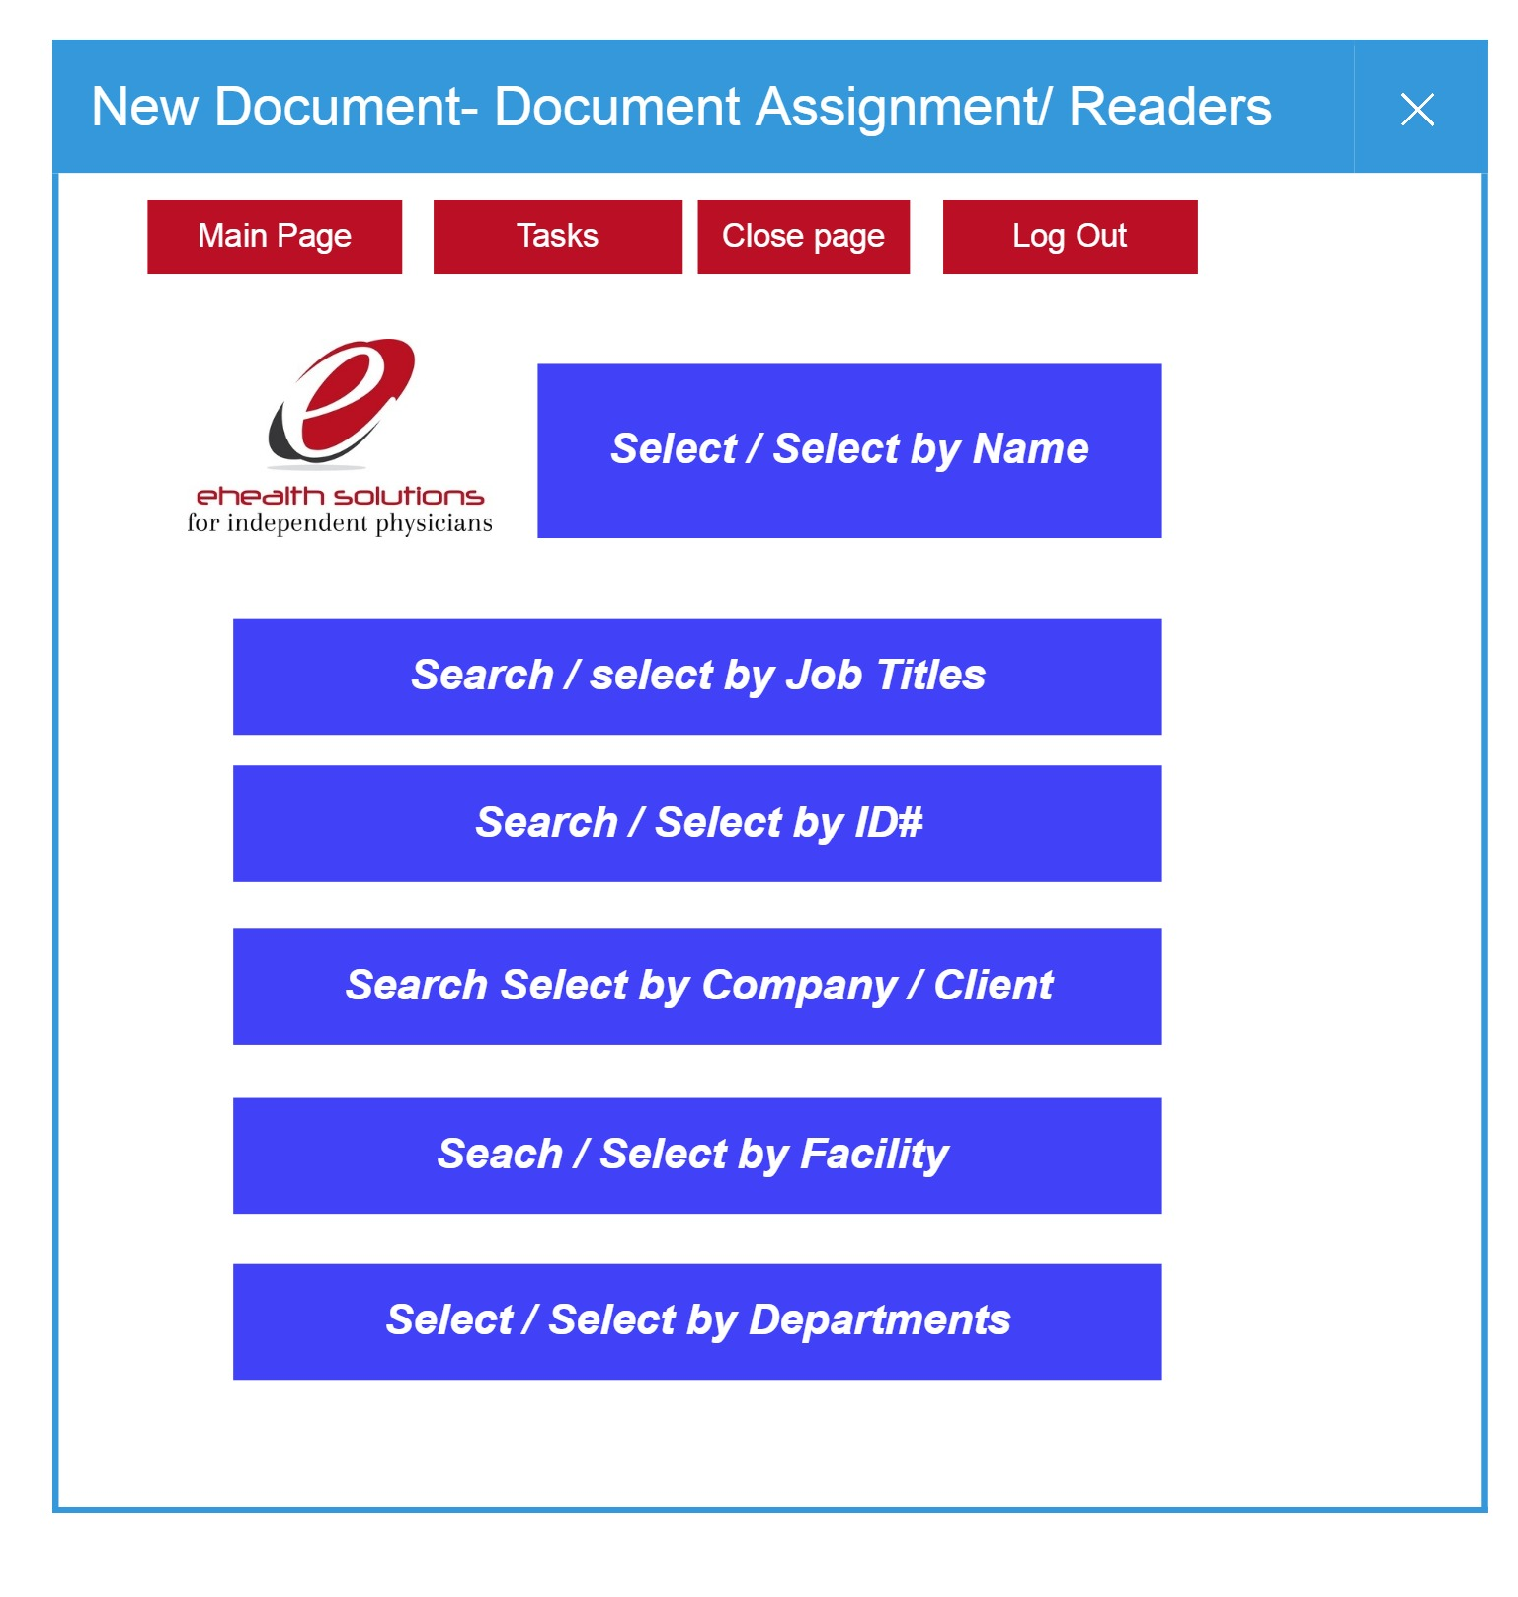
      7. New Document- Content 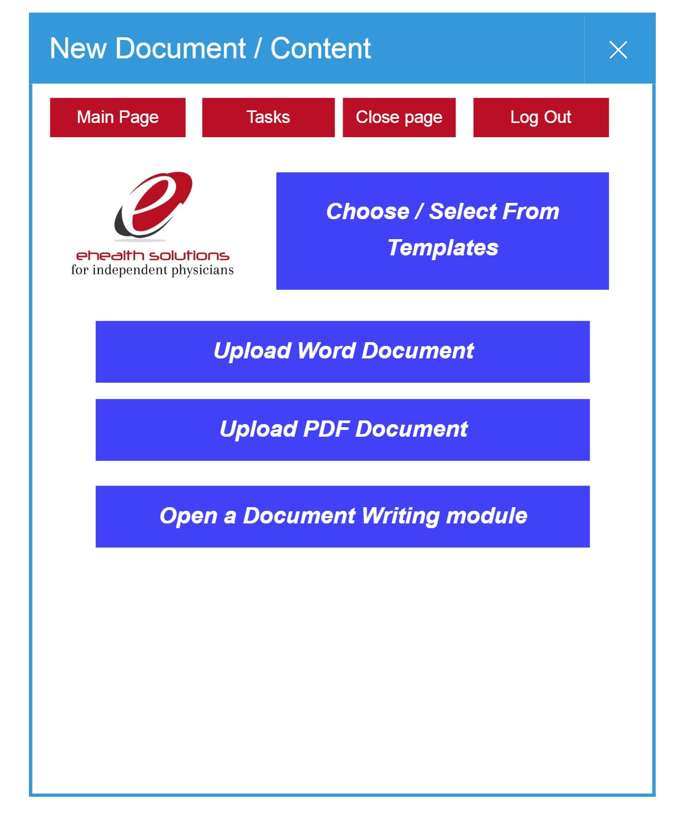
      8. New Document- Administrative action setting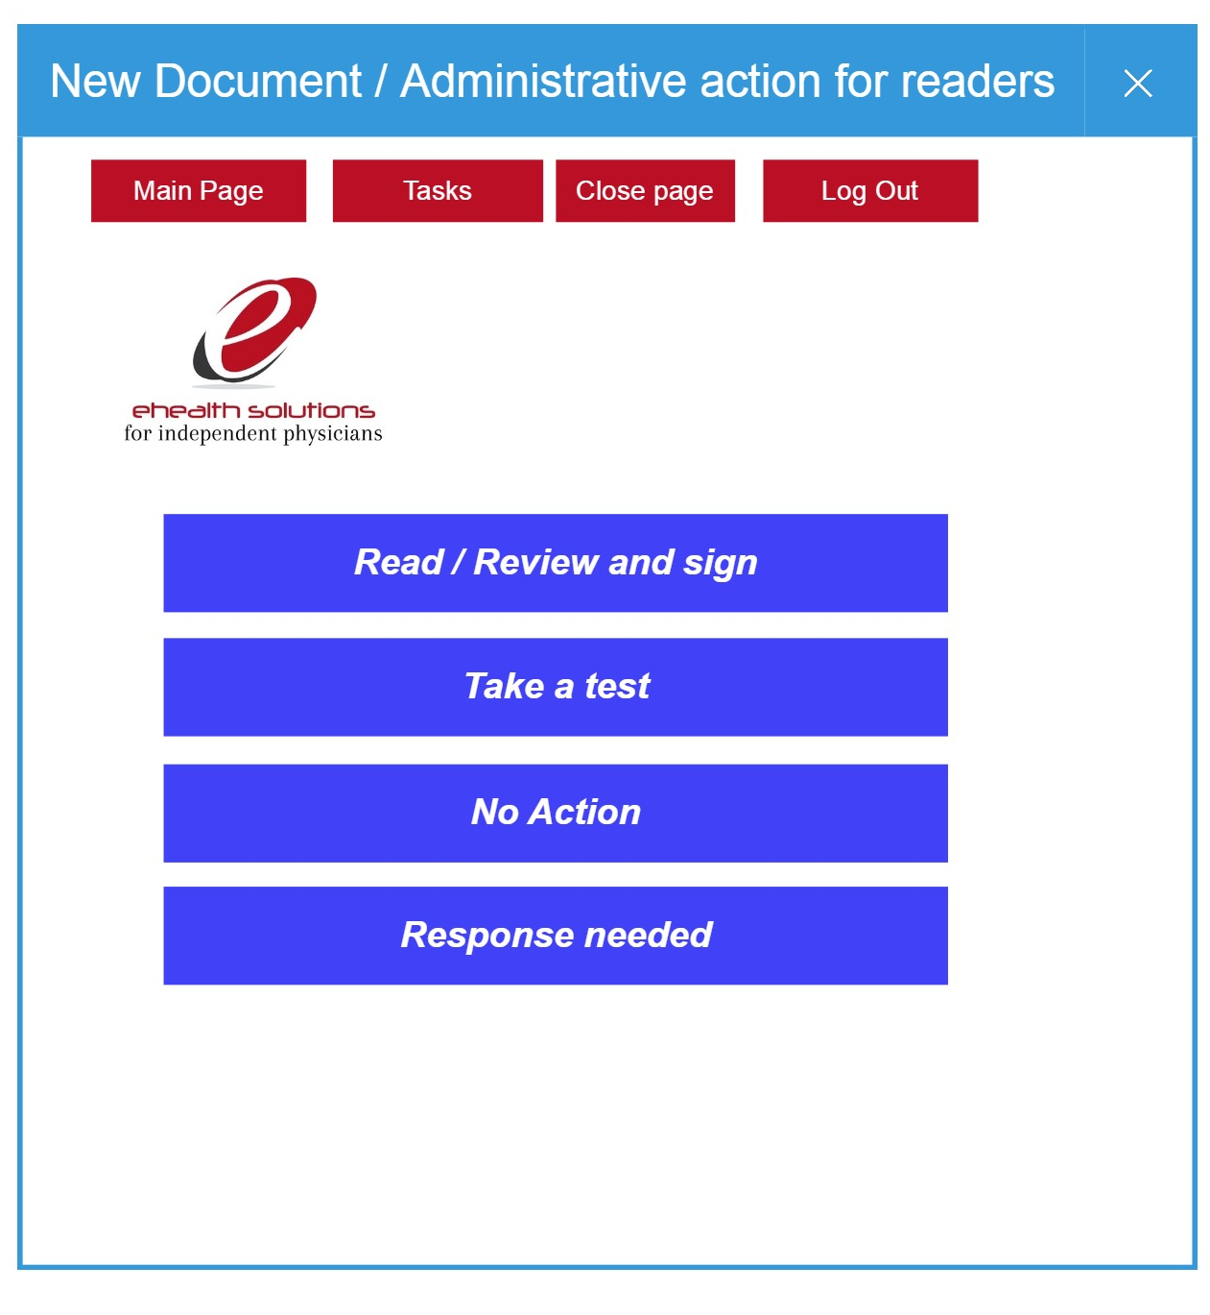
      9. New Document- Administrative action Test creation wizard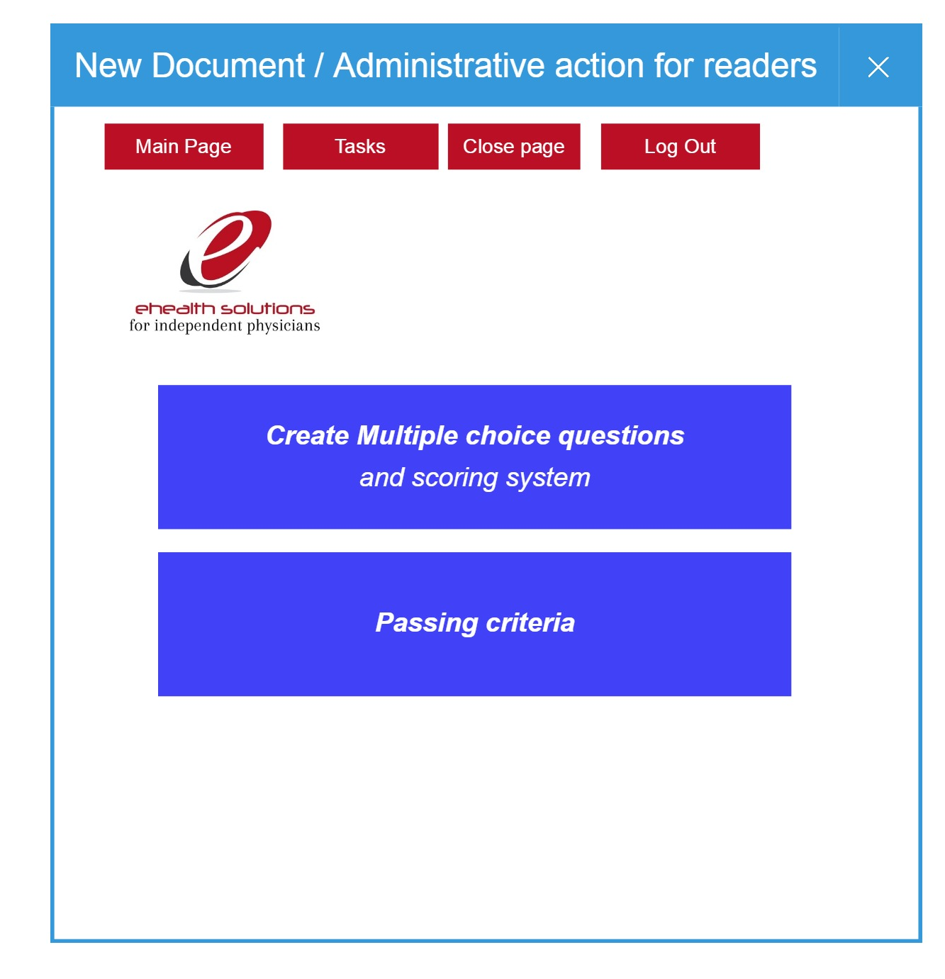
      10. New Document- Content / finalize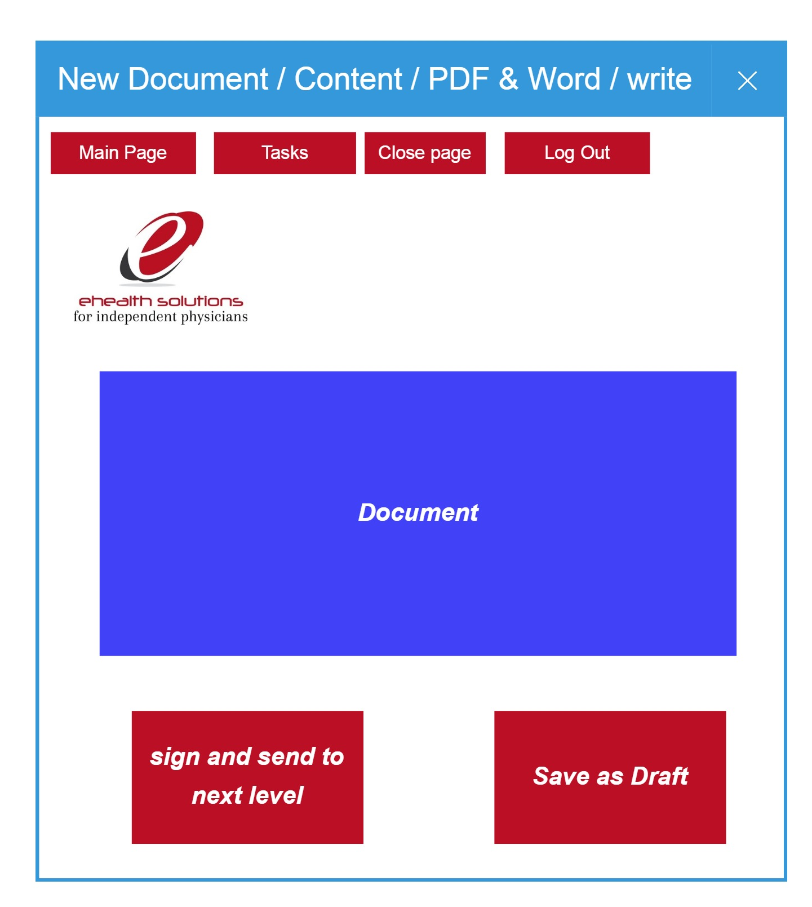

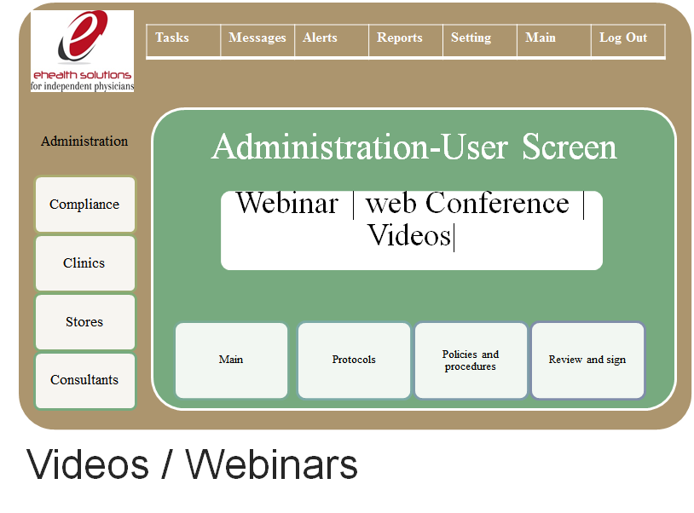

### Protocols

* Policies must be distributed to the designated users/readers after going through final approval
* Periodic reminders must (as set while creating the document) for readers
* Periodic alerts must be sent to administration to update and rewrite policies and procedures (As set on initial Document)
* Customizable alert system be in place for protocols.

### Technical Requirements: (Back End Data Process)

### Technical Requirements: (Front End User Interface)

### Additional Technical Details: (Code, Diagrams,etc)

## Electronic Medical Record Module (EMR)

### Use-Case Realizations

### Clinical Requirements

### Administrative Requirements

### User Interface (UI)

### Protocols

### Technical Requirements: (Back End Data Process)

Information Origination :

* All design need to captured and recorded in various sections
* All the code and software artifacts to be added to github
* Each Service to have a separate section
* Each feature to have subsection under that Service .



Initial Model Based Architecture :

* The plug-in mode architecture
  + Each Service is independent of each other
  + Each Service may use common data
  + All services t have set four operation
    - Create
    - Update
    - Retrieve
    - Delete

### Technical Requirements: (Front End User Interface)

### Additional Technical Details: (Code, Diagrams,etc)

## 

## Telemedicine Module

### Use-Case Realizations

### Clinical Requirements

### Administrative Requirements

### User Interface (UI)

### Protocols

### Technical Requirements: (Back End Data Process)

### Technical Requirements: (Front End User Interface)

### Additional Technical Details: (Code, Diagrams,etc)

## Virtual office / Store Module

### Use-Case Realizations

### Clinical Requirements

### Administrative Requirements

### User Interface (UI)

### Protocols

### Technical Requirements: (Back End Data Process)

### Technical Requirements: (Front End User Interface)

### Additional Technical Details: (Code, Diagrams,etc)

## Data Base and Cloud Storage

### Use-Case Realizations

### Clinical Requirements

### Administrative Requirements

### User Interface (UI)

### Protocols

### Technical Requirements: (Back End Data Process)

### Technical Requirements: (Front End User Interface)

### Additional Technical Details: (Code, Diagrams,etc)

## e-Commerce

### Use-Case Realizations

### Clinical Requirements

### Administrative Requirements

### User Interface (UI)

### Protocols

### Technical Requirements: (Back End Data Process)

### Technical Requirements: (Front End User Interface)

### Additional Technical Details: (Code, Diagrams,etc)

## Medical Wearable Integration

### Use-Case Realizations

### Clinical Requirements

### Administrative Requirements

### User Interface (UI)

### Protocols

### Technical Requirements: (Back End Data Process)

### Technical Requirements: (Front End User Interface)

### Additional Technical Details: (Code, Diagrams,etc)